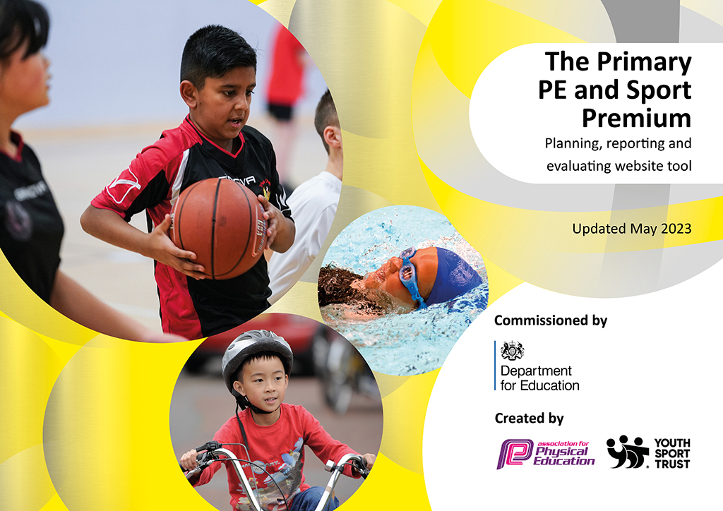
0
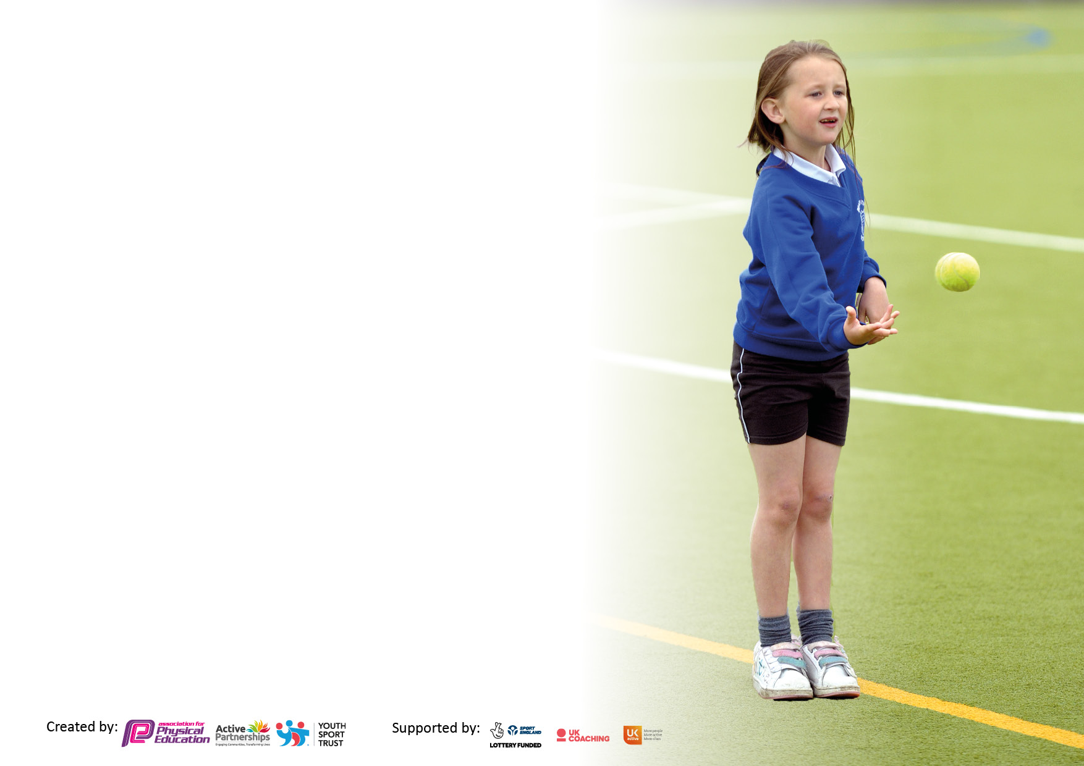

It is important that your grant is used effectively and based on school need. The Education Inspection Framework makes clear there will be a focus on ‘whether leaders and those responsible for governors all understand their respective roles and perform these in a way that enhances the effectiveness of the school’.

Under the Quality of Education Ofsted inspectors consider:
Intent - Curriculum design, coverage and appropriateness
Implementation - Curriculum delivery, Teaching (pedagogy) and Assessment
Impact - Attainment and progress

To assist schools with common transferable language this template has been developed to utilise the same three headings which should make your plans easily transferable between working documents.

Schools must use the funding to make additional and sustainable improvements to the quality of Physical Education, School Sport and Physical Activity (PESSPA) they offer. This means that you should use the Primary PE and sport premium to:

- Develop or add to the PESSPA activities that your school already offer
- Build capacity and capability within the school to ensure that improvements made now will benefit pupils joining the school in future years
- The Primary PE and sport premium should not be used to fund capital spend projects; the school’s budget should fund these.

Pleasevisitgov.ukfortherevisedDfEguidanceincludingthe5keyindicatorsacrosswhichschoolsshoulddemonstrate animprovement.Thisdocumentwillhelpyoutoreviewyourprovisionandtoreportyourspend.DfEencouragesschools to use this template as an effective way of meeting the reporting requirements of the Primary PE and Sport Premium.

We recommend you start by reflecting on the impact of current provision and reviewing the previous spend.

Schools are required to publish details of how they spend this funding, including any under-spend from 2021/2022, as well as on the impact it has on pupils’ PE and sport participation and attainment. All funding must be spent by 31st July 2023.

We recommend regularly updating the table and publishing it on your website throughout the year. This evidences your ongoing self-evaluation of how you are using the funding to secure maximum, sustainable impact. Final copy must be posted on your website by the end of the academic year and no later than the 31st July 2023. To see an example of how to complete the table please click HERE.

Details with regard to funding
Please complete the table below.

Total amount carried over from 2021/22 | £0
Total amount allocated for 2021/22 | £21290
How much (if any) do you intend to carry over from this total fund into 2022/23? | £0
Total amount allocated for 2022/23 | £21140
Total amount of funding for 2023/23. To be spent and reported on by 31st July 2023. | £ 21140
Swimming Data
Please report on your Swimming Data below.

Meeting national curriculum requirements for swimming and water safety.

N.B. Complete this section to your best ability. For example you might have practised safe self-rescue techniques on dry land which you can then transfer to the pool when school swimming restarts.
Due to exceptional circumstances priority should be given to ensuring that pupils can perform safe self rescue even if they do not fully meet the first two requirements of the NC programme of study
What percentage of your current Year 6 cohort swim competently, confidently and proficiently over a distance of at least 25 metres?  N.B. Even though your pupils may swim in another year please report on their attainment on leaving primary school at the end of the summer term 2022.  Please see note above | 77.8%
What percentage of your current Year 6 cohort use a range of strokes effectively [for example, front crawl, backstroke and breaststroke]?  Please see note above | 60.98%
What percentage of your current Year 6 cohort perform safe self-rescue in different water-based situations? | 80.48%
Schools can choose to use the Primary PE and sport premium to provide additional provision for swimming but this must be for activity over and above the national curriculum requirements. Have you used it in this way? | No

Action Plan and Budget Tracking
Capture your intended annual spend against the 5 key indicators. Clarify the success criteria and evidence of impact that you intend to measure to evaluate for pupils today and for the future.

Academic Year: 2022/23 | Total fund allocated:£21,140 | Date Updated: 3rd July 2023
Key indicator 1: The engagement of all pupils in regular physical activity – Chief Medical Officers guidelines recommend that primary school pupils undertake at least 30 minutes of physical activity a day in school |  |  |  | Percentage of total allocation:
 |  |  |  | 96.4%
Intent | Implementation |  | Impact
Your school focus should be clear what you want the pupils to know and be able to do and about  what they need to learn and to  consolidate through practice: | Make sure your actions to achieve are linked to your intentions: | Funding allocated: | Evidence of impact: what do pupils now know and what can they now do? What has changed?: | Sustainability and suggested next steps:
Support and challenge children during PE lessons with the aim to motivate them to play more games during playtime and lunchtime.  Ensure MTPS have differentiation for those with SEND, working below, working at and those with greater depth.  Reward children for their active participation in PE lessons  Reward children for being active outside of PE lessons  Sports Leaders to lead different activities during lunch time for their phase.  Engage children with Dance and embed more of a focus for Dance on the curriculum.  Introduce 'GoNoddle' to the school to keep children active and have brain-breaks in the classroom  Re-introduce Rock n Roller (SEND focus PE) sessions into the timetable.  Sports Coaches active in the playground Motivate children to be active  Create Sports Teams  Upgrade equipment  Offer a wider range of Sports clubs for all years from Reception - Year 6  Close the gap with low attainers.  Broaden children's knowledge of sporting activities.  Book with Chance 2 Shine for a cricket coach to come and teach a year group.  Book Bikeability for Years 3-6 children.  Book a fundraising athlete event for all children nursery - reception | Continue to buy-in to Primary PE Planning (PPP) for differentiated schemes of work and ensure there is a broad curriculum covering many different areas of skills and sports.  Use PPP to select appropriate MTPS that are differentiated and can ensure the teacher is teaching high-quality differentiated lessons.  Purchase medals/stickers and trophies to give to children who are making the effort to stay active.  Train Sports Leaders to lead a range of different activities in the playground - training in school and through Newham School Sports Partnership  Organise a Shaftesbury Dance Appreciation event during the Summer Term to showcase Dance's learned in PE lessons - giving the Dance in PE more of a focus.  Get teachers to join GoNoddle (free account) and then use during Wet play/lunch, for brain breaks within learning and when there is spare time.  Also invite parents to join the service for free at home (message sent to parents with link to join).  Train staff to run SEND PE sessions - focusing on improving gross motor skills  Timetable Sports Coaches to be out on playground duty and UKS2 lunch duty to help lead and facilitate activities during play/lunch time.  Ensure the curriculum is broad, update and improve playground equipment and resources to motivate and engage more children in physical activity.  Create sports teams to represent our school in events outside of the school - ran by NSSP.  Update play and lunch equipment to ensure there is a broad range of resources available for all children.  Use internal and external coaches to run after school clubs.  At least 9 clubs minimum. Use one of the Sports Coaches to run lunch time intervention clubs for low attainers.  Use NSSP for their Challenge activities and book either New Age Kurling or Boccia for children to do as a challenge activity.  Book with Chance 2 Shine in Autumn 1 for cricket coaching in Autumn 2  Book with Bikeability for Autumn funded training.  Book with Sporting for Champions for another fundraising circuit for the whole school including the nursery children. | £  £594 – Primary PE Planning scheme subscription  £15 - NSSA membership  £594 (already accounted above)  £2631.05 - medals, trophies and stickers.  £2887.50 (NSSP membership)  £4335.96- equipment  £9900 - Clubs through Premier Sport | More children are playing different games during break time and lunch time.  Children are being exposed to a broader PE curriculum, covering lots of skills with different sports.  Children are more motivated to be active in school during PE lessons and play time to receive the rewards offered.  Trophies offered half termly to 2 pupils in each class, medals offered weekly and stickers offered daily.  Sports leaders are engaging more children in the playground. They approach those who are alone or sitting down and encourage them to join in the games.  Children have been keen to learn the dance to showcase to the rest of the school.  Many children are practicing in their own time during lunch and at home.  Children are using GoNoddle at different times of the day and some have been using it at home.  Children with SEND are more engaged with PE lessons as a result of the extra intervention they have received.  All SEND children love attending their SEND PE sessions.  Sports coaches run regular activities in the playground engaging most children throughout the week.  Children really wanted to join the Sports Team (especially after they saw children represent our school in events during the Autumn term).  More children are wanting to sign up to after - school clubs to join these teams. As we now have a wider and broader range of equipment, more children are staying active as they have more to use and more to play with.  All Sports Clubs have been fully booked and waiting lists had to be created for them as there was a lot of interest in children joining them this year.  This year, our low attainers have shown more progress than previous years as they have received extra intervention at lunch time and as teachers and the coaches have been teaching PE lessons together, children have been focuses for the Sports Coach / teacher during lessons.  Year 5 Children participated in a Sports Challenge and learned New Age Kurling through NSSP - this has been used at other times in the school year since they have been taught how to play.  Year 4 children showed tremendous progress in cricket led by Chance 2 Shine via Essex cricket.  More Year 5/6 children are biking to school since completing the Bikeability course.  Children were motivated to participate in the fitness circuit with an athlete (basketballer this year) and really engaged in the activities they did.  Children are now using these activities during PE warm ups that they lead.  Overall, PE lessons are more purposeful, activities outside are offered and more children are engaging with these.  All external agency/people involvement has motivated children. | Continue to buy-in to Primary PE Planning. This is sustainable as plans can be downloaded if we chose not to continue with the purchase of the program.  Continue to use GoNoddle and use this to replace 5-a-day in EYFS.  Join NSSP next year to benefit from events and additional offers such as sporting challenges, Sports leader training and 1 after school club in the Summer term.  Continue to purchase stickers, medals and trophies as rewards to help motivate children.  Ensure Sport Leader training for the new Year 6 cohort is done in the Autumn term.  Ensure Year 5 Sports Leader training takes place before Summer term through NSSP.  Re-book chance 2 shine and Bikeability if funding still available. If funding not available, enquire of costs for these activities. Children at Shaftesbury really engage when outside specialist teachers come in.  Re-book an athlete visit for the next academic year - this is free but children fundraise on behalf of the company.  All intents to continue in the next academic year.
Key indicator 2: The profile of PESSPA being raised across the school as a tool for whole school improvement |  |  |  | Percentage of total allocation:
 |  |  |  | 99.1% (96.4% already accounted for above)
Intent | Implementation |  | Impact
Your school focus should be clear what you want the pupils to know and be able to do and about  what they need to learn and to  consolidate through practice: | Make sure your actions to achieve are linked to your intentions: | Funding allocated: | Evidence of impact: what do pupils now know and what can they now do? What has changed?: | Sustainability and suggested next steps:
Ensure children are encouraged and engaged during P.E lessons (bringing in their P.E kits twice weekly).  Offer bi-weekly P.E certificates and stickers for children. Offer a variety of stickers, medals and trophies for Sports Day.  Offer a variety of stickers, medals and trophies for weekly achievement assemblies, half termly trophy awards and yearly PE performance acknowledgement.  Take more pictorial and video evidence of PE to support assessment and as a focus. Develop a WET PE plan for UKS2 linked to science/theory Ensure all teachers have access to GoNoddle for WET PE lessons.  Celebrate PE in school with a display board.  Offer a wide range of Sporting after school clubs.  Join NSSP to take part in inter-school events.  Ensure intra school events take place at least once every half term per year group (focusing on the sport they have been learning).  Facilitate Sports Events at Shaftesbury and invite classes to watch our team compete against others.  Raise the awareness of PESSPA across the school.  Celebrate all Sports including dance in our school.  Sign up for National Sports Week. | Provide bi-weekly P.E certificates to be given out in the achievement certificates.  Send letters home to children if they haven't brought their P.E kit 2 times a week.  Purchase stickers, certificates and medals for achievement rewards.  Purchase cameras to use in PE lessons and for videos to be played to children to look at how they are developing techniques.  Create 'in class' PE lessons looking at the theory behind different sports (such as muscles used, bones affected etc) for UKS2 to use during WET PE lessons.  Send GoNoddle link and monitor that this is used for LKS2, KS1 and EYFS when WET PE takes place.  Create and update the PE display board, celebrating sport in our school.  Take part in events offered through NSSP and Newham Schools Football league  Embedded intra school competitions in the MTPS so each half term children can compete with each other in their year groups and also ensure Sports Day is packed with events celebrating and showcasing a range of skills taught this year - not just athletics focus but focusing on other sporting skills like batting, throwing etc.  Invite schools within the trust and other schools within our connection to come to our school to participate in inter school competitions.  Invite sporting guests in to speak to children to motivate them to be sports people in the future.  Book London track/ West Ham Park for Sports Day and facilitate a dance appreciation day at Shaftesbury.  Teachers and coaches to team teach lessons to have more focus children, stretch, challenge and motivate others.  Host a range of activities during National Sports Week. | £  £594 – Primary PE Planning scheme subscription  £15 - NSSA membership  £2631.05 - medals, trophies and stickers.  £2887.50 (NSSP membership)  £4335.96- equipment  £9900 - Clubs through Premier Sport  £218.33 – West Ham Park hire  £360 – Travel to interschool events | Children are motivated and eager to gain PE rewards so are participating more in lessons.  More children are bringing in their PE kits and less letters are being sent home.  Children love watching themselves in PE lessons and comparing to videos on PPP.  Year 5/6 are developing a deeper understanding of PE through theory lessons when it is WET PE.  More children are engaging with GoNoddle throughout the school week, especially EYFS who use it at least twice a day.  Children love seeing what's new on the PE board and also seeing themselves being celebrated for something other than written work.  Shaftesbury have joined and facilitated a range of events this academic year.  Children in school have been keen to be supporters.  Children love Sports Day and have enjoyed practicing for the dance appreciation day in Summer 2. | Join NSSP for the next academic year.  Facilitate more events at Shaftesbury.  Create and attend events for the Boleyn Trust. Continue to reward children for participation and progression.  Continue to keep GoNoddle as a resource. Use more pictures from PE evidence on the PE celebration wall.  Continue to offer team teaching with coaches and teachers.  Hold annual Dance appreciation events.  Book West Ham Park or London Track for Sports Day 2023  Continue to complete activities during National Sports Week.  Try to introduce either daily mile or weekly mile onto school timetable.

Key indicator 3: Increased confidence, knowledge and skills of all staff in teaching PE and sport |  |  |  | Percentage of total allocation:
 |  |  |  | 16.5% (already included above)
Intent | Implementation |  | Impact
Your school focus should be clear | Make sure your actions to | Funding | Evidence of impact: what do | Sustainability and suggested
what you want the pupils to know | achieve are linked to your | allocated: | pupils now know and what | next steps:
and be able to do and about | intentions: |  | can they now do? What has
what they need to learn and to |  |  | changed?:
consolidate through practice:
Teachers confidence and knowledge/ skills to develop further.  Coaches to be offered CPD for sports/skills covered in our schemes of work.  Run PE insets throughout the year that focuses on knowledge and skills for staff.  Support staff inset on how to support during PE lessons.  PE coordinator/ coaches to attend network meetings related to PE.  PE lead and coaches to complete training offered through YST | Timetable coach to teach/team teach PE lessons with teachers.  Rotate termly to ensure all teachers receive CPD through observation of the coach for the academic year.  Join NSSP for CPD opportunities and send coaches/ staff if availability permits.  PE insets to cover knowledge of areas of the curriculum and skills children will learn.  Offer TAS an inset on how to support children during PE lessons and how to keep them engaged.  Send Sports Coaches and 1:1s to observe SEN PE with specialist within the trust.  YST membership included in NSSP costings, look at CPD offered and webinars and book on. | £  £594 – Primary PE Planning scheme subscription  £2887.50 (NSSP membership) | Teachers are much more confident teaching PE.  They understand what they need to teach and know different ways in which is can be taught.  Coaches have increased their knowledge and skillset for a range of activities including Early Movers. | Re-join NSSP for the next academic year.  Continue to send staff/coaches and support staff on relevant CPD opportunities. Try to arrange for an inset for TAs (especially 1:1s).  Contact P.A from the Boleyn Trust to organise when coaches and 1:1s can go and observe SEN PE - timetabling prevented this from happening this academic year but they were trained/advised by the PE Coordinator.  Continue to use YST CPD opportunities throughout the year.
Key indicator 4: Broader experience of a range of sports and activities offered to all pupils |  |  |  | Percentage of total allocation:
 |  |  |  | 83.8% (already accounted for above)
Intent | Implementation |  | Impact
Your school focus should be clear | Make sure your actions to | Funding | Evidence of impact: what do | Sustainability and suggested
what you want the pupils to know | achieve are linked to your | allocated: | pupils now know and what | next steps:
and be able to do and about | intentions: |  | can they now do? What has
what they need to learn and to |  |  | changed?:
consolidate through practice:
Additional achievements:  Continue to offer a wider range of activities both within and outside the curriculum in order to get more pupils involved, including attending sporting events.  The school offers a range of sports clubs (Monday-Thursday) ran by Premier Sports.  Coaches to provide children with additional sports clubs to fill the gaps.  Get Sports for Champions to come and run a circuit in the whole school (nursery to year 6).  Ask the Bikeability program to come and train our Year 3-6 bikers  Sports leaders to run and facilitate games at lunch time  Organise Dance Appreciation Day  Run a Sports Week during National Sports Week.  Organise Sports Day outside of school for years 1-6  Time table SEND PE intervention sessions.  Low attainers lunch time club | Offer at least 12 Sporting clubs per term across year groups.  Email Bikeability and book a week in the Autumn term.  Organise Dance Appreciation and link this to the dance they are learning on the curriculum.  Train sports leaders to run games during lunch and organise a rota system for this.  Facilitate sport activities during National Sports Week.  Contact London Track and West Ham Park to book Sports Day (2 days)  Train coaches to facilitate SEND PE  Timetable coaches to run lunch time clubs for low attainers. | £  £15 - NSSA membership  £2887.50 (NSSP membership)  £4335.96- equipment  £9900 - Clubs through Premier Sport  £218.33 – West Ham Park hire  £360 – Travel to interschool events | More children have joined our sporting clubs and wait lists have had to be created due to the popularity of clubs on offer.  Coaches have 6 clubs between them that are full.  They also train our girls' and boys' football teams.  Children are more engaged with different activities ran by the Sports Leaders at lunch time.  All children including SEND children took part in Sports Week and Sports Day.  All children have been practicing the dance for Dance Appreciation week.  Gap with low attainers has lowered as extra PE intervention is proving successful.  SEND children more engaged in PE due to having SEND PE sessions - they want to participate more in PE lessons too. | Continue with all set out in intent.  This has worked very well for our school so should continue.  Timetable SEND PE sessions for SEND children.  Identify low attainers and give them a lunch time club space.  Book either the London Track or West Ham Park for Sports Day.  Consider whether we can take children to Plashet or West Ham Park for orienteering purposes.

Key indicator 5: Increased participation in competitive sport |  |  |  | Percentage of total allocation:
 |  |  |  | 100% (99.1% accounted for above)
Intent | Implementation |  | Impact
Your school focus should be clear | Make sure your actions to | Funding | Evidence of impact: what do | Sustainability and suggested
what you want the pupils to know | achieve are linked to your | allocated: | pupils now know and what | next steps:
and be able to do and about | intentions: |  | can they now do? What has
what they need to learn and to |  |  | changed?:
consolidate through practice:
Develop a wide range of opportunities to try different sports through extracurricular activities.  Join a sports partnership and take children to borough/ partnership competitions.  Expand range of activities available as extra-curricular clubs to encourage pupils to be more involved.  Signpost families to opportunities outside of school to engage in further activities.  Create Trust sporting competitions.  Take years 1-6 out of school for Sports Day and use a 400m track to run events.  To consolidate learning and improve during inter school competitions, arrange for school competition games (intra school) to be completed at the end of each half term.  Facilitate more Sporting events with other schools.  Kits for coaches to wear at interschool events. | Enhance the afterschool club activities – provide a wider range of activities.  Join Langdon Sports Partnership and the Newham Football League.  Send out information for sporting clubs in and around the borough.  West Ham academy and other leaflets that are distributed.  Source additional clubs families can take their children to.  Use the internet.  Liaise with other coordinators/coaches within the Boleyn Trust to arrange inter school competitions.  Ask teachers to complete a game at the end of each unit. Favouring a competition environment to allow children to showcase their skills and talent.  Invite other schools to our school for a range of sporting competitions. | £  £594 – Primary PE Planning scheme subscription  £15 - NSSA membership  £2631.05 - medals, trophies and stickers.  £2887.50 (NSSP membership)  £4335.96- equipment  £9900 - Clubs through Premier Sport  £218.33 – West Ham Park hire  £360 – Travel to interschool events  £198.16 – coach kits | Children have been more competitive this year.  They have participated in more events out of school and also in school.  Intra competitions have given more focus to developing skills in PE lessons as they know have an end goal (to be the winning class).  A wider range of clubs have proved popular and wait lists had to be created - more clubs were proposed but due to space in school and the companies timetable they were unable to be facilitated. | Continue to offer a wide range of clubs (see if lunch time clubs are also a possibility to reduce wait lists).  Re-join NSSP and go to at least 1 event each half term.  Re-join the football league for both boys and girls.

