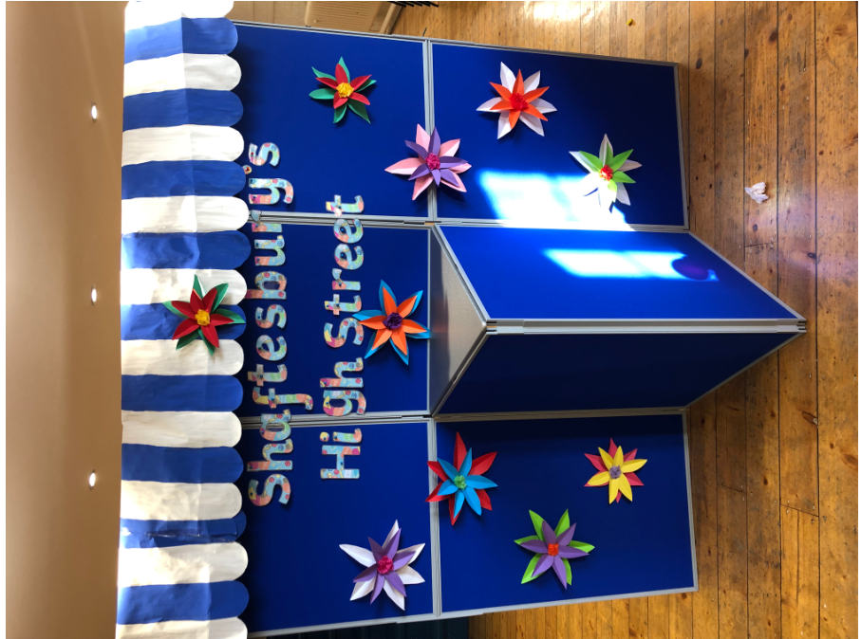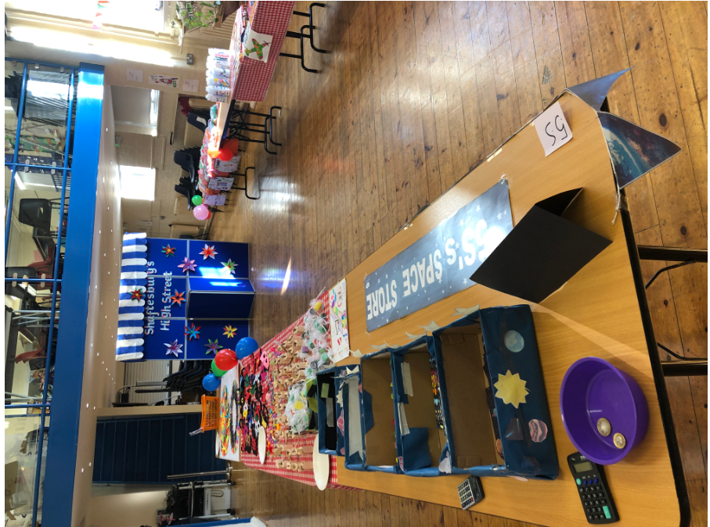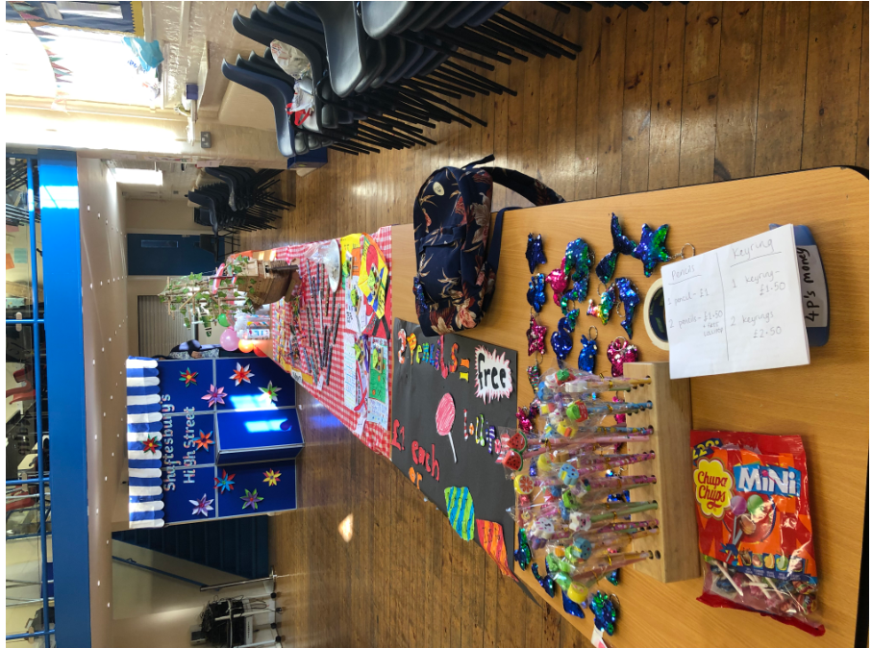

We thought of a product and sold it at ‘Shaftesbury’s High Street. We learnt about profit and loss and how to give the correct change.