Transition into school

- School starts on 2nd September 2021 and your child will either attend in the mornings or afternoons for the first two weeks. Their session will either be 8:55am to 11:20am or 12:30pm to 2:55pm. In the 2nd week they will stay for lunch.
- During this settling children will familiarise themselves with the new environment, learn to follow class rules and participate in free-flow activities.
- The children will have their lunch in the dining hall and they will be accompanied by their class teacher and the teaching assistant
- This programme may be revised for children who are finding it more difficult to settle and we will be as flexible as possible to support individual needs.
- From week 3 children will attend full time:
8:55 to 2:55.

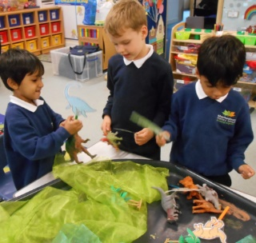
Uniform

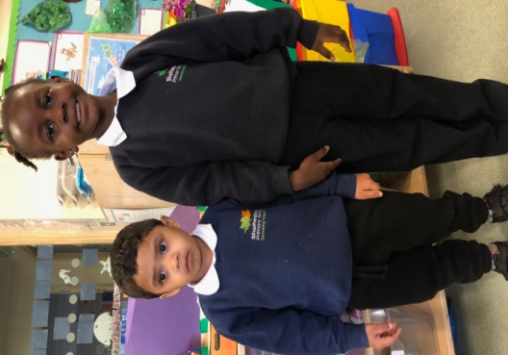

- Our uniform can be purchased with the school logo on a badge for jumpers and cardigans. This is available from either Fashion Stop (02085523200) or directly from the school’s office.
The uniform is as follows:
- Grey, navy or black shorts/trousers/skirt
- white shirt or collared polo shirt
- Navy jumper/cardigan
- Black velcro shoes
- PE – white t-shirt, black/grey/navy shorts and tracksuit trousers (winter), black velcro plimsolls.
- PE bags, book bags, white polo shirts, navy jumpers and nursery navy polo shirts will be
on sale from the office all year round.

Lunchtimes

- At lunchtime the children have the option to have a school meal or bring packed lunch. We encourage parents to send a fresh and healthy lunch each day without sweets or fizzy drinks.
- School dinners are free of charge, and a range of options are provided including vegetarian and halal choices.
- Children are also given fruit as a snack each afternoon in class and this is free.
- We ask that you provide a plastic water bottle for your child with their name on which can be re-filled throughout the day.

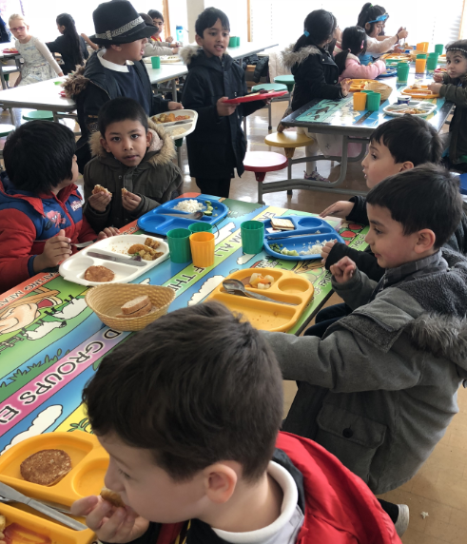

Playtimes

- The morning playtime starts at 10.05 and
lasts for 15 minutes. This may be revised in September.
- The children join Key Stage One pupils and they are closely supervised by teachers and teaching assistants.
- If your child falls over or is injured during playtime they will be taken to the medical room for immediate attention. Unless it is a serious injury such as a bang to the head we will not contact you. If your child is very upset and cannot be comforted by us we would let you know.
- In the afternoon children will have access to the outdoor provision all year round.

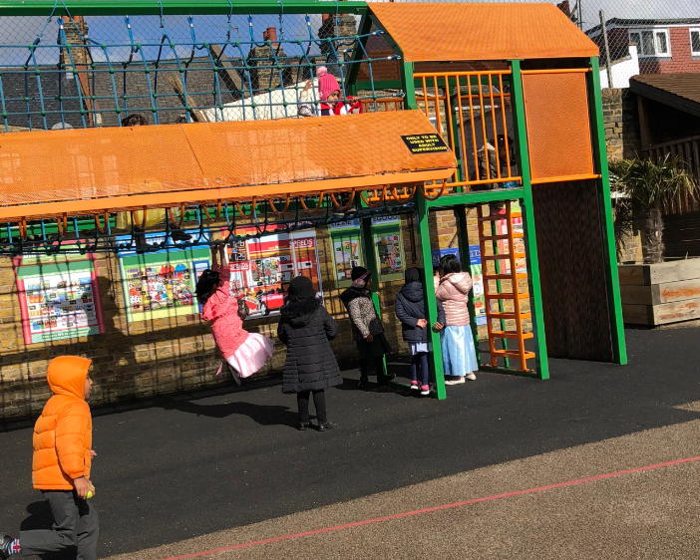

Curriculum

In Reception, children begin to develop their skills in Reading, Writing and Maths. They also develop their Communication and Language skills, Expressive Arts and Design (Art, Making and Music), Physical Development, Understanding the World, and Personal, Social and Emotional Development.
In Reception we focus on learning through play, including outdoor play. Children choose activities from a range provided and activities are free-flowing particularly in the afternoons.
Over the summer, if you wish to undertake activities to prepare your child for Reception, we recommend:
- Lots and lots of purposeful talking! The more language a child has, the better they do in all subjects.
- Dressing – encourage your child with their self-help skills such as dressing themselves and taking themselves to the toilet.
- Reading – please read to your child so they learn to sit and listen to a story and develop a passion for books.
- Counting and comparing objects (for example - count out pasta shells or everyday objects you have in your home)
- Preparation for writing – cutting with child scissors, drawing lines, colouring, playdough and threading activities.
Welcome

Welcome to Shaftesbury Primary School. We are really pleased that your child will be joining our school in September and we are looking forward to a long, happy and productive partnership with you.

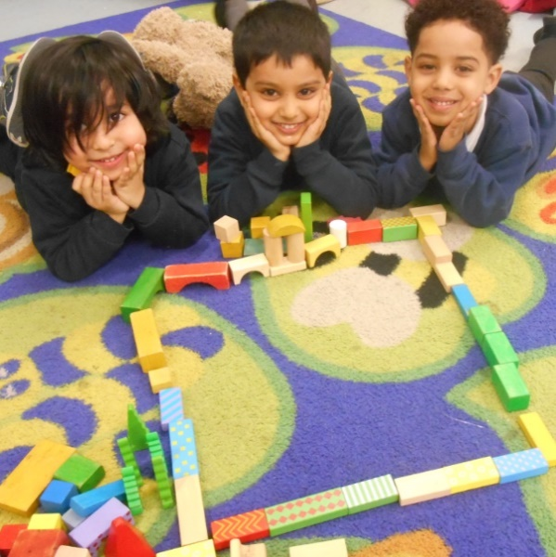
Starting school
Information for parents/carers

