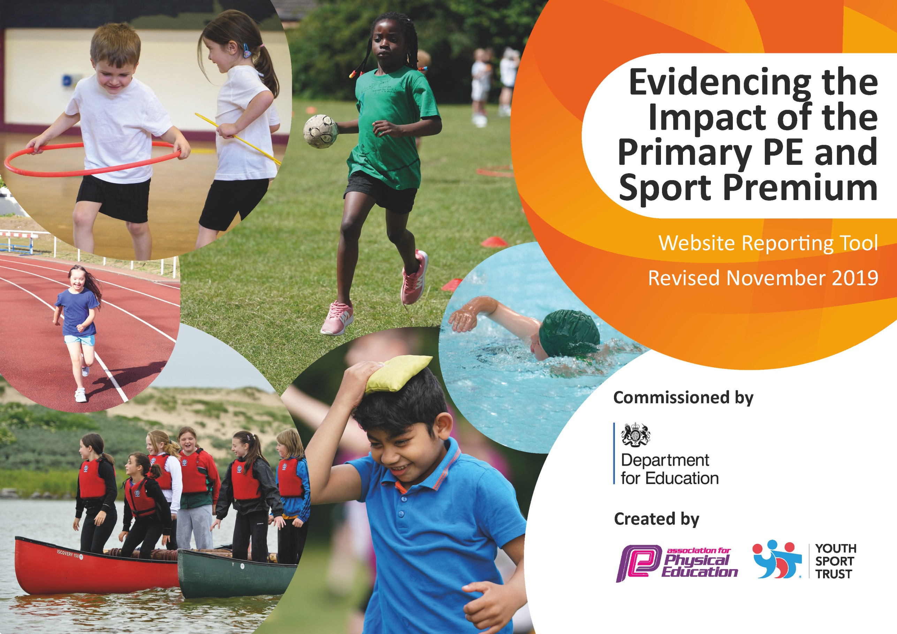
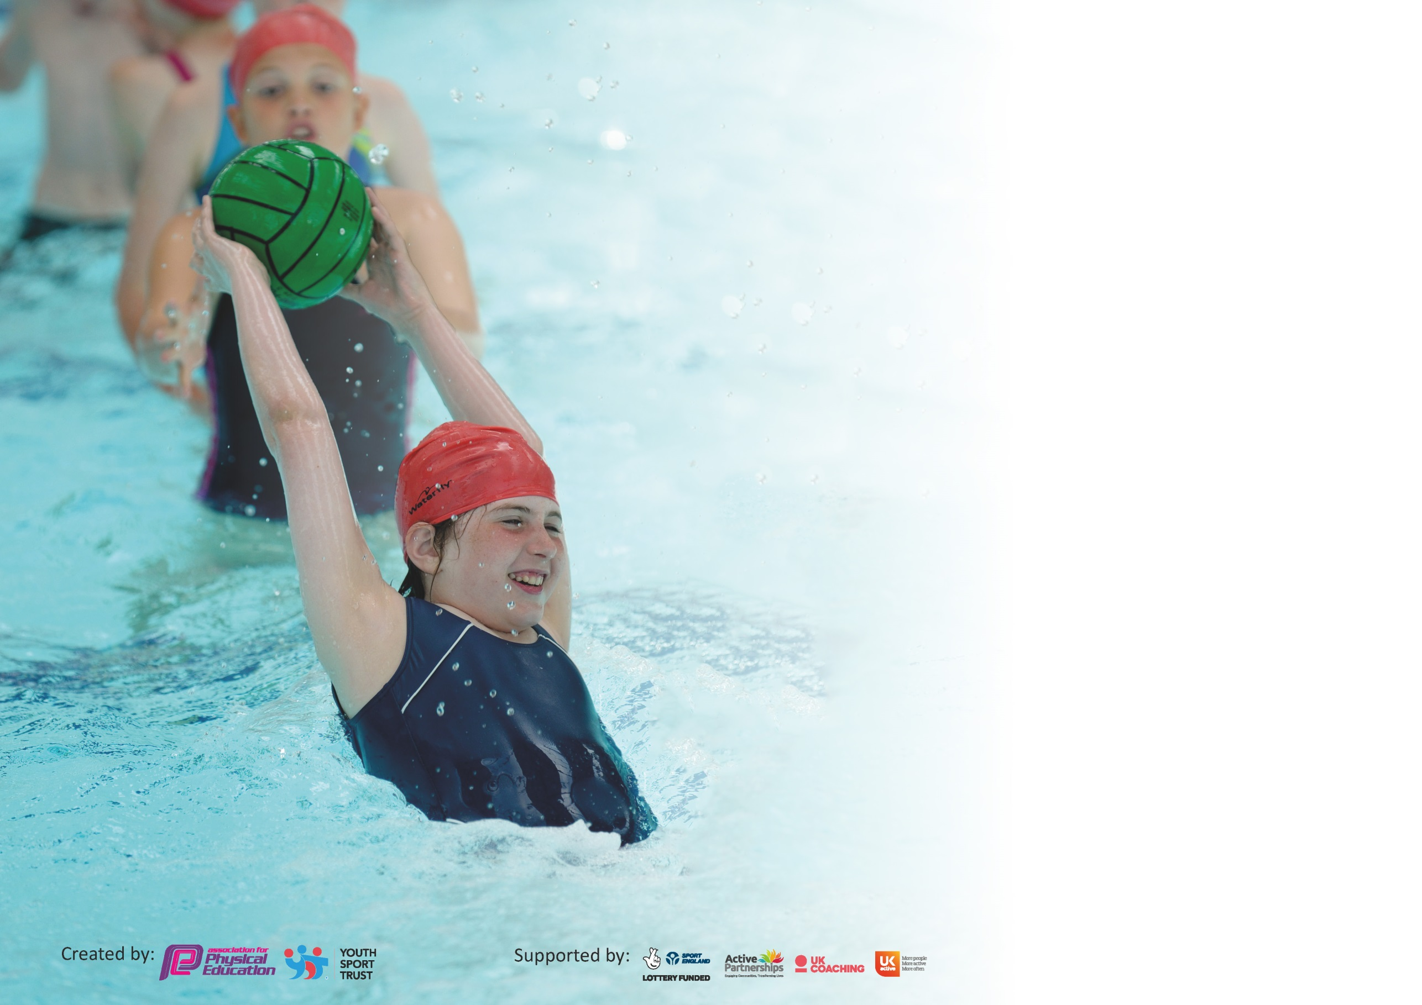

It is important that your grant is used effectively and based on school need. The Education Inspection Framework (Ofsted 2019 p64) makes clear there will be a focus on ‘whether leaders and those responsible for governors all understand their respective roles and perform these in a way that enhances the effectiveness of the school’.

Under the Quality of Education criteria (p41) inspectors consider the extent to which schools can articulate their curriculum (INTENT), construct their curriculum (IMPLEMENTATION) and demonstrate the outcomes which result (IMPACT).

To assist schools with common transferable language this template has been developed to utilise the same three headings which should make your plans easily transferable between working documents.

Schools must use the funding to make additional and sustainable improvements to the quality of Physical Education, School Sport and Physical Activity (PESSPA) they offer. This means that you should
use the Primary PE and Sport Premium to:

- Develop or add to the PESSPA activities that your school already offer
- Build capacity and capability within the school to ensure that improvements made now will benefit pupils joining the school in future years

Please visit gov.uk for the revised DfE guidance including the 5 key indicators across which schools should demonstrate an improvement. This document will help you to review your provision and to report your spend. DfE encourages schools to use this template as an effective way of meeting the reporting requirements of the Primary PE and Sport Premium.

We recommend you start by reflecting on the impact of current provision and reviewing the previous spend.

Schools are required to publish details of how they spend this funding as well as on the impact it has on pupils’ PE and sport participation and attainment by the end of the summer term or by 31st July 2020 at the latest.

We recommend regularly updating the table and publishing it on your website throughout the year. This evidences your ongoing self-evaluation of how you are using the funding to secure maximum, sustainable impact. Final copy must be posted on your website by the end of the academic year and no later than the 31st July 2020. To see an example of how to complete the table please click HERE.

Support for review and reflection - considering the 5 key indicators from DfE, what development needs are a priority for your setting and your pupils now and why? Use the space below to reflect on previous spend and key achievements and areas for development.

Key achievements to date until July 2020: | Areas for further improvement and baseline evidence of need:
The engagement of all pupils in regular physical activity – we have added Sports Leader activities to KS2 lunch time to ensure more physical activity is taking place. Sports leaders lead activities in groups and encourage children to play with more equipment outside. Increased the number of sports clubs available at lunch time and after school. Some children in Years 3-6 have participated in inter school competitions with the Langdon Sports Partnership and Boleyn Trust P.E tournaments. All children from nursery to Year 6 participated in a ‘fun run’ circuit for Sports Relief. A wider range of equipment is available for play and lunch time – engaging children using a range of skills and activities.  The profile of PE and sport is raised across the school as a tool for whole-school improvement – weekly assemblies with P.E certificates given to different children across the school. Introducing a star P.E pupil of the week per assembly. Children identified as working below expected standards are placed into lunch time sporting clubs to help close gaps in their learning/ development.  Increased confidence, knowledge and skills of all staff in teaching PE and sport – P.E coordinator attended a British Gymnastic teaching course and the whole teaching staff received 1hour Yoga training (by a yoga instructor) and half a day gymnastics CPD by a teacher at the British Gymnastics.  Broader experience of a range of sports and activities offered to all pupils – a range of afterschool and lunchtime sports clubs are in place, taught by school teachers and Premier Sports.  Increased participation in competitive sport – KS2 have participated in Boleyn Trust Football tournament and also a range of sporting events organised via the Langdon Sports Parntership. | The engagement of all pupils in regular physical activity – Ensure more children are involved in outdoor activities. Making regular use of Sports Leaders to run activities during lunchtime. Asking midday supervisors to provide additional activities for children in KS1. Participating in a daily/ active mile. Continue to offer lunch time clubs to children who are working below the expected standards.  The profile of PE and sport is raised across the school as a tool for whole-school improvement – introduce more rewards for P.E engagement, participation and progression. Ensure those constantly trying and those exceeding are being celebrated.  Increased confidence, knowledge and skills of all staff in teaching PE and sport – Staff inset ran by P.E coordinator, introducing staff to new P.E software and how to accurately assess in P.E. Further Gymnastics CPD to increase teacher confidence in other areas (hand stands etc)  Broader experience of a range of sports and activities offered to all pupils – Continue to ensure sporting clubs offer a wide range of activities. Introduce new sports/ activities within P.E lessons. Continue to expand lunch time activities with Premier Sports (or equivalent) and Sports Leader activities in the playground.  Increased participation in competitive – Enter more inter school competitions and organise more Boleyn Trust sporting competitions (especially KS1 and lower KS2).  Additional - Ensuring more pupils achieve minimum swimming requirements  Assessment for pupils – needs to be more fine-tuned. New P.E software  purchased at the end of 19/20 should allow for better assessment.  Swimming – children need to achieve better swimming results, further lessons may be required to ensure this happens.

Meeting national curriculum requirements for swimming and water safety. | £4,405 costing for swimming 20.6% of budget used.
What percentage of your current Year 6 cohort swim competently, confidently and proficiently over a distance of at least 25 metres?  N.B. Even though your pupils may swim in another year please report on their attainment on leaving  primary school at the end of the summer term 2020. | 60%
What percentage of your current Year 6 cohort use a range of strokes effectively [for example, front crawl, backstroke and breaststroke]? | 20%
What percentage of your current Year 6 cohort perform safe self-rescue in different water-based situations? | 3%
Schools can choose to use the Primary PE and Sport Premium to provide additional provision for swimming but this must be for activity over and above the national curriculum requirements. Have you used it in this way? | No

Action Plan and Budget Tracking
Capture your intended annual spend against the 5 key indicators. Clarify the success criteria and evidence of impact that you intend to measure to evaluate for pupils today and for the future.

Academic Year: 2019/20 | Total fund allocated: £21,360 | Date Updated: 02.07.2020
Key indicator 1: The engagement of all pupils in regular physical activity – Chief Medical Officer guidelines recommend that primary school pupils undertake at least 30 minutes of physical activity a day in school |  |  |  | Percentage of total allocation:
 |  |  |  | %
Intent | Implementation |  | Impact | 20% = £4,275.61
Your school focus should be clear what you want the pupils to know and be able to do and about  what they need to learn and to  consolidate through practice: | Make sure your actions to achieve are linked to your intentions: | Funding allocated: | Evidence of impact: what do pupils now know and what can they now do? What has changed?: | Sustainability and suggested next steps:
Detailed Mid Term Plans with differentiation for SEN/GD to allow support and challenges.  Purchase new P.E planning and assessment software to enable teachers to teach outstanding P.E lessons and assess pupils more accurately.  Participate in a ‘fun run’ circuit in the playground for Sports relief to engage all children in extra physical activity.  Sports leaders to run regular lunch time activities for KS2 whilst midday supervisors supervise activities for KS1.  Purchase 5 –a-day with home access added on to allow pupils to continue to use the 5-a-day resource at home.  Upgrade P.E equipment for use in lessons to ensure all lessons have appropriate equipment and enough for the children to use.  Create P.E activities to complete at home. | Update current MTP to include differentiated activities and tasks.  Find and source a suitable P.E programme that allows for better assessment and more information for teachers – videos/ examples.  Introduce children and teachers to 2-4 activities that can be done during a run.  Select equipment suitable for lunch time use and show Sports Leaders and Midday supervisors where it is and how it can be used.  Purchase the programme and send a letter to parents with the login details.  Go through current medium term plans and PPE medium term plans. Order equipment to fit the planning and repurchase equipment that is no longer in good condition.  During the pandemic, provide activities that children can complete at home to replace P.E lessons, break and lunch time play. Use plprimarystars resources to assist. | £0  £995  £0  £0  £312  £2,968.61  £0 | All children should be actively participating in P.E lessons – some with support – and children can be challenged to show more skills.  A new P.E programme with aligned assessment to lessons should allow teachers to assess pupils better. Also, videos will help teachers – ensuring they know what should be done and how it will look. Videos will also support pupils as they will be able to see the outcome they are expected to achieve.  Children were very engaged and enjoyed the ‘fun run’ in the playground. They are now using the activities involved in the fun run more in P.E lessons and whilst playing in the playground.  Children have opportunities to engage in activities during lunchtime and more games.  Children can engage more with activities they are familiar with in school, requiring little help or assistance from parents/ guardians.  P.E lessons have run smoother; children have had the appropriate equipment for each lesson and have more than enough equipment to share.  Children have been given a range of activities and websites to keep them physically active at home. | Trial online P.E planning that has video examples and better assessment.  Use new P.E programme to re-plan the curriculum and provide teachers with an inset to help familiarise themselves with the programme.  Create a timetable for children to participate in a daily/active mile to ensure regular physical activity is increased starting September 2020.  Begin this at the beginning of the academic year (Autumn 1) and run through until Summer 2.  Ensure a letter is sent at the beginning of the academic year to remind parents of the login details and how to use the website.  Continue to audit P.E equipment, replace when needed and look for more equipment to keep children entertained during play and lunch times.  Continue to offer at home sporting activities accessible on the school website.
Key indicator 2: The profile of PESSPA being raised across the school as a tool for whole school improvement |  |  |  | Percentage of total allocation:
 |  |  |  | %
Intent | Implementation |  | Impact | 4.5% = £950.78
Your school focus should be clear what you want the pupils to know and be able to do and about  what they need to learn and to  consolidate through practice: | Make sure your actions to achieve are linked to your intentions: | Funding allocated: | Evidence of impact: what do pupils now know and what can they now do? What has changed?: | Sustainability and suggested next steps:
Ensure children are encouraged and engaged during P.E lessons (bringing in their P.E kits twice weekly). Offer bi-weekly P.E certificates for children.  Offer a variety of stickers, medals and trophies for Sports Day and achievement awards.  Update the P.E schemes of work to ensure support is offered and challenges are created. Purchase a new P.E programme for 2020-2021  P.E wall of fame to be created celebrating the children who have achieved certificates weekly and also pictures of children and staff participating in sports outside of school.  Create a Sports Leaders display and event display. | Provide bi-weekly P.E certificates to be given out in the achievement certificates.  Send letters home to children if they haven’t brought their P.E kit 3 times a week.  Purchase stickers, certificates and medals.  Add a front cover for all mid-term plans, stating what the children have previously learnt, what they will need to show if they are working at or above the expected level and also include rules and differentiation activities. Re-do once new scheme has been purchased.  Create a display in the reception area that celebrates physical activity.  A display used to show who the Sports Leaders are and also to celebrate Shaftesbury School Sporting achievements, including pictures of children who represent our school in competitions. | (already stated above £995 for new P.E programme).  £950.78  £0  £0  £0 | More children are bringing their P.E kit to school across the school.  Children have been showing off their certificates and achievements in P.E.  Teachers have more direct focus of teaching and have clear progression within the scheme / across different year groups.  Children have been eager to receive the bi-weekly certificate and also show great joy in seeing their name on the celebration wall.  Children know who the Sports Leaders are and have become familiar with them and running lunch time activities. | To continue to encourage children further, include more rewards for P.E (certificates, stickers and half termly trophies).  Continue to offer rewards for pupils to encourage them to participate and try their best in every P.E lesson.  Provide challenges and support activities for GT/SEN/WT pupils.  This has worked so I will continue and send out a letter to ask children if they have more images to display. Also, continue to reward and acknowledge children who are doing well/ trying their best.  Continue to display Sports Leaders, event information and school teams to celebrate P.E in the school.

Key indicator 3: Increased confidence, knowledge and skills of all staff in teaching PE and sport |  |  |  | Percentage of total allocation:
 |  |  |  | %
Intent | Implementation |  | Impact | 3.6% = £778
Your school focus should be clear | Make sure your actions to | Funding | Evidence of impact: what do | Sustainability and suggested
what you want the pupils to know | achieve are linked to your | allocated: | pupils now know and what | next steps:
and be able to do and about | intentions: |  | can they now do? What has
what they need to learn and to |  |  | changed?:
consolidate through practice:
Coordinator and a KS1 teacher to attend a gymnastics course offered by British Gymnastics.  Gymnastics CPD booked for teachers. Two half day insets.  Yoga inset for teachers to help build confidence when teaching Yoga.  Front pages to all mid-term plans.  Renew Youth Sports Trust membership to allow for training and CPD opportunities for the coordinator and teaching staff.  Purchase new P.E programme to help with planning and assessment.  P.E inset for staff.  P.E coordinator to attend trust networking meetings focusing on P.E | Book course organised via Cleves Primary School (Boleyn Trust School) Coordinator attended and then relay information back to staff.  Book with A.P at the British Gymnastics for Spring and Summer terms.  Find a yoga instructor who delivers insets to schools to help raise teachers’ confidence.  Create front covers to support each mid-term plan. Include: previous learning, future learning, what to expect if working at the expected level and above the expected level, rules and differentiation activities and questioning to promote thinking skills.  Select membership option when enrolling onto the Langdon Sports Partnership.  Trial complete P.E, Primary PE planning and Striver (2simple). Select most cost effective and appropriate programme for the school.  To be delivered by subject coordinator. Reminding teachers of expectations, rules and new planning. Liaise with SLT to book a slot  Book and attend meeting through the Boleyn Trust and arrange inter school competitions and ways the trust can work together in sports. | £170  £320  £88  £0  £200  (already stated in Key1 - £995)  £0  £0 | Coordinator confident in teaching gymnastics and has passed on all information to teaching staff to increase their confidence. Two insets have been booked to allow teachers to better develop their confidence.  Teachers feel more confident however 2nd inset was postponed until after the pandemic.  Teachers feel confident in teaching Yoga and appreciated the additional mindfulness activities given and shown.  Front covers have enabled teachers to see prior and future learning whilst also being able to link skills to expected or working above.  CPD booked for Netball as will be implementing into the curriculum in September 2020. Unfortunately, this was cancelled due to the pandemic.  Purchase Primary PE Planning to begin using in the next academic year (2020-2021). Train teachers how to use the plans and assessment areas.  Slot booked for summer term.  Coordinator attended 2 meetings, 1 in the autumn term, 1 in the spring term and regularly liaises with colleagues in the trust. | Continue to audit P.E for areas that teachers are not confident in and arrange insets for this (either ran by P.E coordinator or outside agency).  Re-book 2nd gymnastics inset for teachers in the next academic year.  Continue to prompt mindfulness and well-being in school using Yoga for the beginning or end of lessons.  Use the new programme bought at the end of the academic year to change assessment and provide an inset for teachers on how to use this.  Continue to renew membership and take advantage of CPD opportunities.  Deliver an inset at the beginning of the academic year to show teachers how to use the programme and how to access using the new grids and criteria.  To be rebooked for 1st September 2020. Inset to cover new programme, assessment and daily mile initiative.  Attend all networking meeting and create a interschool competition timetable for the academic year.
Key indicator 4: Broader experience of a range of sports and activities offered to all pupils |  |  |  | Percentage of total allocation:
 |  |  |  | %
Intent | Implementation |  | Impact | 43.8% = £9345.61
Your school focus should be clear | Make sure your actions to | Funding | Evidence of impact: what do | Sustainability and suggested
what you want the pupils to know | achieve are linked to your | allocated: | pupils now know and what | next steps:
and be able to do and about | intentions: |  | can they now do? What has
what they need to learn and to |  |  | changed?:
consolidate through practice:
Additional achievements:  Continue to offer a wider range of activities both within and outside the curriculum in order to get more pupils involved, including attending sporting events.  The school offers a range of sports clubs (Monday-Thursday) ran by Premier Sports.  Teachers to provide children with additional sports clubs to fill the gaps.  Get Sports for Champions to come and run a circuit in the whole school (nursery to year 6).  Ask the Bikeability programme to come and train our Year 3/4 bikers in Summer 2.  Organise a music and dance week, celebrating dance and music combined for after National Sports Week.  Organise Sports Day during National Sports Week  Organise a ‘fun run’ for Sports Relief.  Sports Leaders to run and lead lunchtime games with KS2 | Liaise with Premier Sport to find suitable afterschool and lunchtime clubs for all years.  Offer a range of clubs to Years 1-6 over the course of the week.  Teachers to use assessment grids and then give information to coordinator to allocate sports club spaces to children who are working below.  Create a timetable for an athlete to come and complete a fitness circuit with the children.  Enquire via the bikeability programme for availability in the Summer Term for Year 3 and 4 pupils.  Arrange with the music coordinator a week worth of dance and music activities to showcase in the playground at the end of the week. Send out a letter and text to inform parents of the Big Dance, in association with Havering borough, to get children to participate in the dance at home.  Sports week booked for the week beginning 22nd June. Arrange medals, stickers and badges and organise an assembly to celebrate at the end of the week.  Create a differentiated fun run with at least 4 activities suitable for the entire school (Nursery to Year 6)  Year 6 Sports Leaders to run activities and games at lunch time with KS2. Midday supervisors to run with KS1. | After school and lunchtime activities through Premier Sport £9345.61  Above  £0 – fundraising opportunity for the charity  £0 – free to schools  £0  (already stated above K1 - £950.78 for rewards)  £0  Equipment purchase price included above - £2968.61 | Premier sports offer a range of activities for our school. We have at least 3 clubs ran by them Monday-Thursday.  Children very engaged with sporting clubs.  Children identified as working below the expected level where placed into lunch time clubs. Their skills have been developing.  Children began fundraising but due to the pandemic this has been postponed until 2020-2021  This needs to be rescheduled for the next academic year due to the pandemic.  Due to the pandemic, this year we have decided to join in with Havering’s Big Dance. Allowing children at home and those at school to learn and participate in a dance on the 9th July 2020  Children participated in a virtual Sports Day at home. Differentiated activities were given for KS1 and KS2. Certificates were downloaded from Primary Planning PE virtual Sports day and those who participated in school received stickers and badges also.  Children thoroughly enjoyed this day and activities are now being used in P.E lessons and during play/lunch time. | Continue to offer a range of sporting clubs both at lunchtime (for those who are not working at the expected level) and after school.  Continue to offer lunch time clubs to children working below the expected standard to help raise achievement. Ask teachers to identify Greater Depth Pupils who can be included in Inter School Sporting events.  Reschedule booking for 2020-2021.  Rebook for 2020-2021 Summer term.  Organise another music and dance celebration week for the Summer term of 2020-2021.  Continue to run Sports Day during National Sports Week. Use Sports Leaders to lead and assist in activities and the running of the day.  Continue to support Sports Relief (every other year) and organise activities for children to fundraise.

Key indicator 5: Increased participation in competitive sport |  |  |  | Percentage of total allocation:
 |  |  |  | %
Intent | Implementation |  | Impact | 7.5% = £1,605
Your school focus should be clear | Make sure your actions to | Funding | Evidence of impact: what do | Sustainability and suggested
what you want the pupils to know | achieve are linked to your | allocated: | pupils now know and what | next steps:
and be able to do and about | intentions: |  | can they now do? What has
what they need to learn and to |  |  | changed?:
consolidate through practice:
Develop a wide range of opportunities to try different sports through extracurricular activities.  Join a sports partnership and take children to borough/ partnership competitions.  Expand range of activities available as extra-curricular clubs to encourage pupils to be more involved.  Signpost families to opportunities outside of school to engage in further activities.  Create Trust sporting competitions.  To consolidate learning and improve during inter school competitions, arrange for school competition games to be completed at the end of each half term. | Enhance the afterschool clubs activities – provide a wider range of activities.  Join Langdon Sports Partnership and the Newham Football League.  Send out information for sporting clubs in and around the borough. West Ham academy and other leaflets that are distributed.  Source additional clubs families can take their children to. Use the internet.  Liaise with other coordinators/coaches within the Boleyn Trust to arrange inter school competitions.  Ask teachers to complete a game at the end of each unit. Favouring a competition environment to allow children to showcase their skills and talent. | (already stated above in K4 - £9345.61)  Partnership -£1605  £0  £0  £0  £0 | More children (up to 30 per group) are involved in after school activities.  Children are more engaged in the playground.  Leaflet sent out for half term clubs and West Ham Academy Football training.  Local football club sourced this year and information passed on to students.  Tournaments organised in the autumn term for the Spring and Summer term of 2020. 1 tournament attended, others were postponed.  Upper KS2 were able to do this but due to P.E timetables in other year groups this was not suitable. | Begin a lunchtime sports club for vulnerable children.  Change some afterschool clubs to ensure a wide variety.  Enter KS1 and Lower KS2 in partnership events.  Start trust events with other schools within the academy.  Look for more opportunities and more clubs in an around the local area (Newham).  Continue to liaise with trust colleagues to arrange more sporting events for the next academic year.  Rearrange P.E times to allow for competitions to take place during the end of each half term.

Signed off by
Head Teacher:
Date: | 17/07/20
Subject Leader: | Jorden Foster
Date: | 02/07/2020
Governor: | Joanne O’Connor
Date: | 17/7/20

