Design and Technology
Activity 2: Fruit salad

Problem:
It is important to stay healthy and eat lots of fruits and vegetables. Can you design a fruit salad for me? Make sure to include 5 different fruits and they all must be different colours, include 1 juice. I like trying new fruits from around the world, so do some research and see if you can find some exotic fruits that I can use in my fruit salad.

Success criteria:
- I can design a fruit salad for a target market.
- I can design a fruit salad that is bright and colourful.
- I can use 5 different coloured fruits in my fruit salad.
- I have included 1 fruit juice in my fruit salad.
- I have included at least 1 exotic fruit in my fruit salad.

Research:
Look at pictures of fruits from around the world.
What country do they grow in?
Are they grown in hot or cold countries?
Where do they grow? On a tree? Underground? On a bush?
What fruit do you think I would like in my fruit salad? Why?
What fruit do you think I will not like in my fruit salad? Why?

Activity:
Draw and label your fruit salad design on a sheet of A4 paper or using the ‘2Paint a picture’ tool on Purple Mash. Come up with a name for your fruit salad.
If you are able to, you can make your fruit salad at home with an adult! Remember to wash your hands and cut carefully.

You can use Purple mash to share your design on the Shaftesbury Primary School display board. If you create your design on paper, you can upload pictures of your design on there too.

The winning design will receive a prize when we get back to school!
Good luck!

Ms. Mani
Food processing skills.
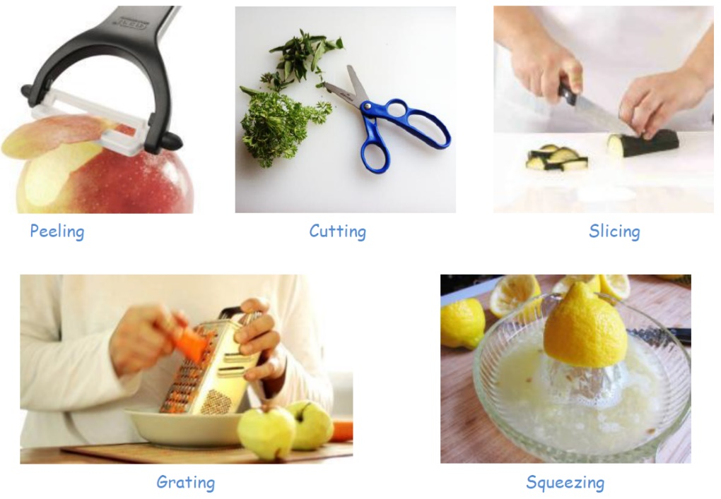

Fruit processing equipment.
Juicer | Used to make fresh juice.
Peeler | Used to remove the skin from fruits.
Knife | Used safely, to cut fruits into smaller pieces.

Food hygiene:
- Remove all jewellery
- Tie your hair back
- Roll your sleeves up
- Wear an apron
- Wash your hands with soap before you start
- Tuck your fingers in when using a knife
- Always work with an adult

