Design and Technology
Activity 4: Puppets

Problem:
The children in reception love reading and listening to stories, especially stories about animals. To make the stories more engaging and exciting, I would like to bring them to life using puppets. I need your help to design and make these puppets for me.
Choose your favourite story and design a puppet for one of the characters, make sure your designs are bright and colourful and use 3 different types of materials (e.g. cotton wool, fur, feathers, glitter, sequins, beads or pom poms).

Success criteria:
- I can design a puppet for a target market.
- I can design a puppet from my favourite story.
- I can design a bright and colourful puppet.
- I can include 3 different types of materials in my design.

Research:
Look at pictures of different types of puppets and have a read through all your favourite books and choose one.
What type of puppet do you like? Why?
What type of puppet do you not like? Why?
What character are you going to make a puppet for? Why?
What materials are you going to use?
Have you identified 3 different materials that you can use?

Activity:
Choose 1 character from your favourite story and design and label a puppet. Remember to include the name of your puppet and the different types of materials that you are going to use. If you are able to, make your puppet using your design.

You can use Purple mash to share your design on the Shaftesbury Primary School display board. If you create your design on paper, you can upload pictures of your design on there too.

The winning design will receive a prize when we get back to school!
Good luck!

Ms. Mani
Using templates and pattern pieces.
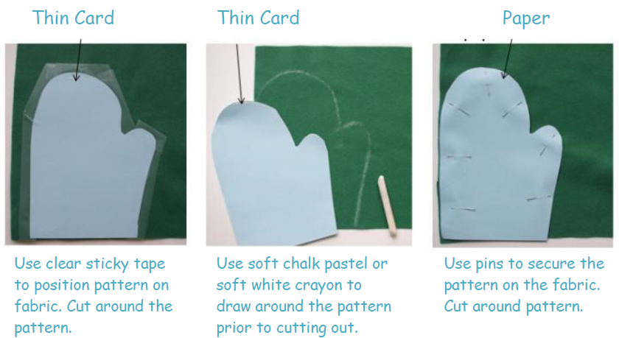

Joining techniques.
