Design and Technology
Activity 5: Shoebox car

Problem:
I would like your help to design a functional, bright and colourful shoebox car for me to display in my classroom. The car must have 4 wheels, it should be able to move in a straight line, it has to be bright and colourful and I would like you to use at least 3 different materials to decorate it (e.g. paint, tissue paper, glitter, shiny paper, cellophane, foil, pom poms, sequins or beads).

Success criteria:
- I can design a shoebox car for a target market.
- I can design a shoebox car that has 4 wheels.
- I can design a shoebox car that can move in a straight line.
- I can design a shoebox car that is decorated using at least 3 different types of materials.

Research:
Look at pictures of different types of shoebox cars.
Which shoebox car do you like? Why?
Which shoebox car do you not like? Why?
How can you ensure that your shoebox car will move in a straight line?
What materials will you choose to design your shoebox car?

Activity:
Design and label your shoebox car, including the materials that you will need.
Come up with a name for your car.
If you are able to, you can use an empty shoebox or box to make your car using your design.

You can use Purple mash to share your design on the Shaftesbury Primary School display board. If you create your design on paper, you can upload pictures of your design on there too.

The winning design will receive a prize when we get back to school!
Good luck!

Ms. Mani

Example of a shoebox car and 2 ways to attach the wheels.
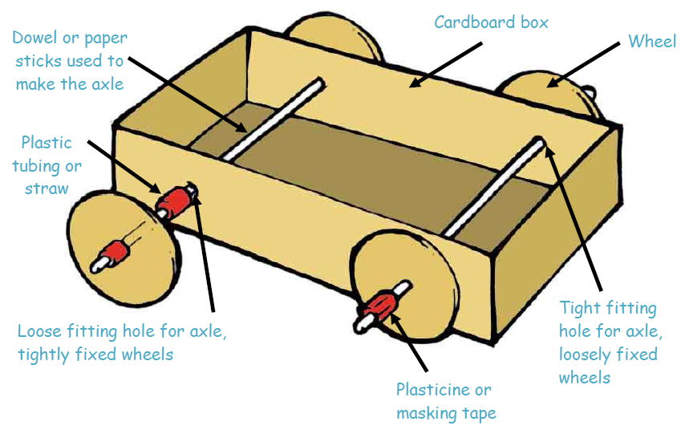

Types of wheels.
