Design and Technology
Activity 3: Sliders and levers

Problem:
I would like to create a collection of cards for the following events:
- Birthdays
- Get well soon
- Thank you
- Congratulations
- Diwali
- Guru Nanak’s birthday
- Christmas
- Holi
- Easter
- Eid
I would like you to help me design these cards for my collection.
I would like them to be extra special, they must have a moving slider or lever inside or on the front of the card.

Success criteria:
- I can design a card for a target market.
- I can include a slider or a lever in my design.
- I can design a bright and colourful card.

Research:
Look at pictures of different sliders and levers that you could use in your card.
What type of slider/lever do you like? Why?
What type of slider/lever do you not like? Why?
How can you add a slider/lever to your card?
Where else have you seen a slider/lever used? How do they work?

Activity:
Choose 1 event that you would like to create a card for. Draw and annotate a design to show where your slider/lever will go and how it will work. If you are able to, you can make your card using your design.

You can use Purple mash to share your design on the Shaftesbury Primary School display board. If you create your design on paper, you can upload pictures of your design on there too.

The winning design will receive a prize when we get back to school!
Good luck!

Ms. Mani

Types of sliders and levers.
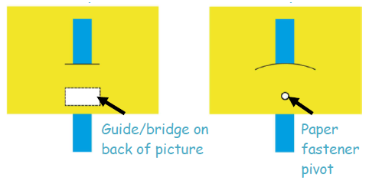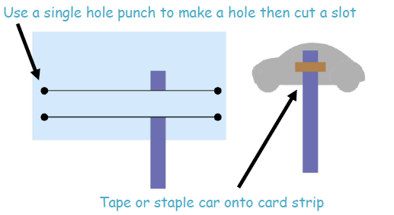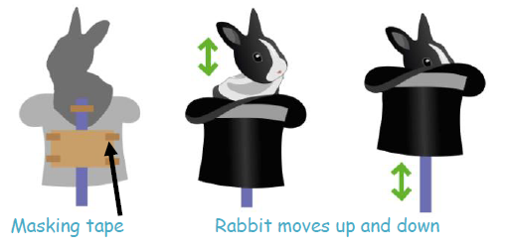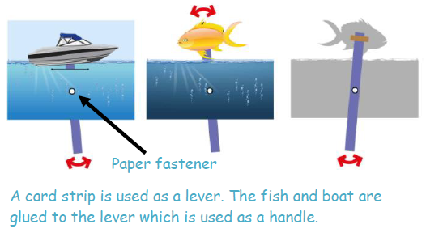

Sliders and levers move:
