Design and Technology
Activity 1: Structures

Problem:
Ms. Mani would like to build a playground in her garden, she is looking for someone to design the playground for her. She has a very large space and can fit a lot of different equipment so be as creative as you can! She needs you to include different playground equipment that can be used by a baby, a child and an adult.

Success criteria:
- I can design a bright and colourful playground.
- I can design playground equipment for a baby.
- I can design playground equipment for a child.
- I can design playground equipment for an adult.

Research:
Look at pictures of different playgrounds to get an idea of equipment that you could use in your design.
What equipment do you like? Why?
What equipment do you not like? Why?
What equipment can be used by a baby? How could you make it better?
What equipment can be used by a child? How could you make it better?
What equipment can be used by an adult? How could you make it better?
How will you ensure that all the equipment is safe?
How will you ensure that all the equipment is stable?

Activity:
Draw and label your design on a sheet of A4 paper or using the ‘2Paint a picture’ tool on Purple Mash. Come up with a name for your playground.
Once you are happy with your design, use an empty box to build a model of your playground.

You can use Purple mash to share your design on the Shaftesbury Primary School display board. If you create your design on paper, you can upload pictures of your design and model playground on there too.
The winning design will receive a prize when we get back to school!
Good luck!

Ms. Mani
Techniques for assembling structures.
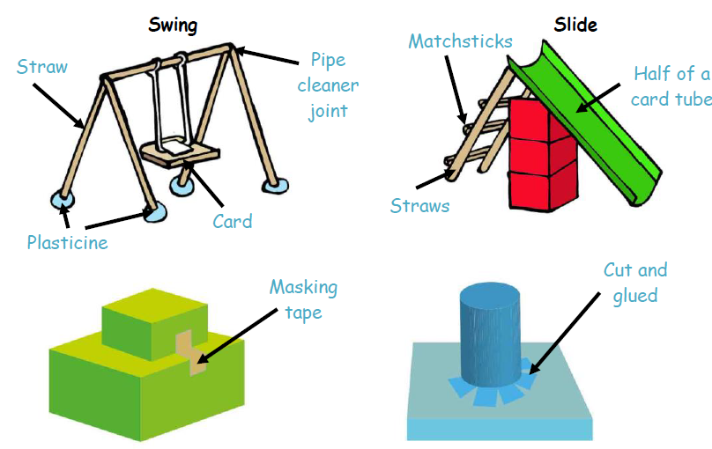

Stability experiment.
Build two walls with these different patterns using blocks (or anything that you can find). Tap away the centre brick in the bottom row of each wall.
What happens?
Which wall is stronger and most stable?

