Week 4
10/8/20
The tiger who came to tea

English
This week we are going to be reading the story ‘The Tiger who came to tea’, if you have the book at home then have a read of it, if not, you can watch it on YouTube.

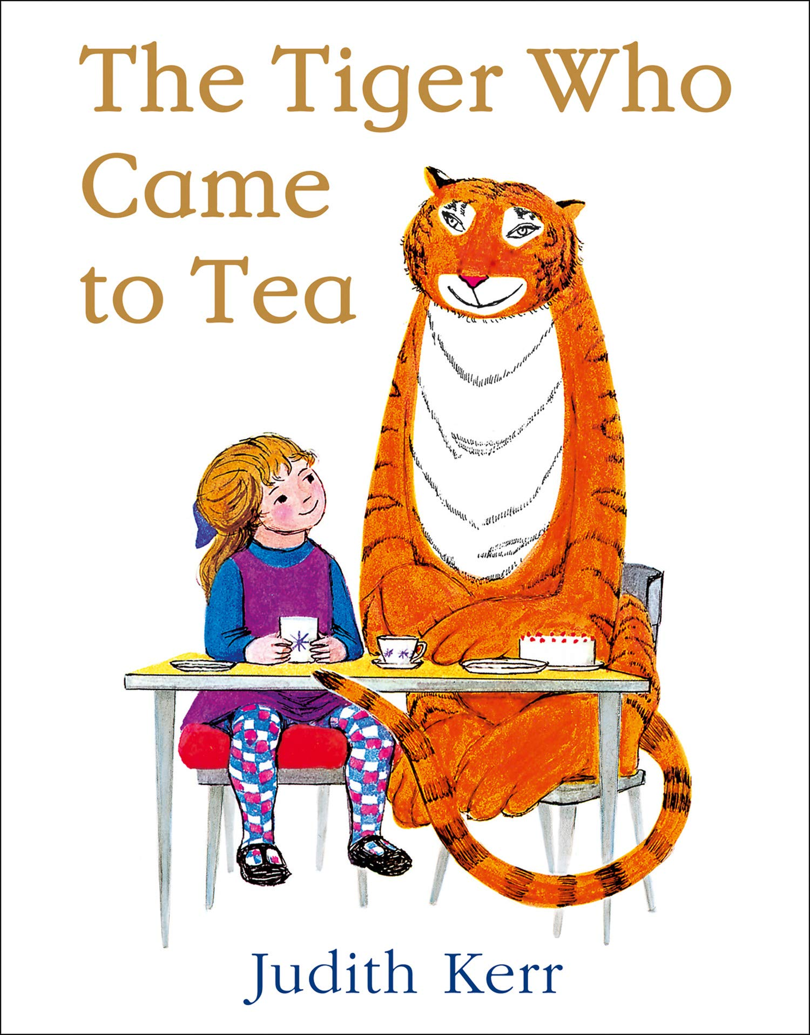

https://www.youtube.com/watch?v=BXgW9UCgpc8

Describing the tiger
Can you describe what the tiger looks like?
You can use the word bank below or think of your own.
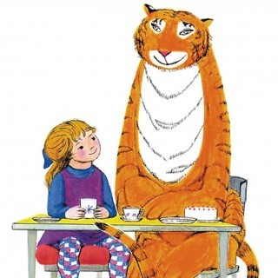

big muscular body | tall
large round head | long stripy tail
orange and brown stripes | sharp claws
________________________________________________________________________________________________________________________________________________________________________________________________________
________________________________________________________________________________

Writing a list
Can you write a list describing what the tiger ate?
Use the key words below and try and remember what else he ate.

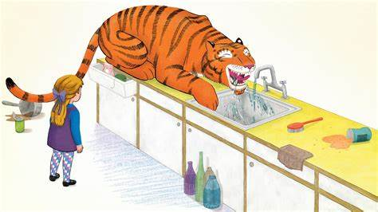

delicious buns | tea from the teapot
crunchy biscuits | packets and the tins
milk from the milk jug | orange juice
- ______________________________
- ______________________________
- ______________________________
- ______________________________
- ______________________________
- ______________________________
- ______________________________
- ______________________________
Speech bubble
Can you write a speech bubble for what mum might say to the tiger when he is eating all their food?

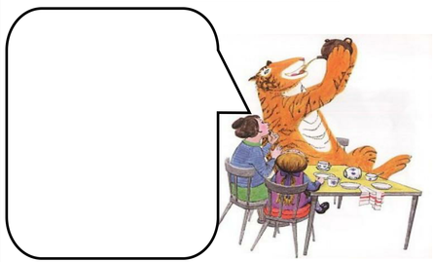

Maths
Addition
Write a number sentence and work out the answer.
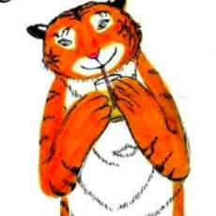 +

____ + ____ = ____

+

____ + ____ = ____

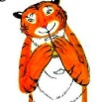 +

____ + ____ = ____

+

____ + ____ = ____

+

____ + ____ = ____

Subtraction
Write a number sentence and work out the answer.
-

____ - ____ = ____

-

____ - ____ = ____

-

____ - ____ = ____

-

____ - ____ = ____

-

____ - ____ = ____
Sharing
Share the iced buns out equally between Sophie and the tiger.

They each get _____ iced buns.

They each get _____ iced buns.

They each get _____ iced buns.

They each get _____ iced buns.

Money
Write down the value for each of these coins.
Read the word problems, circle the important information, write a number sentence and work out the answer.

Sophie brought a tin of tiger food for 15p and an apple for 5p. How much money did she have to pay altogether?

____ + ____ = ____

Sophie brought a bag of pasta for 12p and a lolly for 2p. How much money did she have to pay altogether?

____ + ____ = ____

Sophie brought a tin of baked beans for 5p and some cheese for 20p. How much money did she have to pay altogether?

____ + ____ = ____

Sophie brought some bread for 12p and an ice cream for 6p. How much money did she have to pay altogether?

____ + ____ = ____
Topic
Cardboard tube tiger

Paper tiger
Colour the tiger’s faces and the tiger’s legs in, cut around them carefully and stick them together by folding along the dotted lines to create tabs. Add in the details to make your tigers face.
Can you use your puppets to retell the story?

Design a teapot
Design a tea pot for Sophie and her mummy.

Tiger shaving cream art

