Week 6
24/8/20
Lost and found

English
This week we are going to be reading the story ‘Lost and Found’, if you have the book at home then have a read of it, if not, you can watch it on YouTube.

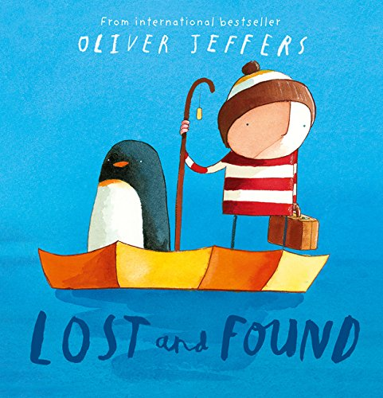

https://www.youtube.com/watch?v=B33hZSjyeO0

Describing the penguin
Can you describe what the penguin looks like?
You can use the key words below or think of your own amazing describing words.

black and white body | fast swimmer
small pointy beak | short oval body
two small eyes | spiky feather
________________________________________________________________________________________________________________________________________________________________________________________________________
________________________________________________________________________________

Imaginative writing
For this activity you will need to use your imagination!

How do you think the penguin got to the boy’s house?
________________________________________________________________________________________________________________________________________________________________

What would you do if you found a penguin at your front door?
________________________________________________________________________________________________________________________________________________________________
Penguin poem
Can you write a poem about the penguin?

P___________
E___________
N___________
G___________
U___________
I___________
N___________

Maths
1 more
Find one more:

1 more is _____

Find one more:

1 more is _____

Find one more:

1 more is _____

Find one more:

1 more is _____
1 less
Find one less:

1 less is _____

Find one less:

1 less is _____

Find one less:

1 less is _____

Find one less:

1 less is _____

2D shapes
Name these 2D shapes:
______________________________
______________________________
______________________________
________________________________
____________________________
________________________________
______________________________
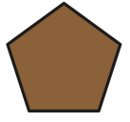______________________________
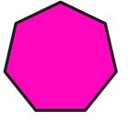_____________________________
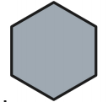______________________________
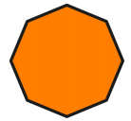______________________________

Can you make a penguin using 2D shapes?

3D shapes
Name these 3D shapes:
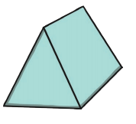______________________________
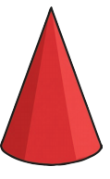_________________________________
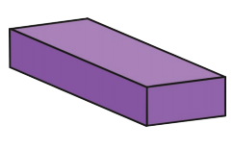_________________________
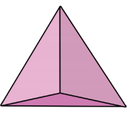____________________________
____________________________
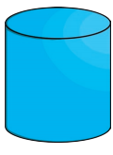______________________________
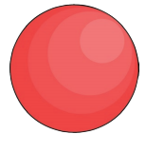________________________
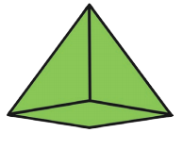_____________________

Topic
Puppets
Carefully cut out the pictures, attach a lolly stick or a rolled up sheet of paper to the back of them to create stick puppets.
Can you use your puppets to retell the story?
Complete the maze
Can you help the little boy and the penguin navigate through the mazes?
Colouring

How to draw a penguin
Follow the instructions and draw your own penguin.

