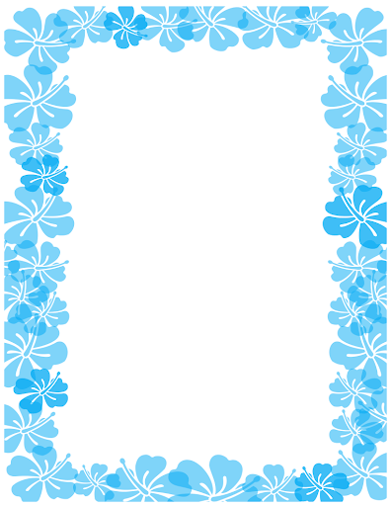

Week 3/8/20
Cinderella

Cinderella
https://www.youtube.com/watch?v=DgwZebuIiXc

Activity 1

English
This week we are going to be reading the story ‘Cinderella’, if you have the book at home then have a read of it, if not, you can watch it on YouTube.

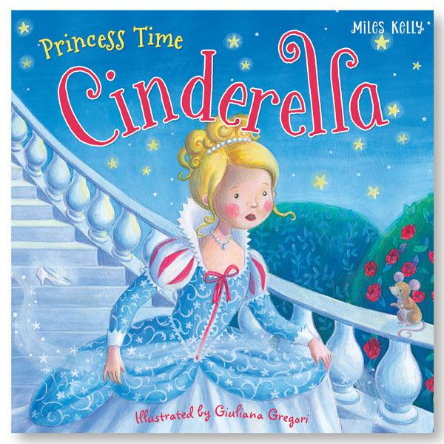

https://www.youtube.com/watch?v=DgwZebuIiXc

Retelling the story
Can you write about your favourite part of the story?
Remember your capital letters and full stops.

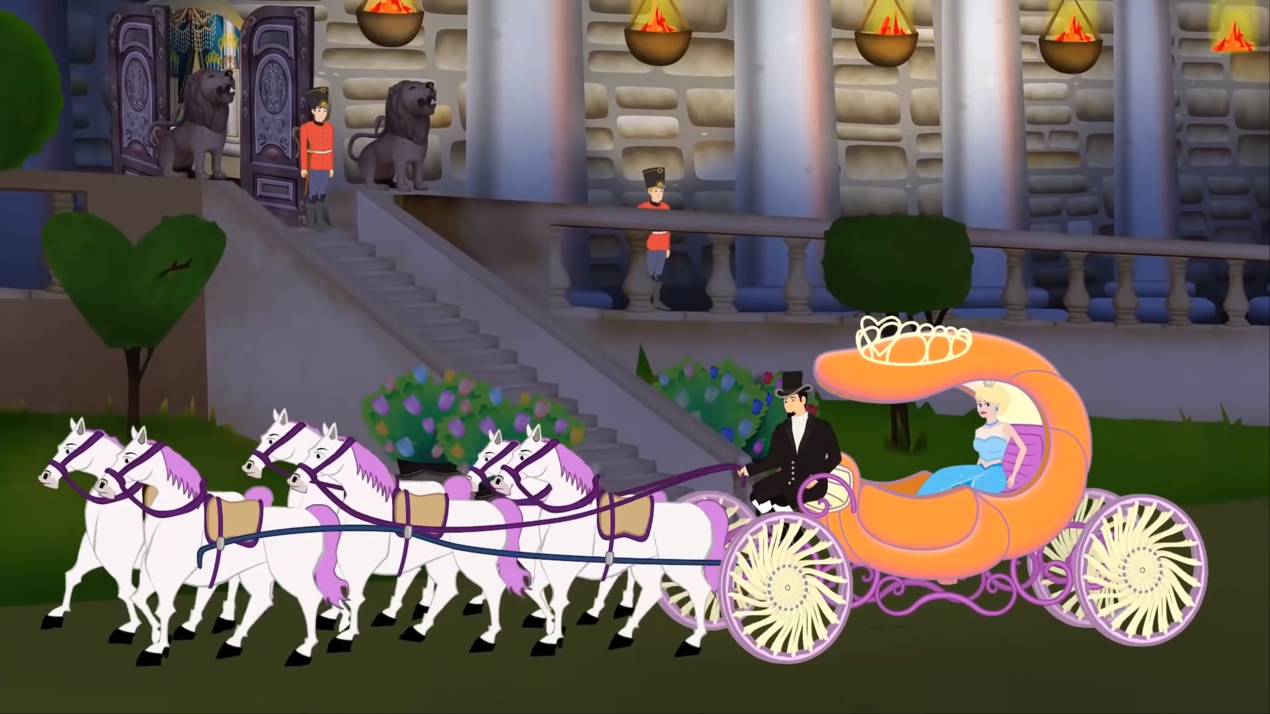
________________________________________________________________________________________________________________________________________________________________________________________________________
________________________________________
________________________________________

Describing Cinderella
Can you write a character description for Cinderella? Write about what she looks like and about her personality.
You can use the word bank below or think of your own amazing describing words.
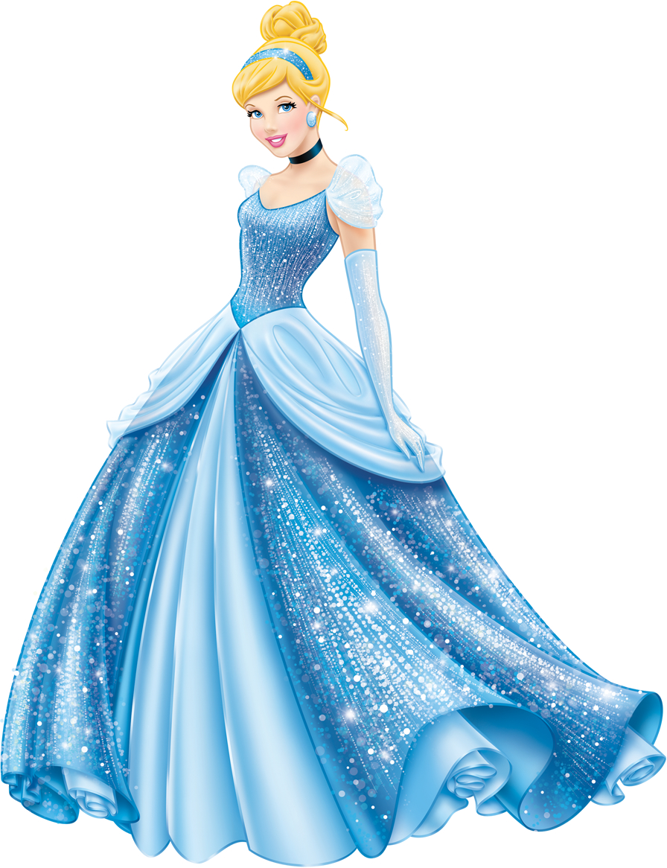
nice | lonely
beautiful | forgiving
kind | bright blue eyes
smart | shiny golden hair
hardworking | soft skin

________________________________________________________________________________________________________________________________________________________________________________________________________
________________________________________
________________________________________
Read and draw
Read the words and draw a picture for the words.

Cinderella word search
Search for the words in the word search, put a circle around the words that you find.

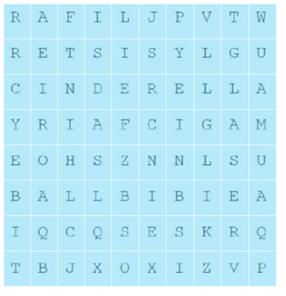

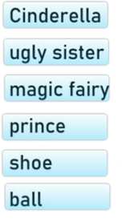
Maths
Counting in 2’s
Count in 2’s to 20:
2, 4, 6, 8, 10, 12, 14, 16, 18, 20
Count in 2’s and write down how many glass slippers there are in total.
Counting in 5’s
Count in 5’s to 50:
5, 10, 15, 20, 25, 30, 35, 40, 45, 50

Count in 5’s and write down how many mice there are in total.

Counting in 10’s
Count in 10’s to 100:
10, 20, 30, 40, 50, 60, 70, 80, 90, 100

Count in 10’s and write down how many pumpkins there are in total.

Topic
Maze

Cinderella paper model
Cut out the model of Cinderella, roll it a little and close it up to create a model of Cinderella.

Healthy meal
Can you design a healthy meal for Cinderella? What do you need to remember to include to make it a healthy meal?

