Week 2
27/7/20
We’re going on a bear hunt

English
This week we are going to be reading the story ‘We’re going on a bear hunt’, if you have the book at home then have a read of it, if not, you can watch it on YouTube.

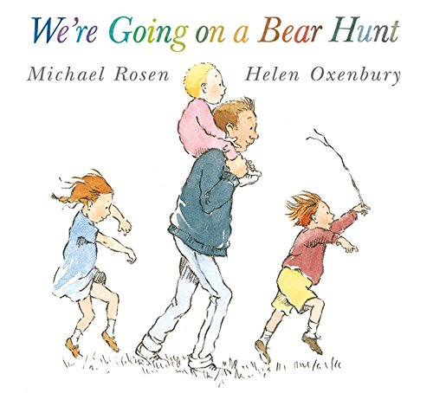
https://www.youtube.com/watch?v=0gyI6ykDwds

Read and match
Read the sentences and match them to the correct picture.
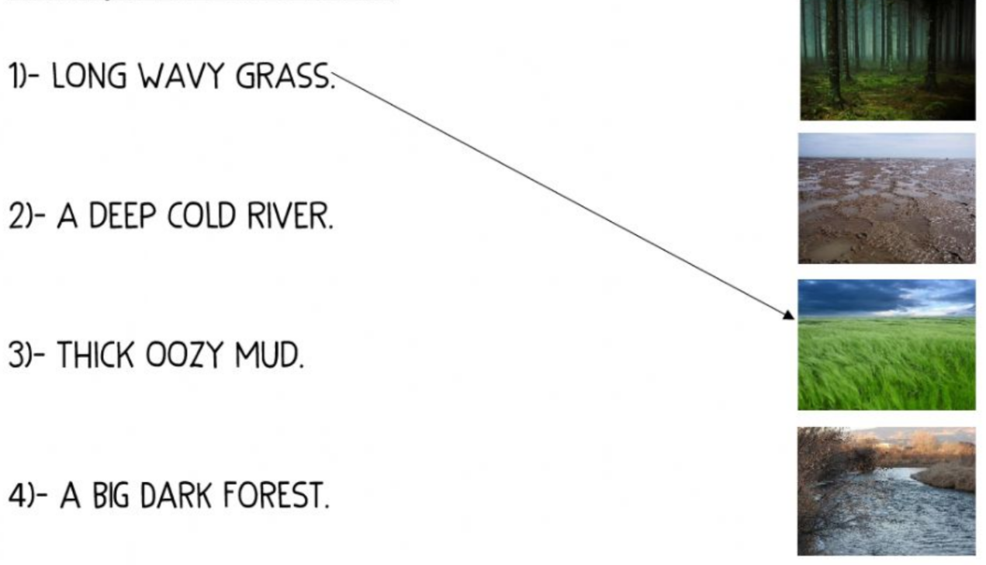

Complete the sentences
After reading or listening to the story, fill in the missing words.

We’re going on a bear hunt
We’re going to ___________ a _______ one
What a beautiful ___________!
We’re not scared.

Uh-Uh! Grass!
Long ______ grass.
We can’t go ________ it.
We can’t go ________ it.
Oh No!
We’ve got to go ________ it.
Swishy Swashy, Swishy Swashy.

Uh Uh! A river!
A deep _______ river.
We can’t go _______ it.
We can’t go _________ it.
Oh no!
We’ve got to go _________ it.
Splash, splosh, splash, splosh.

Uh Uh! Mud!
Thick _________ mud.
We can’t go ________ it.
We can’t go ________ it.
Oh No!
We’ve got to go ________ it.
Squelch! Squerch! Squelch! Squerch!

Describing the bear
Describe what the bear looks like.
You can use the word bank below or think of your own amazing describing words.

googly eyes | shiny wet nose
sharp claws | big furry ears
thick fur | huge furry body
________________________________________________________________________________________________________________________________________________________________________________________________________
________________________________________________________________________________

Maths
Doubling
Double the number of bears, write a number sentence and work out the answer

Double 3

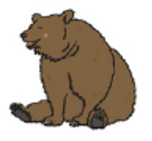

____ + ____ = ____

Double 5

____ + ____ = ____

Double 7

____ + ____ = ____
Distance
Cut out the pictures and follow the instructions.

- Put the girl near the bear

- Put the girl far away from the bear

- Put the bear near the dog

- Put the bear far away from the dog

Weight
Cut these objects out and put them in order of weight, from the heaviest to the lightest.

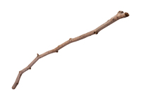

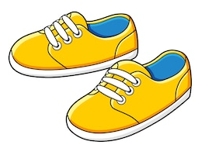

Capacity
Draw a line on the cup to show the capacity.
1. Empty 2. Nearly empty

3. Half empty 4. Half full

3. Nearly full 4. Full

Topic
Different environments
What environments did the family visit before they found the bear?
Colour the pictures in and draw some animals or insects that live in the environment.

Cave building

Bear hunt headbands
Cut out the headband pieces and put them together to create a character headband. Use the headbands to retell the story ‘We’re going on a bear hunt.’

Additional activities

