Week 1
20/7/20
The 3 Billy Goats Gruff

English
This week we are going to be reading the story ‘The Three Billy Goats Gruff’, if you have the book at home then have a read of it, if not, you can watch it on YouTube.

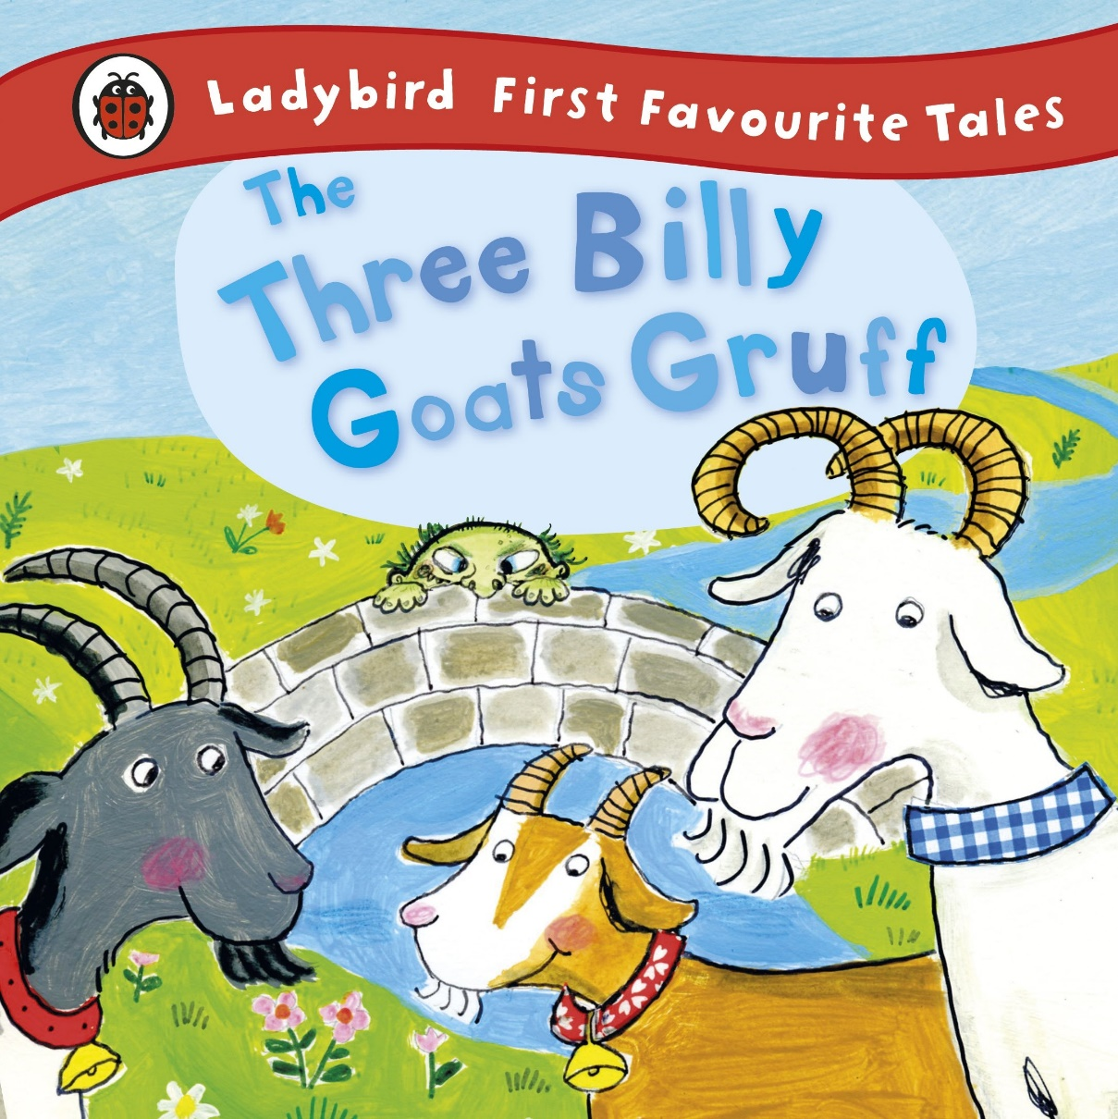

https://www.youtube.com/watch?v=3QzT1sq6kCY

Describing the Troll
Can you describe what the troll looks like?
Remember to use lots of describing words.

You can use the word bank below or think of your own amazing describing words!

________________________________________________________________________________________________________________________________________________________________________________________________________
________________________________________________________________________________

Describing the setting
Can you describe the setting?
Remember, the setting is where the story takes place.

You can use the word bank below or think of your own amazing describing words!

________________________________________________________________________________________________________________________________________________________________________________________________________
________________________________________________________________________________

Read and match
Can you match the words to the correct picture?

goat

grass

bridge

troll

river

big

small

Maths
Counting
Count how many billy goats there are and write down the answer.

Order by size
Cut out the goats and order them by order of size, from the biggest to the smallest.

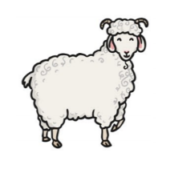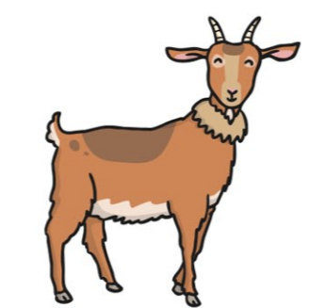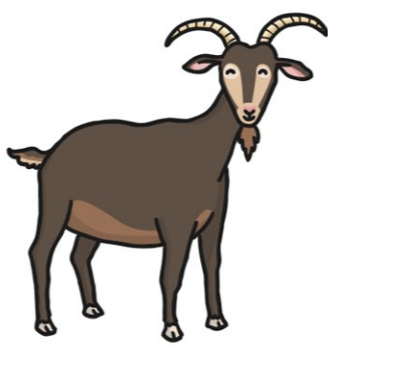

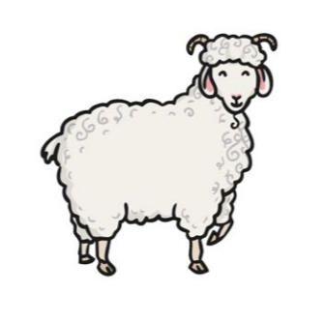

Circle the biggest goat.
Circle the smallest goat.

Position
Cut out the pictures and follow the instructions.

- Put the troll next to the goats

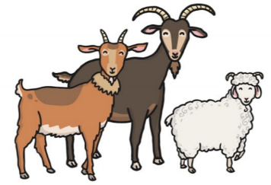
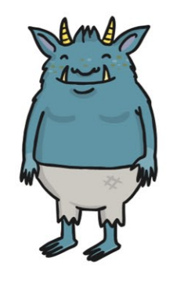

- Put the troll in front of the goats

- Put the troll behind the goats

- Put the troll under the bridge

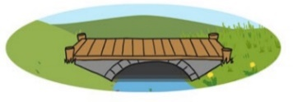

- Put the goats on top of the bridge

- Put the goats between the bridge and the troll

Time
Draw the hands of the clock to make the correct time.
1. 4 o’clock 2. 12 o’clock
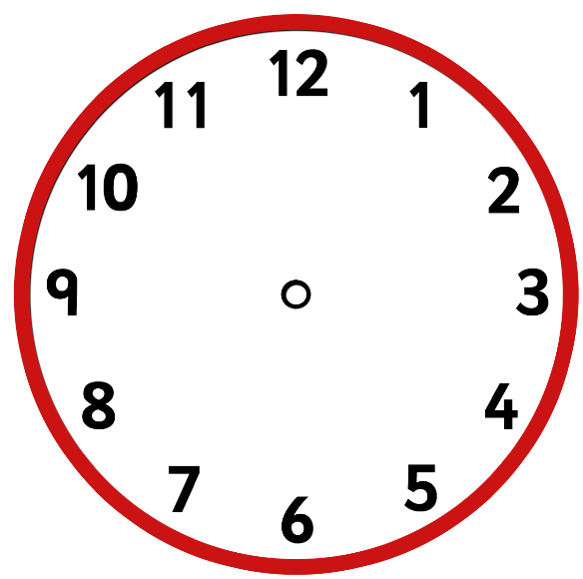

3. 9 o’clock 4. 3 o’clock

5. 8 o’clock 6. 11 o’clock

Time word problems

- The goats started eating at 9 o’clock, they finished eating at 12 o’clock. How long did they spend eating?

____ + ____ = ____

- The goats started walking to the bridge at 1 o’clock, they arrived at the bridge at 7 o’clock. How long did they walk for?

____ + ____ = ____

- The goats started crossing the bridge at 4 o’ clock, the arrived at the end of the bridge at 5 o’clock, how long did it take them to cross over the bridge?

____ + ____ = ____

- The troll went for a swim at 6 o’clock, he finished his swim at 9 o’clock, how long did he swim for?

____ + ____ = ____

Topic
Stick puppets
Carefully cut out the 3 goats and the troll, attach a rolled up paper or a lolly stick to the back to create puppets. Can you retell the story using your puppets?
Spot the difference
There are 6 differences between the 2 pictures below, can you spot them all?

Science experiment

Additional activities

