Week 5
17/8/20
The rainbow fish

English
This week we are going to be reading the story ‘The rainbow fish’ , if you have the book at home then have a read of it, if not, you can watch it on YouTube.

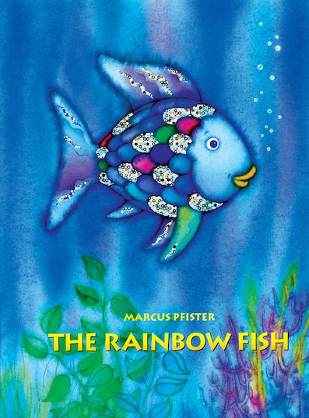

https://www.youtube.com/watch?v=ifXlc0QI2kY

Describing the rainbow fish
Describe what the rainbow fish was like at the start of the story.
You can use the words below or think of your own.

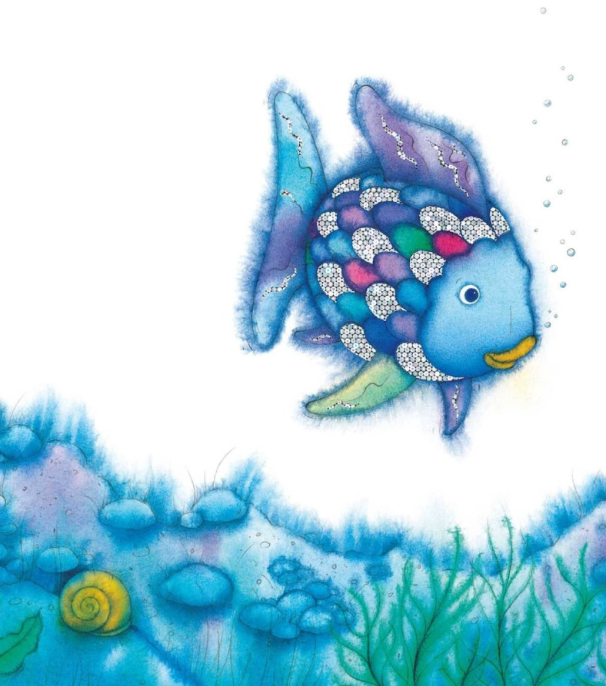
Rude
Selfish
Unfriendly
Proud

________________________________________________________________________________________________________________________________________________________________________________________________________
________________________________________________________________________________

Describing the rainbow fish
Can you describe the beautiful rainbow fish? Describe what he looks like. You can use the word mat below to help you.

________________________________________________________________________________________________________________________________________________________________________________________________________
________________________________________________________________________________

Ordering the story
Cut out the pictures below and put them in order to retell the story.

Maths
Counting
Count how many rainbow fish there are and write down the answer.

Ordering numbers
Cut out the ice creams and put the numbers in order from 1 to 20.
Patterns
Continue the patterns by colouring in the blank circles the correct colour.
Can you say your pattern out loud to describe it?

Halving
Can you help rainbow fish to halve the number of scales?

Half of 2 is _____

Half of 4 is _____

Half of 6 is _____

Half of 10 is _____

Half of 12 is _____

Half of 14 is _____

Topic
CD fish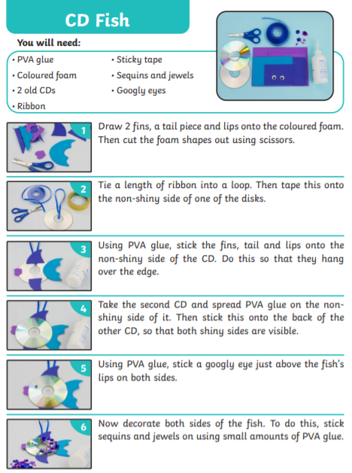
Design a fish
Can you draw the rest of the rainbow fish? Or you could design your own fish.

Fish collage
Use different materials to create your own rainbow fish collage.

Rainbow fish masks
Carefully cut out the masks, cut out the eyes and attach a lolly stick to the back to create a mask.
Can you retell the story using your masks?

Making colourful scales

