Week beginning 18th May 2020
Hello everyone!
Thank you for all your hard work last week. We hope our new tasks will keep you busy:)
ENGLISH
Describing the setting

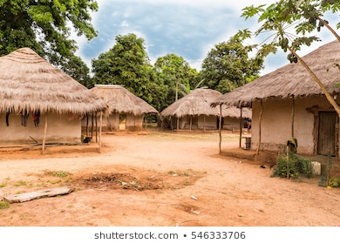
Can you describe the African village from the Calabash Boy story?

Key vocabulary:
Peaceful farms
Small
Quite
Dusty paths
Charming houses
Vibrant fields
Rolling hills
Surrounded with tall trees

Henry Croft

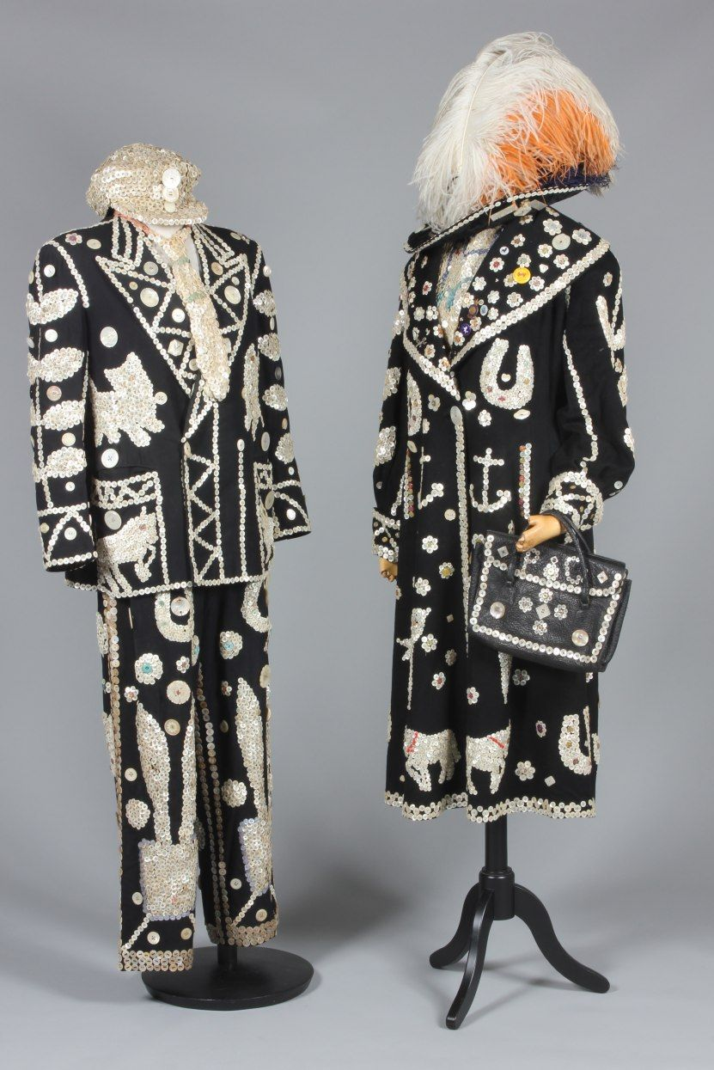
Henry wore a pearly suit to raise money for the orphans who lived in the tall house.
Can you describe Henry Croft?
Key vocabulary:
Black suit
Smooth suit
Pearly buttons
Shiny buttons
Black hat
E.G. Henry Croft has a black smooth suit.

MATHS
Time word problems: read and solve the word problems. Circle the important information, write a number sentence and work out the answer. You can use objects, a number line or work it out in your head.

- Henry Croft started sweeping at 10 o’clock and he finished at 12 o’clock, how long did he spend sweeping?

_____ hours

- The Calabash boy started cooking at 3 o’clock and he finished at 7 o’clock, how long did he cook for?

_____ hours

- Henry Croft went to the market at 12 o’clock and he went home at 2 o’clock, how long did he spend at the market?

_____ hours

- The Calabash boy went to sleep at 11 o'clock and he woke up at 12 o'clock, how long did was he asleep for?

_____ hours

- Henry Croft started sewing at 2 o’clock and he finished at 3 o’clock, how long did he spend sewing?

_____ hours

- The Calabash boy went for a walk at 3 o'clock and he returned home at 6 o'clock, how long did he go for walk?

_____ hours

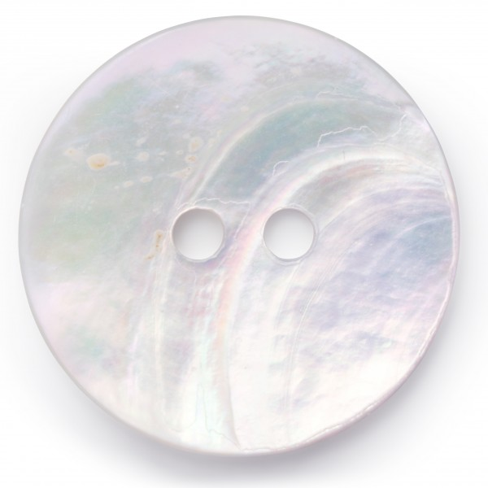
Ordering by size: can you put these pearl buttons in order of size, from the biggest to the smallest?

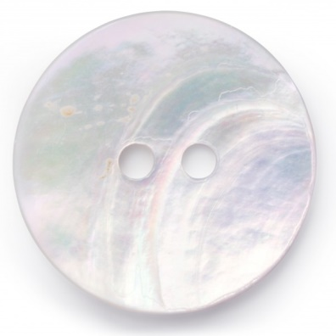

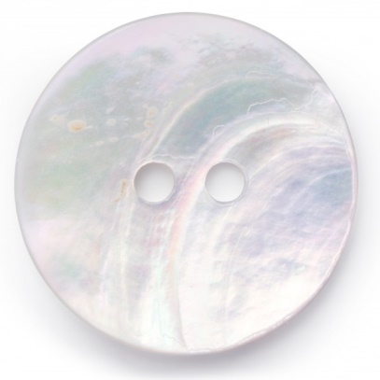

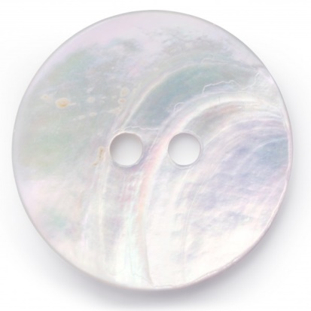

Ordering by height: can you put these calabashes in order of height, from the tallest to the shortest?
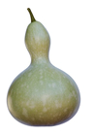

Days of the week: can you put these days of the week in order?

What day is it today?
What is your favourite day of the week? Why?
Months in the year: can you put these months in the year in order?

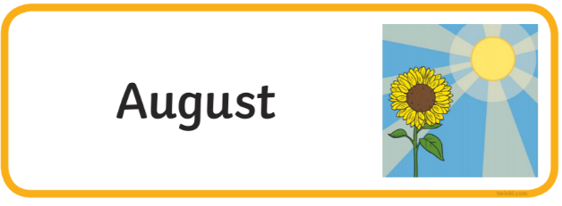

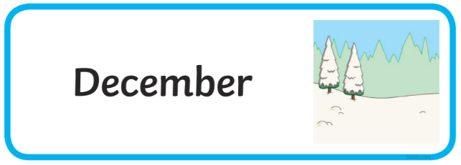

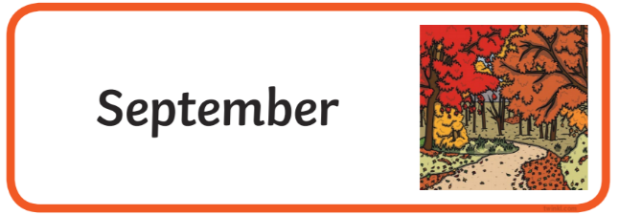

What month is it?
What is your favourite month in the year? Why?
When is it your birthday?
What is your favourite season?
Counting in 5’s: watch the video and practise counting in 5’s
https://www.youtube.com/watch?v=amxVL9KUmq8

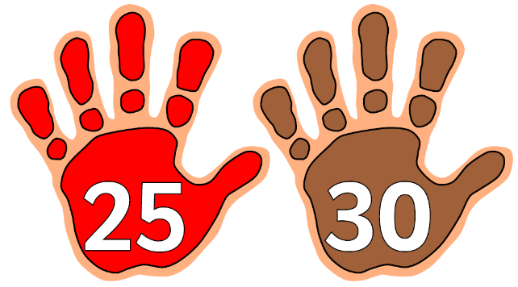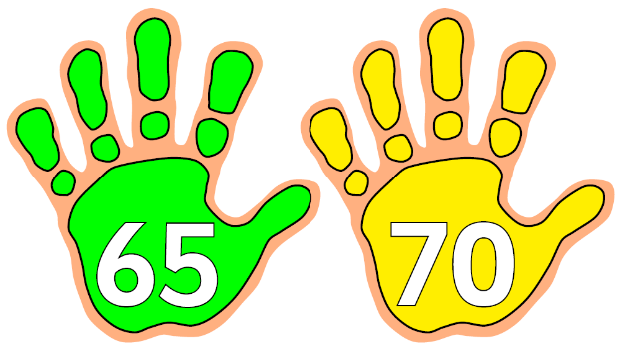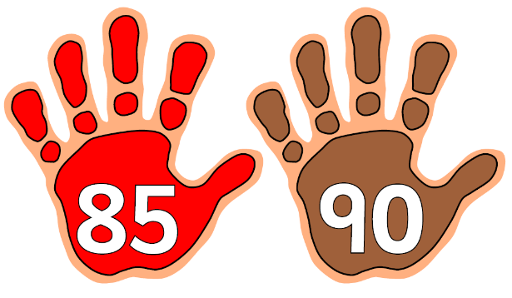
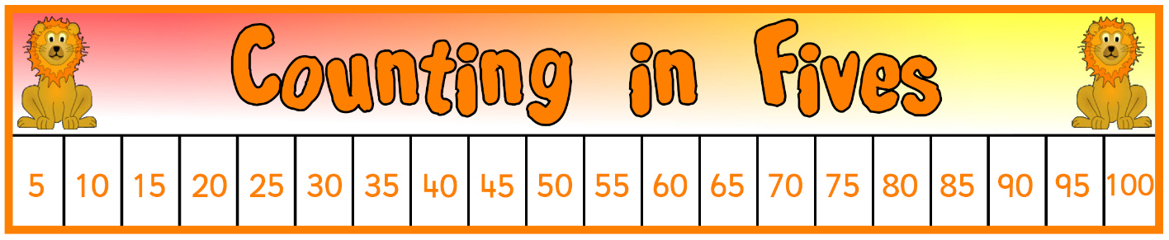

Fill in the missing numbers for the number sequences, for every number sequence we are counting in 5’s:

5, 10, ___, 20, 25, ___, 35, 40, ___, 50, 55, ___, 65, 70, ___, 80, 85, ___, 95, 100.

___, 10, 15, 20, ___, 30, 35, 40, ___, 50, 55, 60, ___, 70, 75, 80, ___, 90, 95, 100.

___, 10, 15, 20, 25, ___, 35, 40, 45, 50, ___, 60, 65, 70, 75, ___, 85, 90, 95, 100.

5, 10, 15, 20, 25, ___, 35, 40, 45, 50, 55, ___, 65, 70, 75, 80, 85, ___, 95, 100.

___, 10, ___, 20, ___, 30, ___, 40, ___, 50, ___, 60, ___, 70, ___, 80, ___, 90, ___, 100.

TOPIC
PSED – Just like Henry thought about making others happy. Can you write about how you can be kind and helpful to others.
Draw around your hand and write in each finger how you can be helpful.

UTW – Can you do some research about the River Thames and write down 5 key facts
https://kids.kiddle.co/River_Thames
Can you do some research about Africa, maybe you can draw a picture of a mountain in Africa or a river.
https://africa.mrdonn.org/geography.html

PD/EAD – Can you use newspaper and other materials to create a picture of an animal?
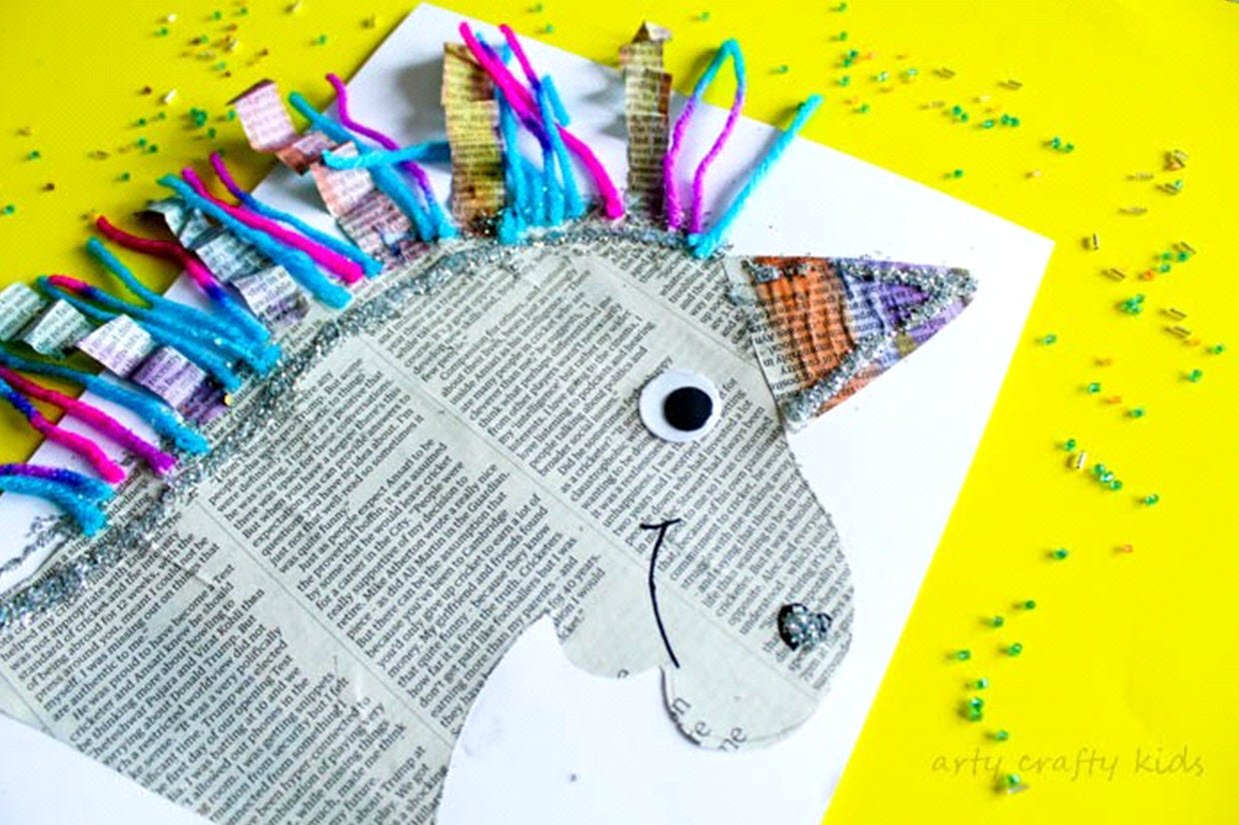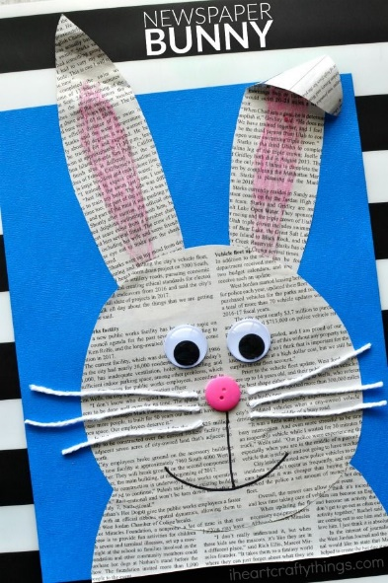

PD – Remember the beans game…. Can you play this with someone?
Runner Bean – jog on the spot
Frozen Bean – freeze
Baked Bean – curl up into a small ball
String Bean – Stretch to the sky
Jumping Bean – Jump on the spot

Can you add your own new actions?

Enjoy completing the activities. Send us your wonderful work to share with everyone.
Lots of love,
Reception teachers

