Week beginning 18th May 2020
Hello everyone!
Thank you for all your hard work especially the fantastic spider pictures and name writing!
This week we are learning about caterpillars!
Literacy:
The story of the week is ‘The Very Hungry Caterpillar’ watch the story on YouTube and draw a picture of a caterpillar eating the different fruits. Have a go in writing some of the names of the fruits in the story using your letter sounds.
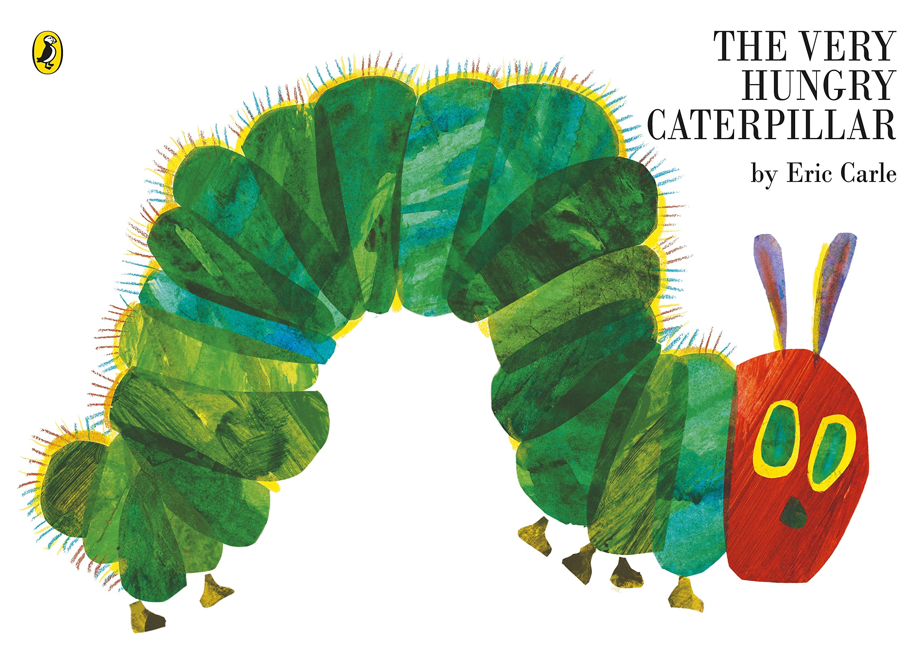

https://youtu.be/75NQK-Sm1YY

caterpillar

Write over the green caterpillar name and remember to hold the pencil correctly!
Maths:
Can you use the circles and triangles to make a caterpillar’s body? Remember to draw the tiny legs!

Count how many circles the caterpillar has and write the correct number next to it.

Write the missing numbers on the caterpillar bodies!
9
6
1
3

20
12
19
16

UTW:
Find some fun facts and draw about the life cycle of a butterfly
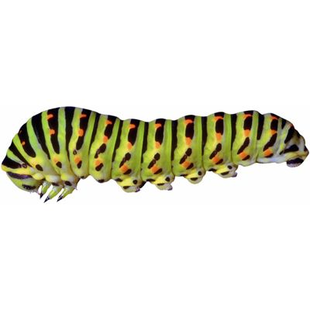
What pattern do you notice on the caterpillar?

Can you describe the different colours and patterns on the butterfly?
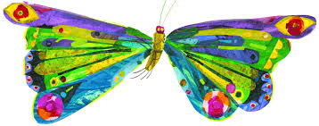

Click here for some caterpillar and butterfly videos!
https://youtu.be/O1S8WzwLPlM
https://youtu.be/QYbMScXPEV0
EAD:
Try out these caterpillar and butterfly arts and crafts activities!
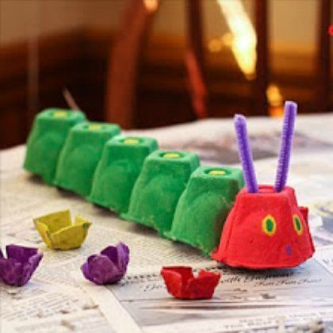
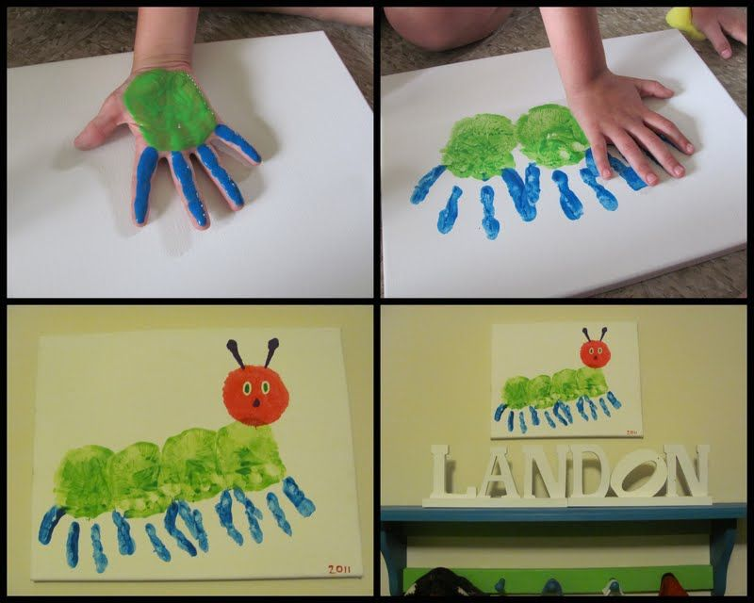

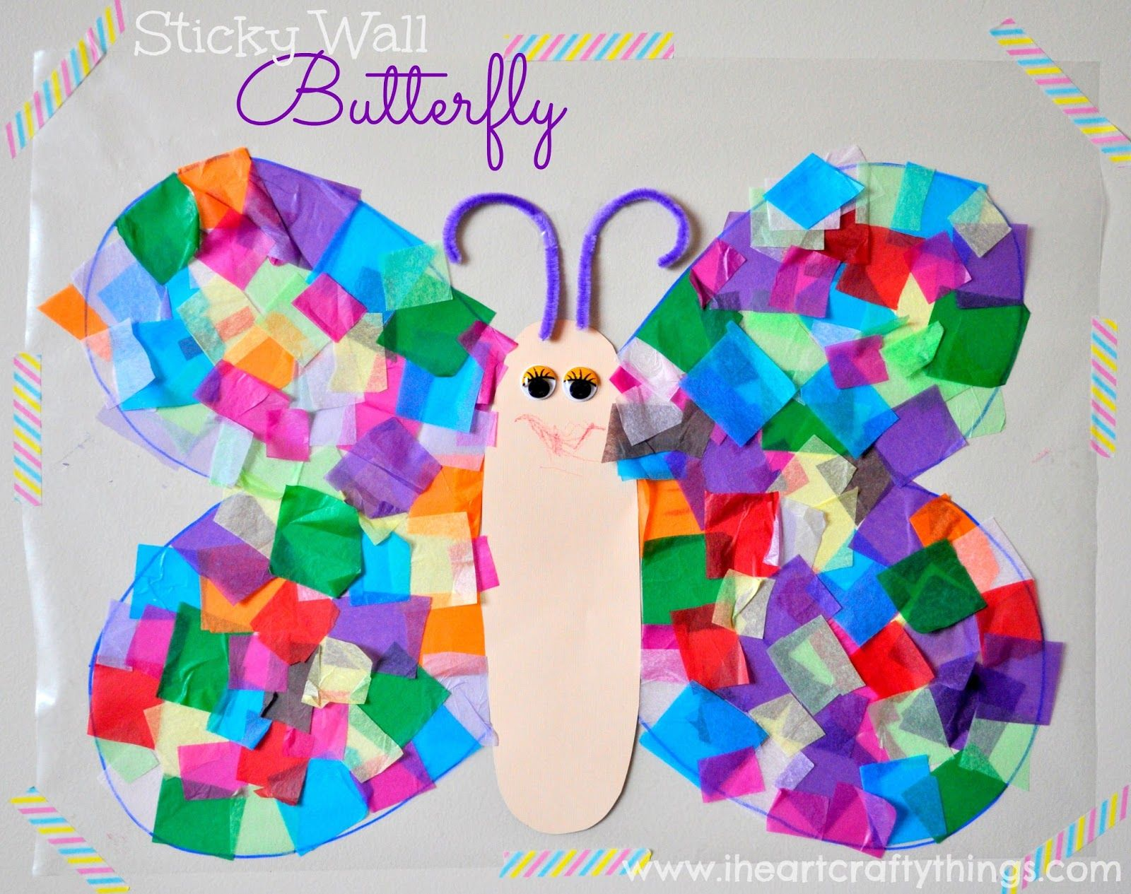
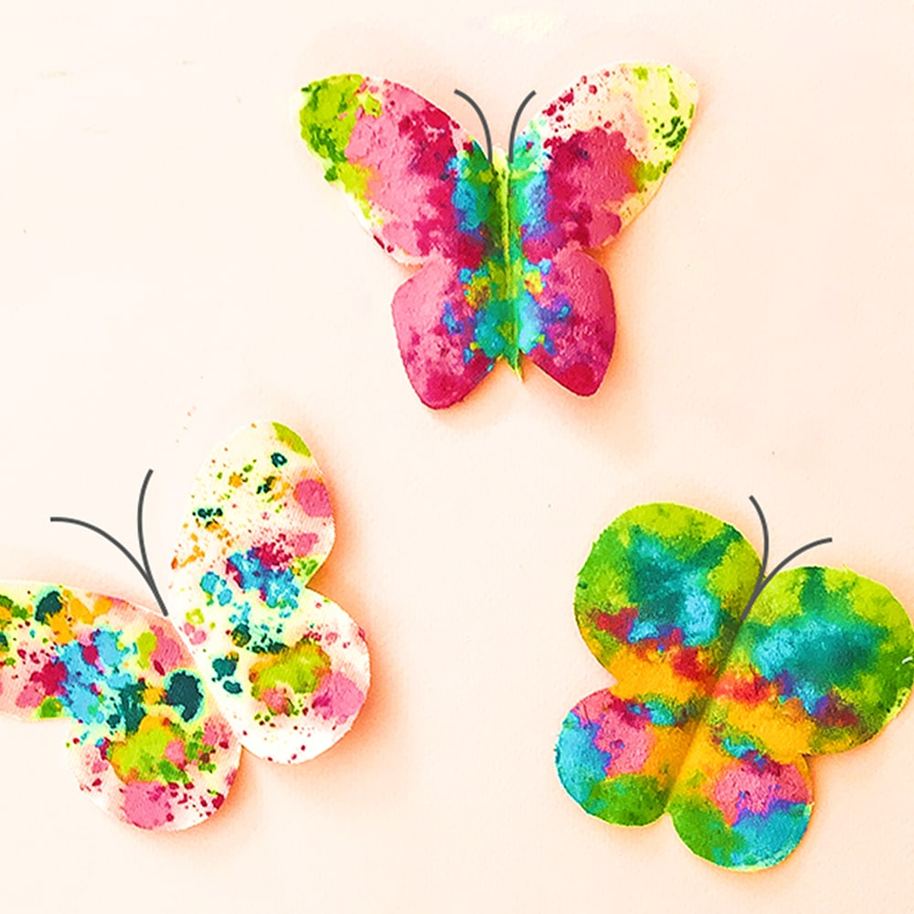
Get ready to flutter like a butterfly with your family!
https://youtu.be/5gs8_VUSnMQ
https://youtu.be/l1B49em1vPU
Try out these science experiments!
https://www.twinkl.co.uk/resource/t-t-27455-eyfs-butterfly-life-cycle-science-experiments-pack
Some twinkl links for you to download
https://www.twinkl.co.uk/resource/t-t-27061-i-spy-with-my-little-eye-activity-to-support-teaching-on-the-very-hungry-caterpillar
https://www.twinkl.co.uk/resource/t-n-568-the-very-hungry-caterpillar-maths-booklet
https://www.twinkl.co.uk/resource/t-t-7411-the-very-hungry-caterpillar-wordsearch
https://www.twinkl.co.uk/resource/t-t-6886-the-very-hungry-caterpillar-pencil-control-workbook
https://www.twinkl.co.uk/resource/t-t-1229-the-very-hungry-caterpillar-colouring-sheets-
https://www.twinkl.co.uk/resource/t-t-1231-the-very-hungry-caterpillar-stick-puppets

Please feel free to email me more of the amazing and constructive pictures!

mariam.mamun@shaftesbury.boleyntrust.org

Eid Mubarak and enjoy the
half term holiday!

As part of RE we are learning about Eid this week. Make some Eid cards and decorations!
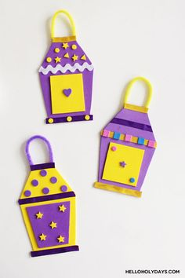
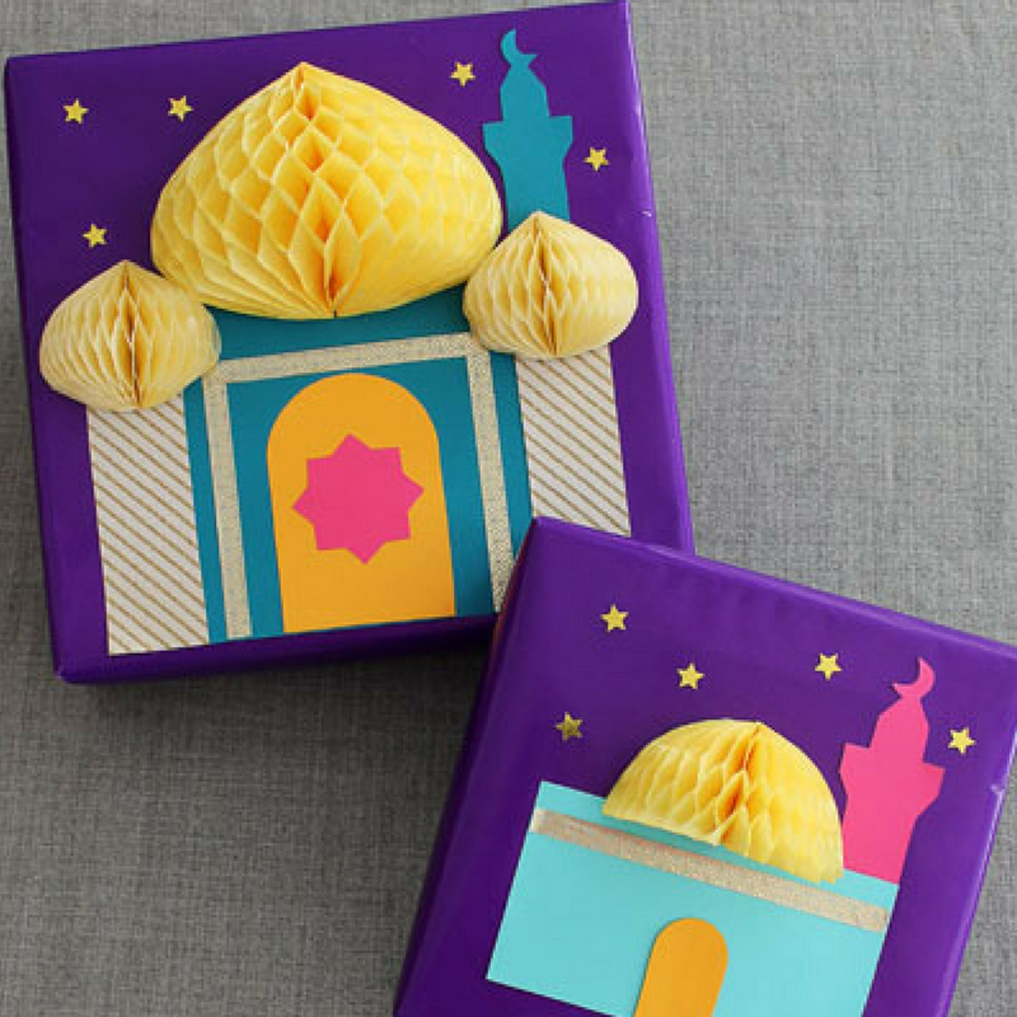

Try the Eid biscuit recipes
https://www.twinkl.co.uk/resource/t-t-20989-eid-recipe-book
https://www.twinkl.co.uk/resource/t-t-21940-making-eid-biscuits-recipe-cards

Ramadan and Eid resource pack ideas
https://www.twinkl.co.uk/resource/eyfs-ramadan-and-eid-school-closure-activity-pack-ages-3-5-t-tp-2549406

Eid videos and songs
https://youtu.be/5gf-BE-pgSg
https://youtu.be/NapxPcm5G5M
https://www.bbc.co.uk/cbeebies/puzzles/lets-celebrate-eid

