Week beginning 20th July 2020
Summer holiday week 1 tasks:
This week is a recap of what we have been learning about in the summer term:
Under the sea
Have a go in drawing and writing about a sea creature that you like with your family!

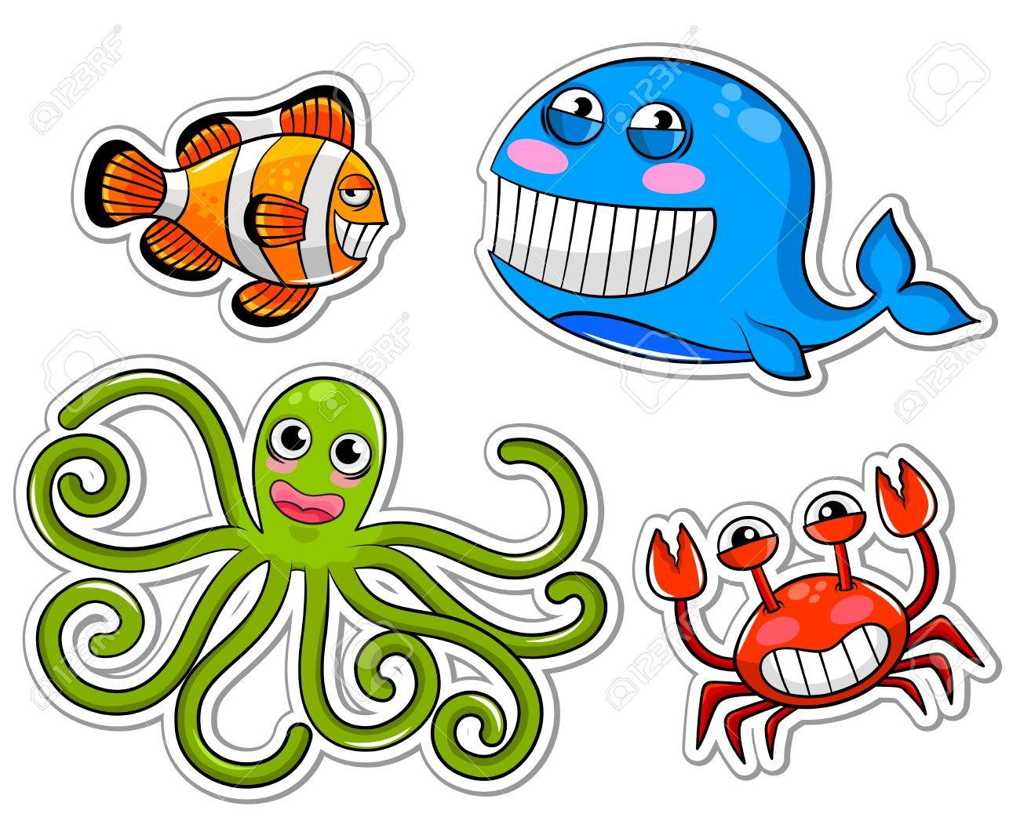

Remember to label your work and use letter sounds to write the words!

Literacy:
Learn the names of these sea creatures and find out some facts about them!

Have a go with this challenge or write the name of the fish and learn to describe about it.

Maths:

Have a go in spotting the sea creatures and add them together on the next page.

Take your time and think about your answers

Have a go in drawing a sea creature using the 2D shapes that you know!

Can you make an octopus using just ovals?
Can you finish the starfish using just triangles?
What shape do you think the snake is made from?
Can you use the rectangles and tringles to make a shark?
Can you add triangles to makes spines for the pufferfish?
What colours can you see?

EAD
Get creative and make a under the sea collage or painting!

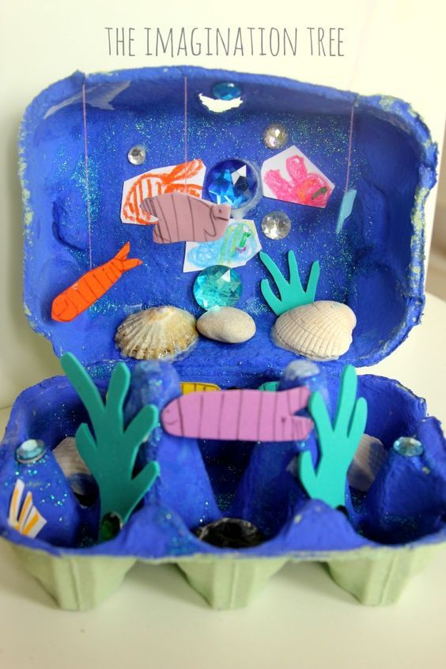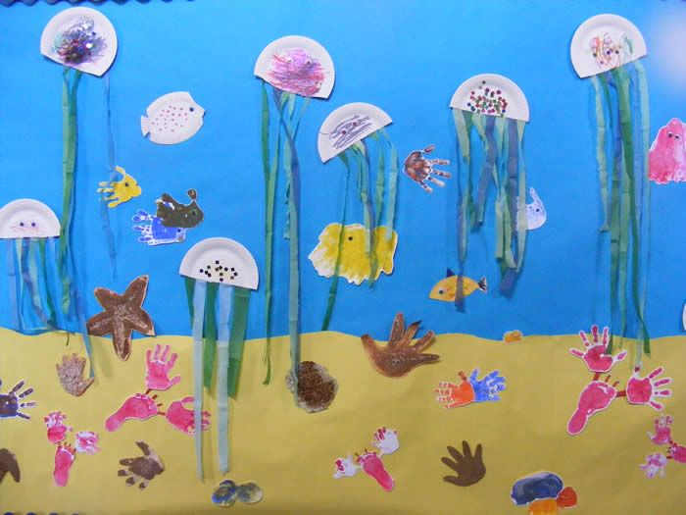

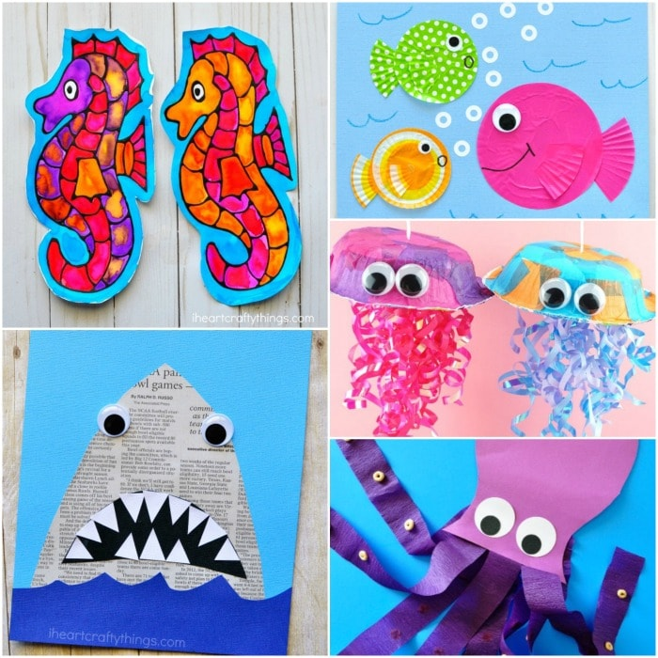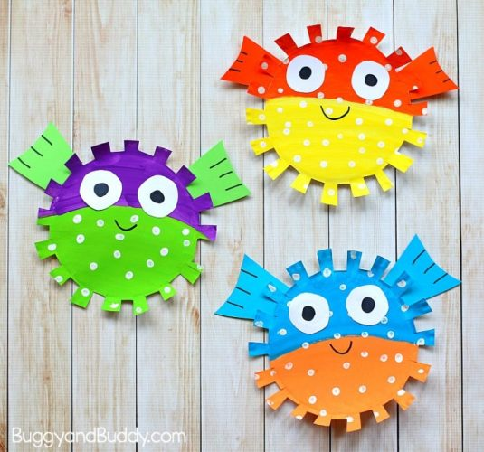

Science experiments
https://content.twinkl.co.uk/resource/e8/24/t-sc-2549961-how-to-grow-a-rainbow-experiment-science-activity_ver_7.pdf?__token__=exp=1589898409~acl=%2Fresource%2Fe8%2F24%2Ft-sc-2549961-how-to-grow-a-rainbow-experiment-science-activity_ver_7.pdf%2A~hmac=a31b913e5df33e5f4be148aa786ac9f26e10f30eb2baea314ec5da9ec1a73007
https://www.twinkl.co.uk/resource/au-eylf-under-the-sea-science-experiments-resource-pack-t-t-252425
Videos to watch
https://www.bbc.co.uk/programmes/p011l4gy
https://youtu.be/Oxw6FoUNeT4
https://youtu.be/J2BKd5e15Jc

You will find many resources on Twinkl to download to help your child
https://www.twinkl.co.uk/

