**Week beginning 17th August 2020**

*Summer holiday week 5 tasks:*

**Literacy:**

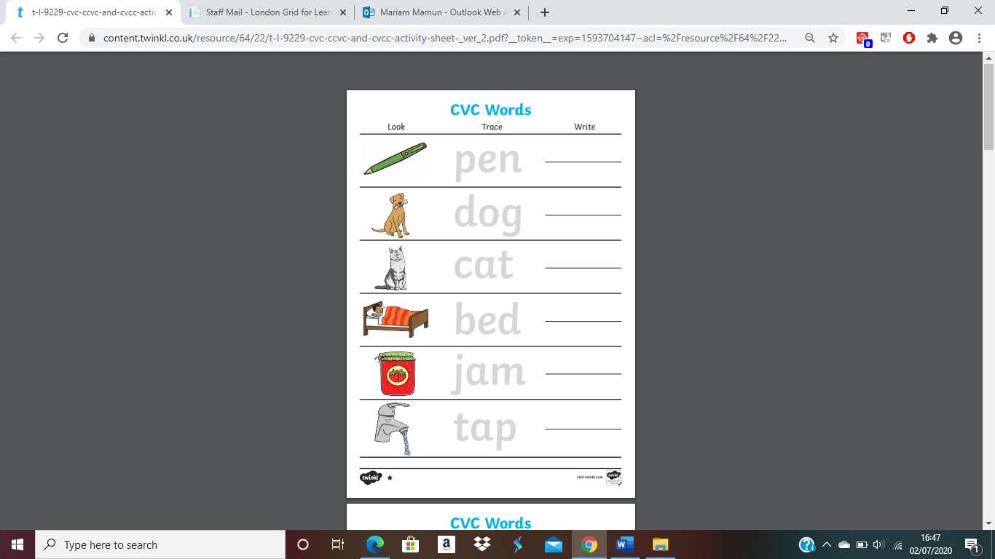

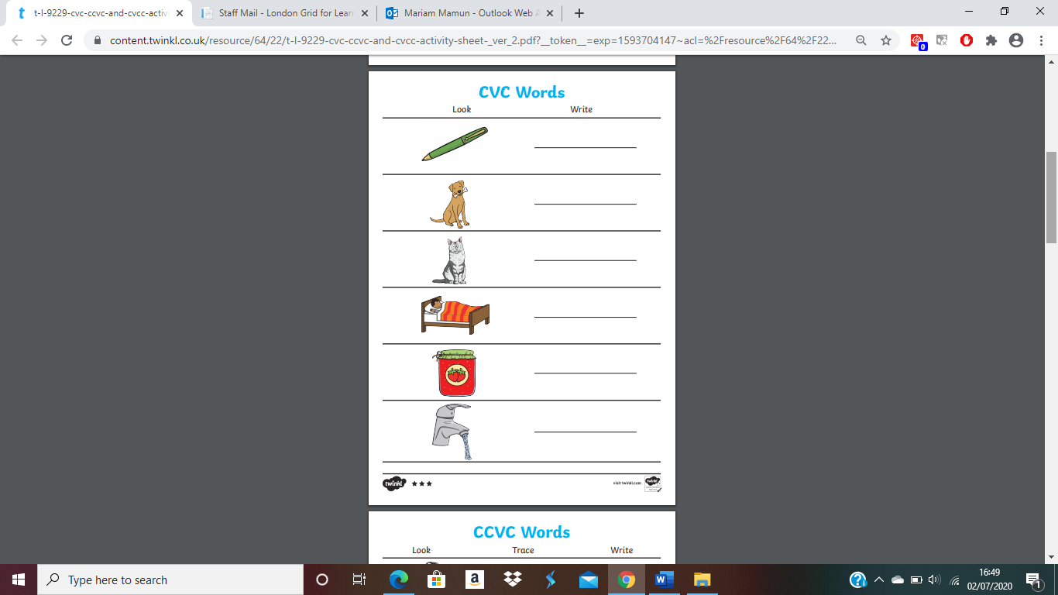

***Maths:***

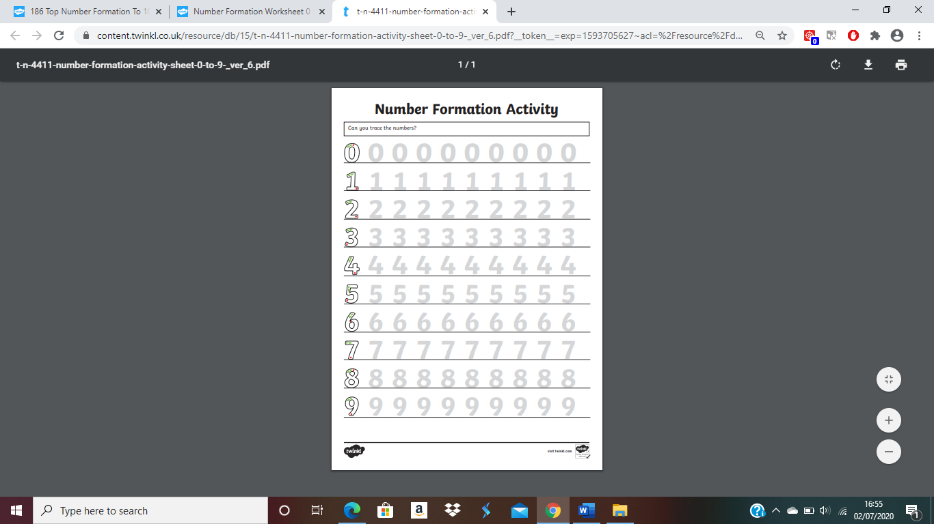

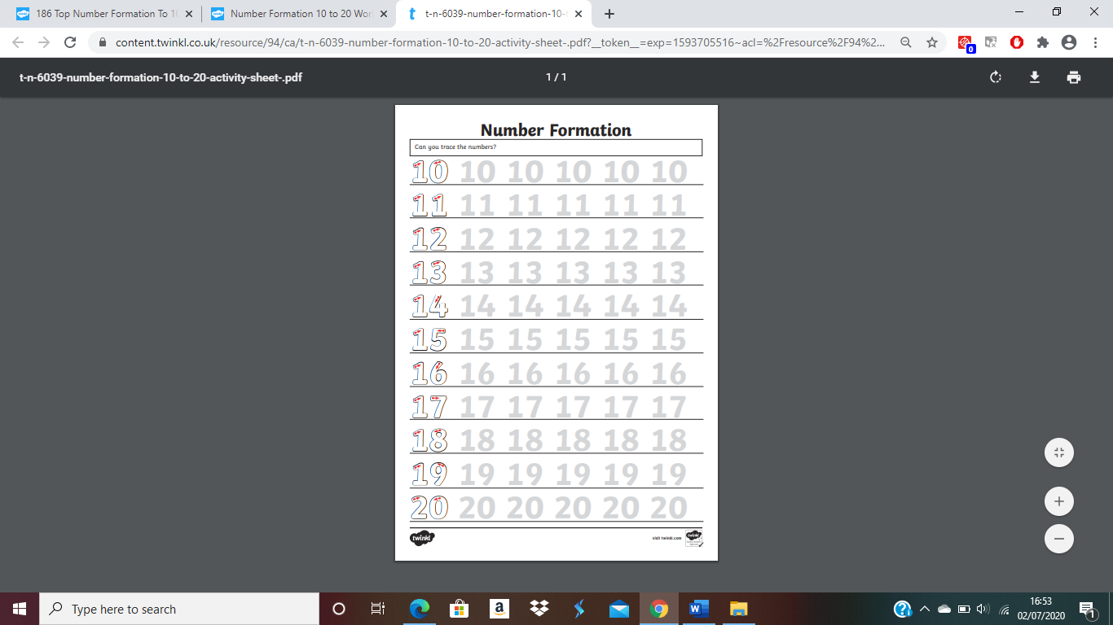

***EAD*: Get creative and make this paper plate crab!**

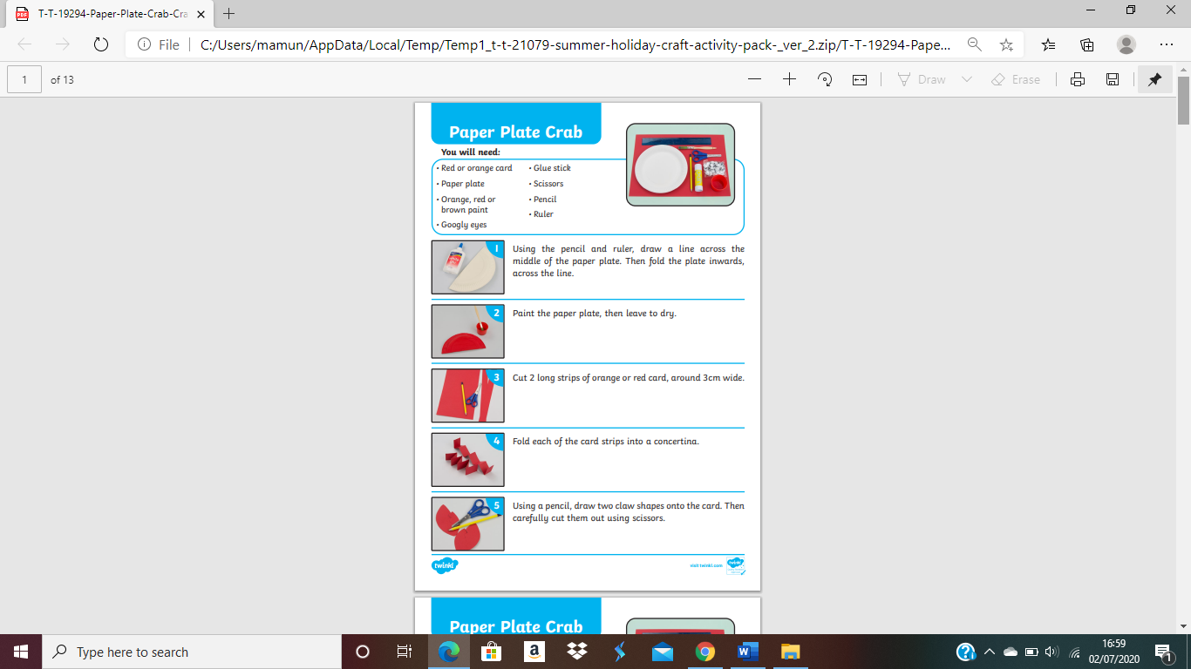

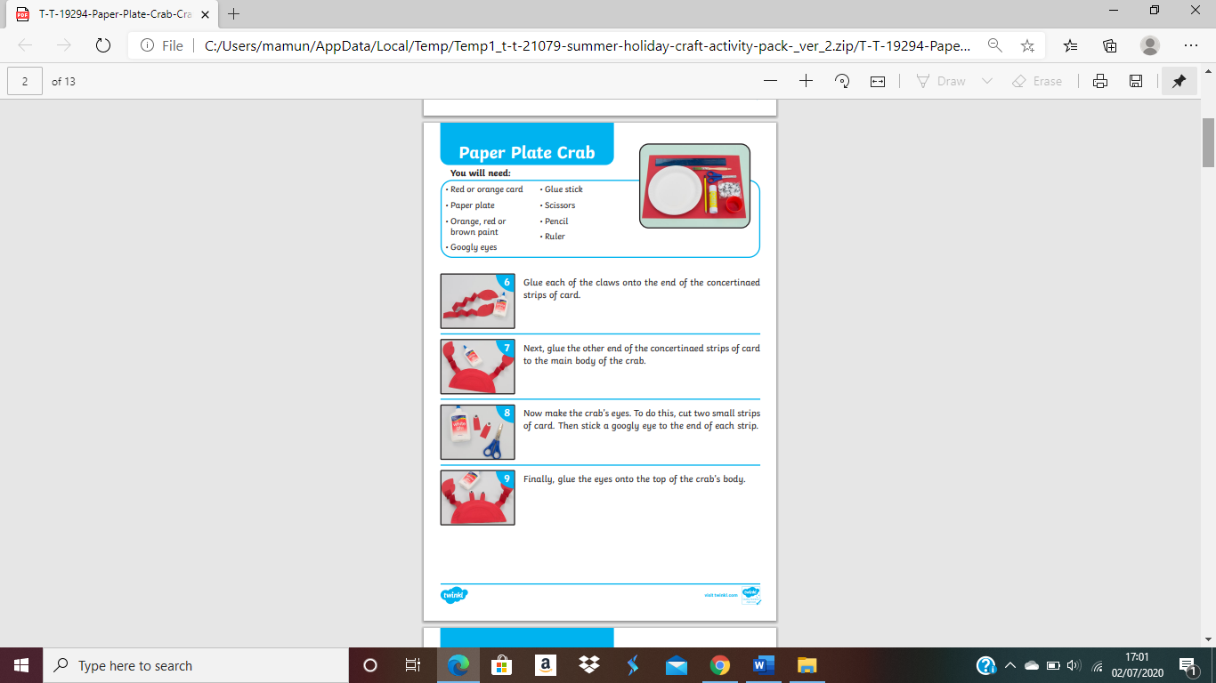

***PD*:** Get fit and try these exercises with your family!

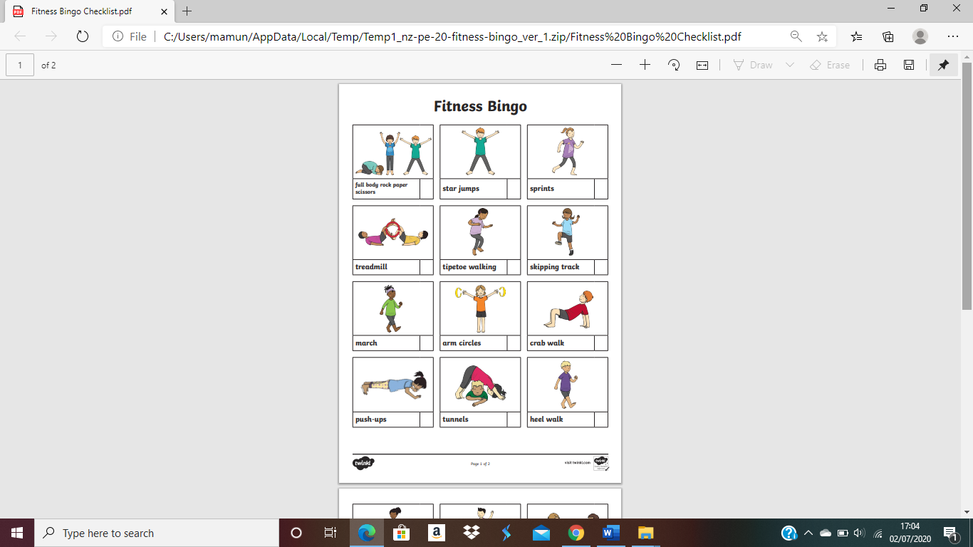

***Try the execerises at least up to 20 seconds and tick them off on the checklist!***