Lesson(s) | Prior Knowledge (Main Lesson)
Starter: (Mental/Oral)  LO: To use mathematical language to find numbers.  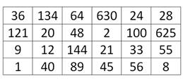  Find all the prime numbers  Find a multiple of 7  Find a multiple of 6 and 8  Find a cube number  Find a multiple of 4 from two square numbers  ~ ~ ~ ~ ~  Main Development:  Key Learning Objectives:  To recognise and use factors.  DEVELOPING STAGE:  Discuss with your talk partner:  What is a factor?  [Factoring is like taking a number apart. It means to express a number as the product of its factors. Factors are either composite numbers or prime numbers (except that 0 and 1 are neither prime nor composite)].  What prior knowledge do you need to know? [times table facts]  What are the factors of…  6 -> 1, 2, 3 & 6  12 -> 1, 2, 3, 4,6 & 12  48 -> 1, 2, 3, 4, 6, 8, 12, 16, 24 & 48  (These could be expressed pictorially through ‘factor bugs’.)  x3 x7  Put these numbers in the correct places: 28 12 2 21  Mini-Plenary  Discuss: An alien has landed on Planet Earth – complete the statement: A factor is… | Success Criteria:  - I can identify prime numbers;  - I can identify factors of numbers;  - I can apply my knowledge of times tables facts.  Key Vocabulary:  factors, highest common factors (HCF), lowest common multiples (LCM), equivalent fractions, prime factors, prime numbers, composite numbers, prime decomposition
Activity | Resources
FLUENCY STAGE:

Discuss: What are the common factors:
48 -> 1, 2, 3, 4, 6, 8, 12, 16, 24 & 48
80 -> 1, 2, 4, 5, 8, 10, 16, 20, 40 & 80

Common factors of 48 & 80 are 2, 4, 8 & 16.
Therefore the HCF is 16.

Discuss: What are the common factors of 60 and 90?

Do all numbers have factors? Which ones do not? Why?
Will there always be a HCF for two numbers? Why?

Mini-Plenary
Discuss: Are all factors even? Why?

 | x1 | x2 | x3 | x4 | x5
x1
x2
x3
x4
x5

Write on the grid the missing numbers 8, 10 and 15.
What are these numbers?

Discuss: What are prime numbers?
- A prime number only has two factors; 1 and itself.
- Can you give some examples of prime numbers?

[2, 3, 5, 7, 11, 13, 17, 19 etc.}

What is significant about the number 2?
[only even number with 2 factors]

Why is this the case?
[every other even number is also a multiple of 2 and will have more than 2 factors]

What are prime factors?

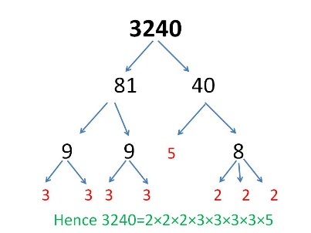
Extension:
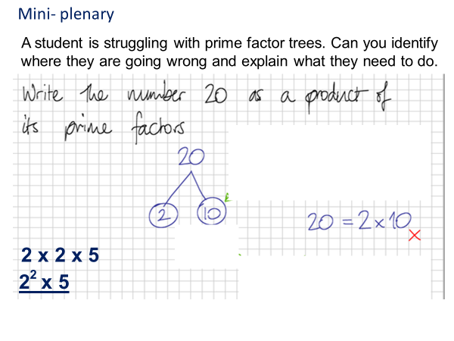

REASONING STAGE:
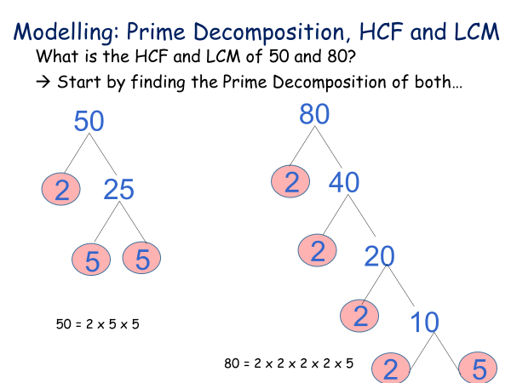

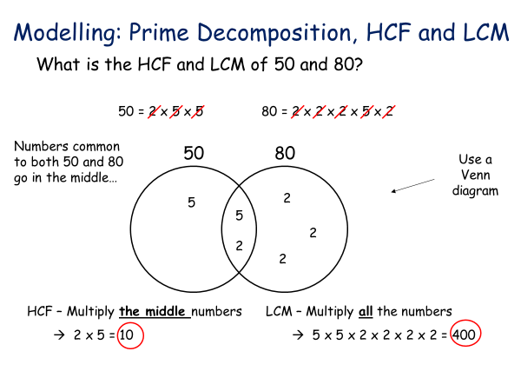
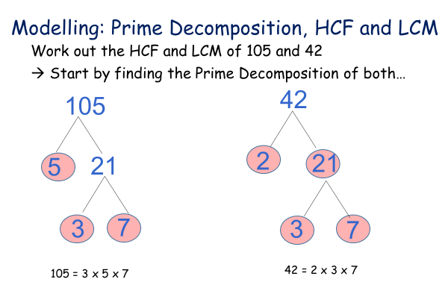
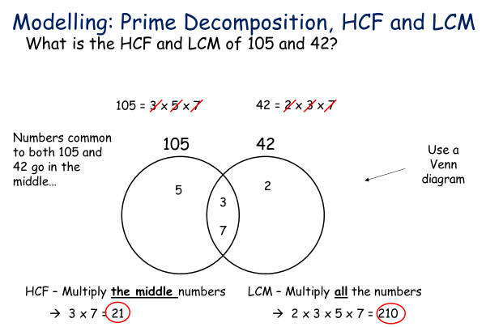
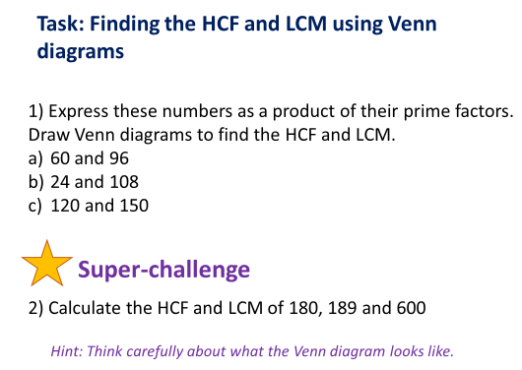

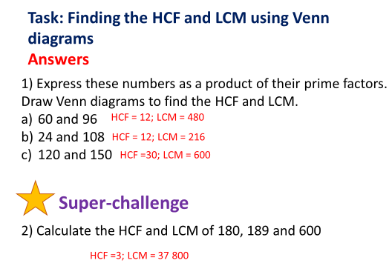
Mini-Plenary
Discuss: What have we learnt about HCF, LCM & Prime Factors?

~ ~ ~ ~ ~

PROBLEM SOLVING STAGE

See next 2 pages

~ ~ ~ ~ ~

PROBLEM SOLVING STAGE - Factors: Expected
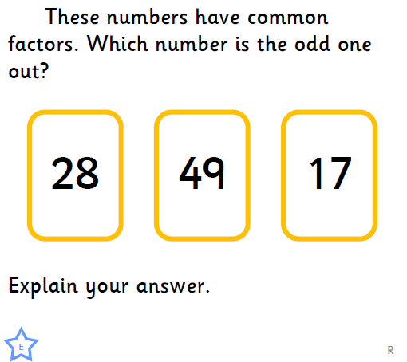 | 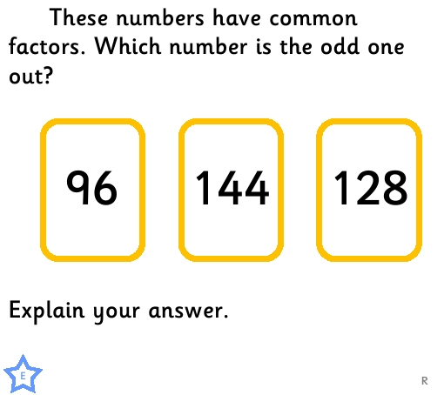
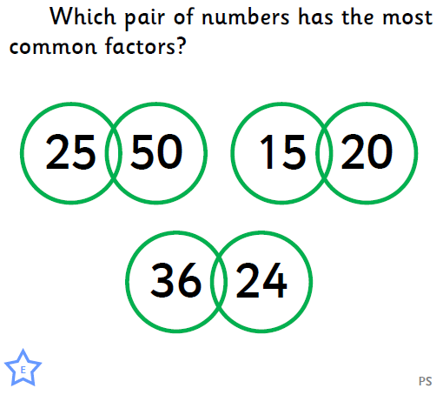 | 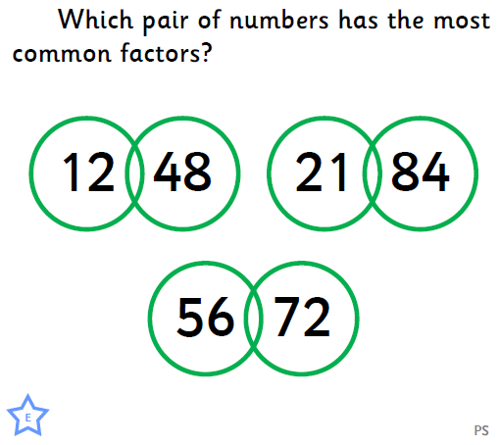
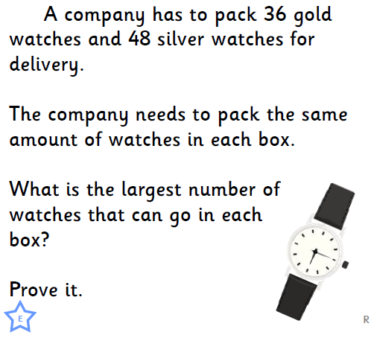 | 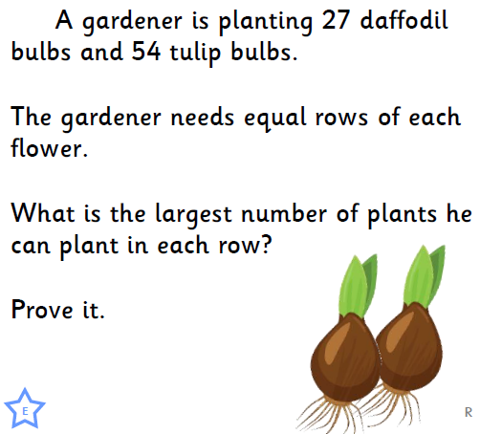

PROBLEM SOLVING STAGE - Factors: Greater Depth
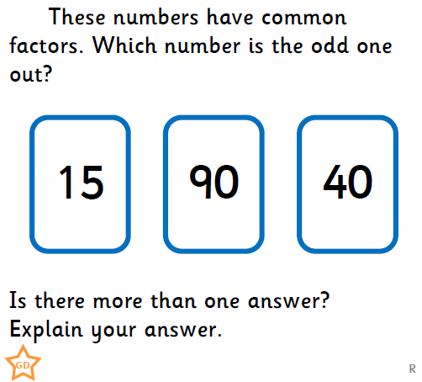 | 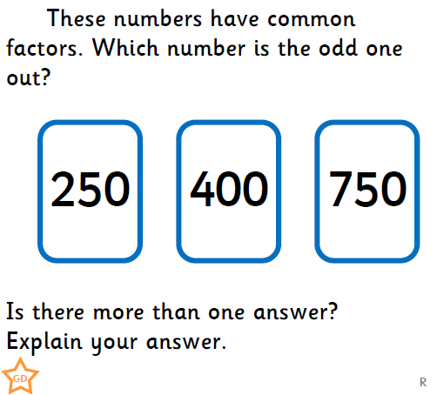
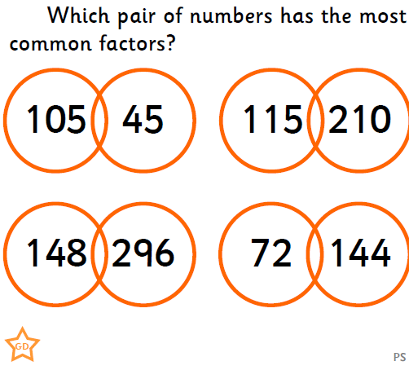 | 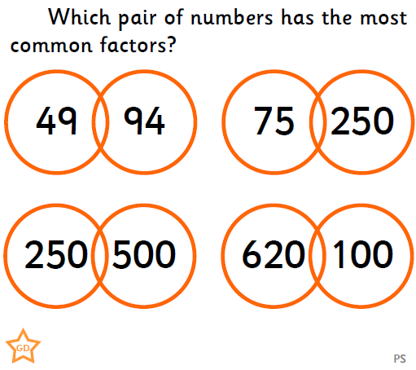
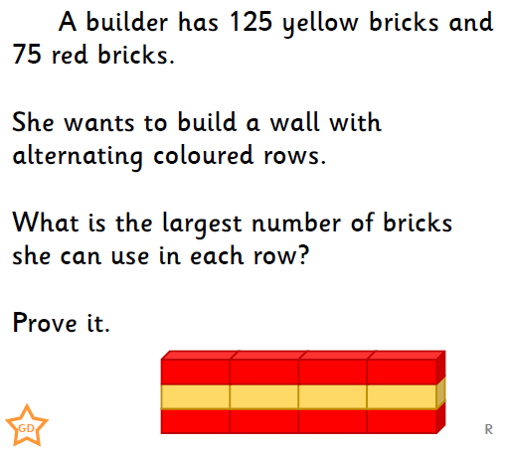 | 