Hello Year 1, we hope that you’re all well and enjoying your Summer holidays. We all agree that you’ve certainly earned a break and hope that you are finding time to relax and recharge ready for September.
As we are continuing to set work for you all over the holidays, please make sure you also concentrate on your reading. You should be reading for ten minutes everyday and hopefully enjoying the stories that you choose. If you have run out of books, the library on Green Street is a fantastic local resource.

English

Diary writing

Please do try to keep your diaries going over the summer holidays. One day you will be able to look back fondly on what you have written. This week think about your feelings about going back to school in September. Try to answer the following questions about how you feel about going into Year 2:
- Are you excited or nervous?
- What are you most looking forward to?
- What subject have you missed the most?
- Who can you absolutely not wait to see?
- What do you think about your new teacher?
- What subject do you think you’ll find hardest?

Reading comprehension

Read the following short story and have a go at answering the questions about it. When you’ve finished, you can create an illustration to compliment the tale.

A New Pet

Tom was six. He lived in a flat with his Mum. The flat was on the top floor. It was very high up!
One day, Tom said to his Mum, “Mum, can I have a dog?”
But Mum shook her head and said, “No Tom, you can’t have a dog. There are no dogs allowed in a flat.”
Tom wanted to cry. Then he said, “Mum, can I have a cat?”
But Mum shook her head and said “No Tom, you can’t have a cat. There are no cats allowed in a flat.”
Now Tom did start to cry, “I want my own pet!” he shouted.
Mum patted Tom on the back and gave him a kiss, “Don’t cry Tom, I will see what I can do.”
The next day, when Tom got home from school, there was a small cage on the table. Tom was excited! He ran to look in the cage. In the cage was an orange hamster! Mum put the hamster in Tom’s hands.
Tom smiled and said, “I will call it Rusty. Thank you, Mum!”

Questions.

Please answer in full sentences.

- How old is Tom?
- Where does Tom live?
- What pets did Tom want?
- How does Tom feel when Mum says “No?” How do you know this?
- How does Mum try to make Tom feel better?
- Why was Tom excited when he saw a cage on the table?
- What was in the cage?
- Why did Tom call his pet, ‘Rusty?’
- How do you know Tom is happy about his new pet?
- Do you have a pet or would you like one? What kind of pet?

Spellings

Copy out and learn the following sellings as many times as you need to. Take it slowly and concentrate on your handwriting whilst you are doing this. Try to join some of the letters together if you can. Once you’re confident that you’ve learned the spellings, check your comprehension (understanding of their meaning) by using each word in a sentence. Again, practise your neatest handwriting.

Grammar

Use the list of verbs below to write your own ‘doing’ sentences. You can make them as exciting as you like! If you’re feeling really clever today, try using some adverbs to explain how the verb is taking place i.e. ‘Mr Turner sneezed loudly!’

ran, ate, laughed, jumped, drove, read, skipped, planted, drank, looked

- Jemal ran quickly to catch the bus.

Story time

It’s time to get creative again! You all know the story of ‘The Gruffalo’ and if you need a reminder there are many versions on YouTube to watch. We would like you to use the character of The Gruffalo to create your own story. You can make anything happen, but I have given some ideas below. When you are writing, concentrate on capital letters, clear finger spaces and full stops. Try to create a picture with your words so that your readers can imagine exactly what you are writing about.

In your story, the Gruffalo could:
- Move to London
- Start Shaftesbury Primary School in September
- Have a party with all of his forest friends
- Get stuck up a tree and need help getting down

Maths

Times tables
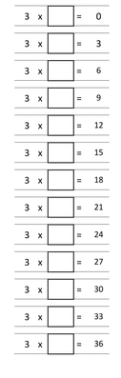
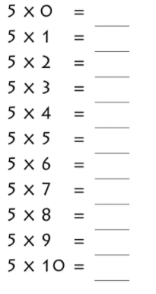

Money

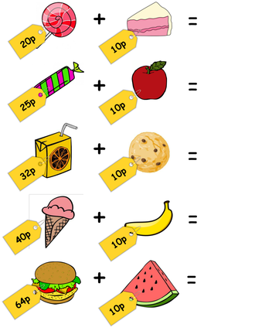

Shape

Name the shape.

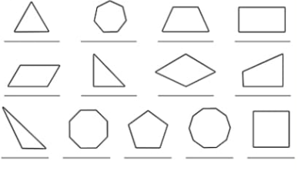
Addition

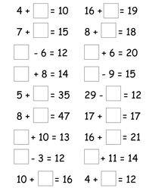

Subtraction

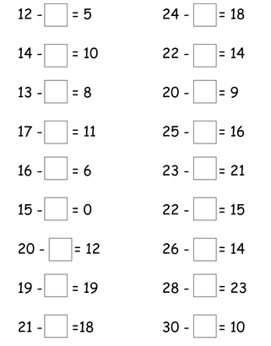
Art

Draw a self portrait. Remember that our eyes are roughly half way down our faces and that the top of your ears should be level with your eyes.

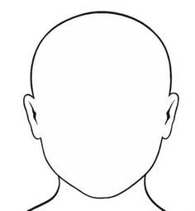

P.E.

If you can, have a look at Joe Wicks’ PE channel on YouTube and join in.

https://www.youtube.com/results?search_query=joe+wicks+pe

How many star jumps can you do in one minute?

Jog on the spot for 2 minutes.

Hold your arms out to the side and draw small circles with your fingertips, keep going until you have to stop.

Lie on your back with your feet in the air. Pretend that you are riding a bike with your feet and legs.

How long can you hold a tin of beans out in front of you with straight arms?

Practise throwing and catching a ball, how many times can you do it before someone drops the ball?

