Happy holidays Year 1! We hope that you are all doing well and enjoying the British summer time weather! Well done to all of you for trying to carry on with your learning throughout the holidays. If you’re finding it tough to work at home or just can’t find the time, don’t worry, but do please make sure that you are reading for enjoyment for a short time everyday.
Keep up the good work and we’ll see you all in September!

English

Diary writing

I hope that you are all enjoying writing a diary. For some of you it may become a lifelong habit that you continue until you’re older than me! Remember, you don’t have to do much in order to write a diary. It could be a record of your thoughts and feelings, or simply your observations of the world around you. If you are lucky enough to go out a lot and visit new places then you should record these events as well. This week try to concentrate on the world around you, start by answering these questions:
- Can you see any animals outside?
- What is the weather like today?
- How many planes can you count in the sky?
- What noises can you hear if you open the window?
- What are the other people in your house doing?

Reading comprehension

Once there was a fish and his name was Tiddler. He wasn’t much to look at, with his plain grey scales. But Tiddler was a fish with a big imagination. He blew small bubbles but he told tall tales.
“Sorry I’m late. I was riding on a seahorse.”
“Sorry I’m later. I was flying with a ray.”
“Sorry I’m late. I was diving with a dolphin.”
Tiddler told a different story every day. At nine o’clock on Monday, Miss Skate called the register. “Little Johnny Dory?” “Yes, Miss Skate.”
“Rabbitfish?” “Yes, Miss.”
“Redfin?” “Yes, Miss.”
“Tiddler? Tiddler? TIDDLER’S LATE!”
“Sorry I’m late. I was swimming round a shipwreck. I swam in to a treasure chest, and someone closed the lid. I bashed and I thrashed till a mermaid let me out again.”
“Oh, no she didn’t.” “OH, YES, SHE DID.”
It’s only a story,” said Rabbitfish and Redfin.
Just a silly story,” said Dragonfish and Dab.
I like Tiddler’s story,” said Little Johnny Dory, And he told it to hi granny, who told it to a crab.
At nine o’clock on Tuesday, Miss Skate called the register.
“Little Johnny Dory?” “Yes Miss.” Sunfish?” “Yes, Miss.” “Tiddler? Tiddler?” “TIDDLER’S LATE!”
“Sorry I’m late, Miss. I set off really early, but on the way to school I was captured by a squid. I wriggled and I struggled till a turtle came and rescued me.” “Oh, no, he didn’t.” “OH, YES, HE DID.

Now, have a go at answering these questions:

What did Tiddler look like?
______________________________________________________________________________________________________
What sort of bubbles did Tiddler blow?
______________________________________________________________________________________________________
What was Tiddler riding on?
______________________________________________________________________________________________________

What did Tiddler do with the dolphin?
______________________________________________________________________________________________________

Who did Tiddler fly with?
______________________________________________________________________________________________________
What did Tiddler do everyday?
______________________________________________________________________________________________________
What time did the teacher call the register?
______________________________________________________________________________________________________
What is the name of Tiddler’s teacher?
______________________________________________________________________________________________________

Spellings

Copy out and learn the following sellings as many times as you need to. Take it slowly and concentrate on your handwriting whilst you are doing this. Try to join some of the letters together if you can. Once you’re confident that you’ve learned the spellings, check your comprehension (understanding of their meaning) by using each word in a sentence. Again, practise your neatest handwriting.

Grammar

Choose an adverb (describes a verb) to describe the verb (doing word).

- Run quickly
- Eat…
- Swim…
- Sing…
- Sleep…
- Drive…
- Cook…
- Think
- Play
- Work

Story illustration.
Do you remember what illustration means? That’s right, drawings. Today I would like you to create an illustration to go with the book that you’ve been reading this week. The illustration should include a picture of the setting from the book (mountains, ocean, forest etc.) and the main characters. If you’re feeling really artistic, you could even try to tell a part of the story through your pictures. Make sure you colour it in when you’re done.
If you haven’t read a book recently (please find a book and start reading it!) then you could illustrate the story of ‘Little Red Riding Hood’ or another favourite fairytale.

Maths

Times tables

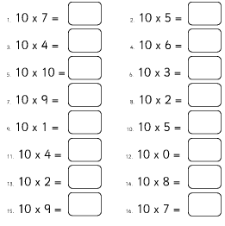

Halving and doubling

- If I half my number I get 2. What is my number?
- If I double my number I get 10. What is my number?
- If I half my number I get six. What is my number?
- If I double my number I get 8. What is my number?
- If I half my number I get eight. What is my number?
- If I double my number I get 22. What is my number?
- If I half my number I get 15. What is my number?
- If I double my number I get twenty-six. What is my number?
- If I half my number I get twenty. What is my number?
- If I double my number I get 100!!! What is my number?

Dividing by two

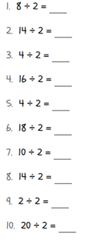

Subtraction on a number line

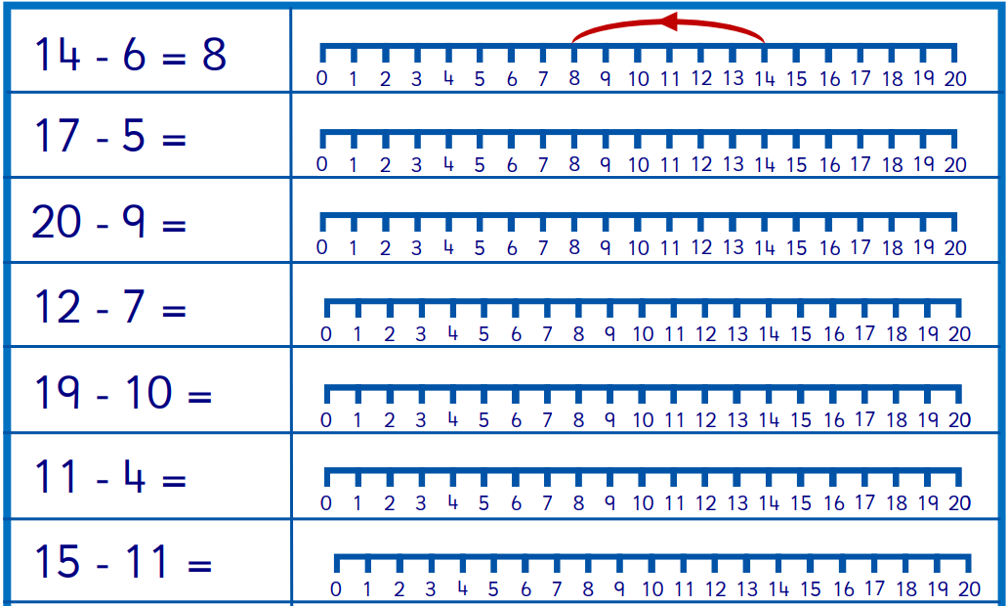

Have a go at creating your own questions:
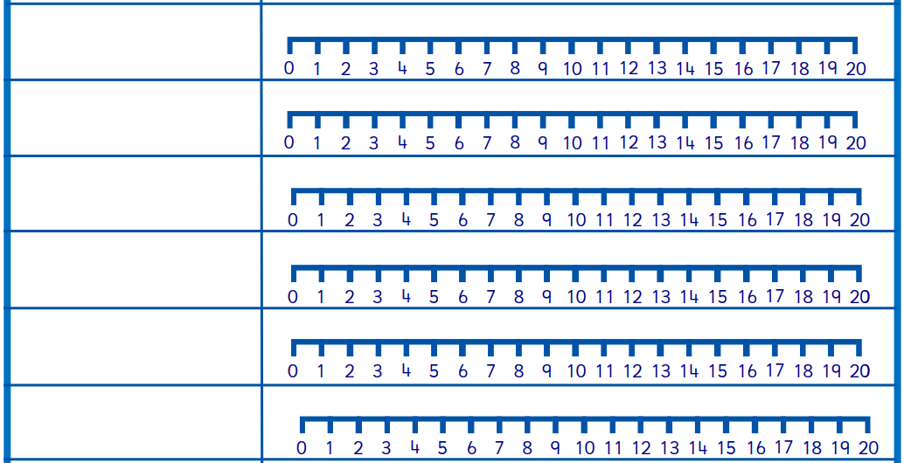

Addition on a number line

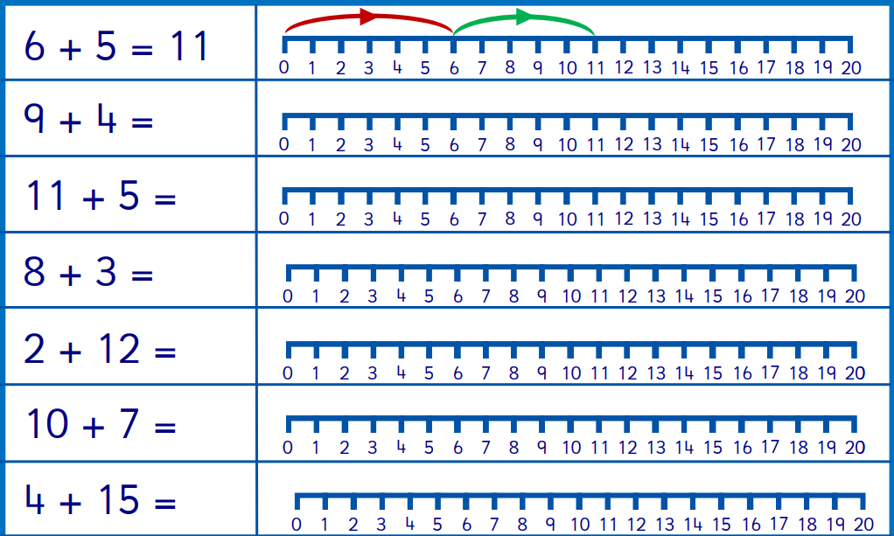

Have a go at your own questions.

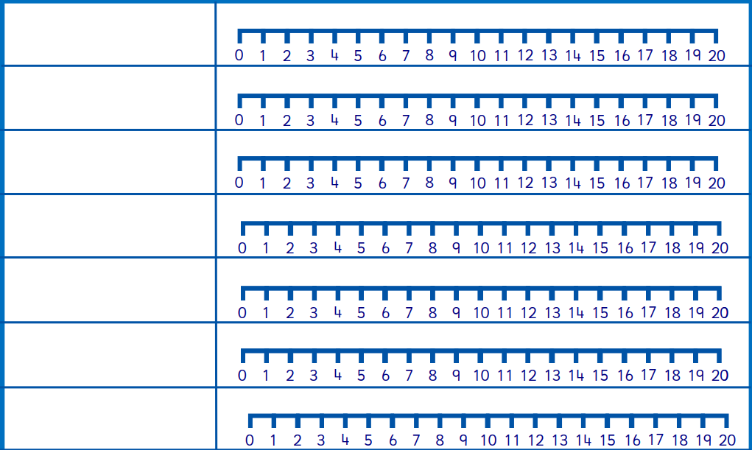

Art

Using leaves, twigs, flowers, conkers, pebbles or anything that you can find on a walk in the park, create a nature collage. I have added some examples below.
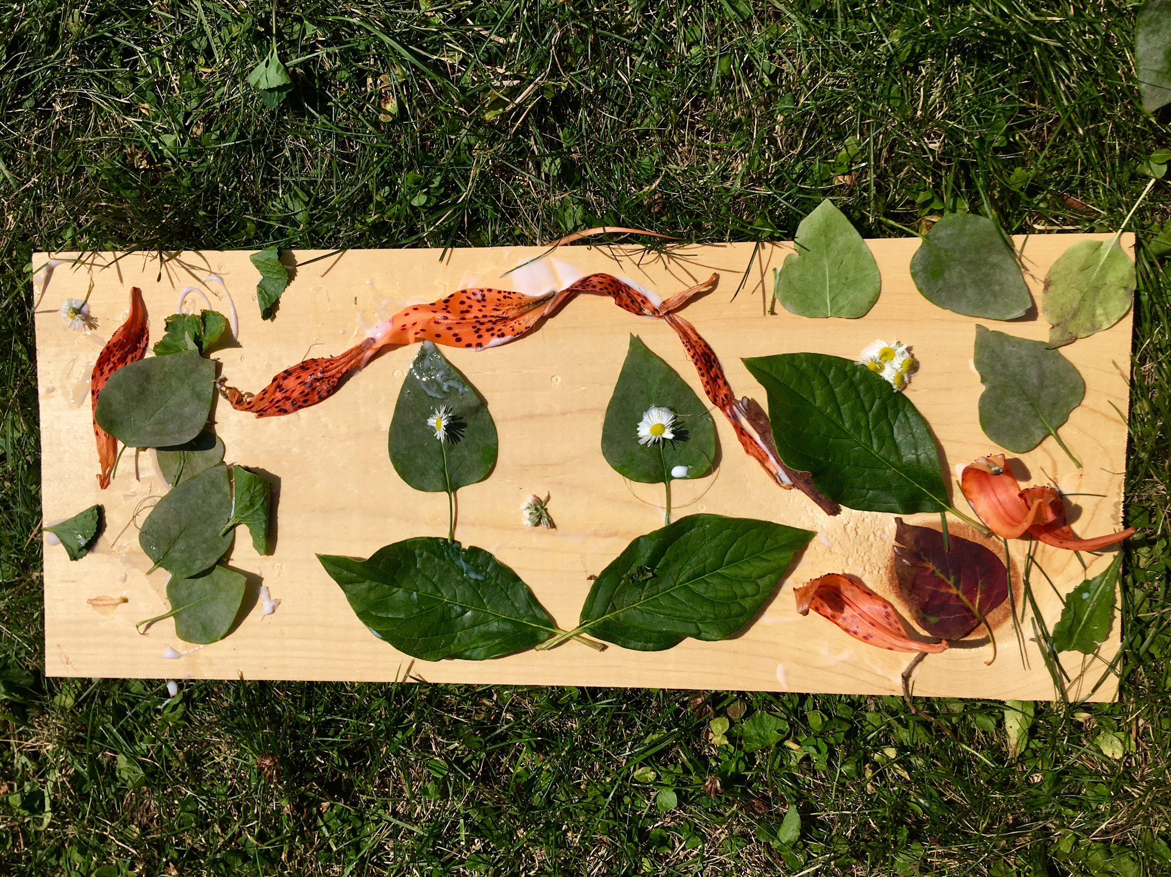
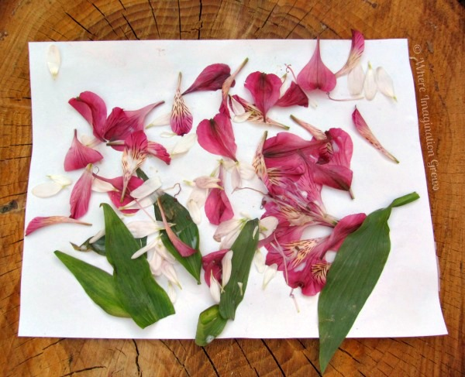
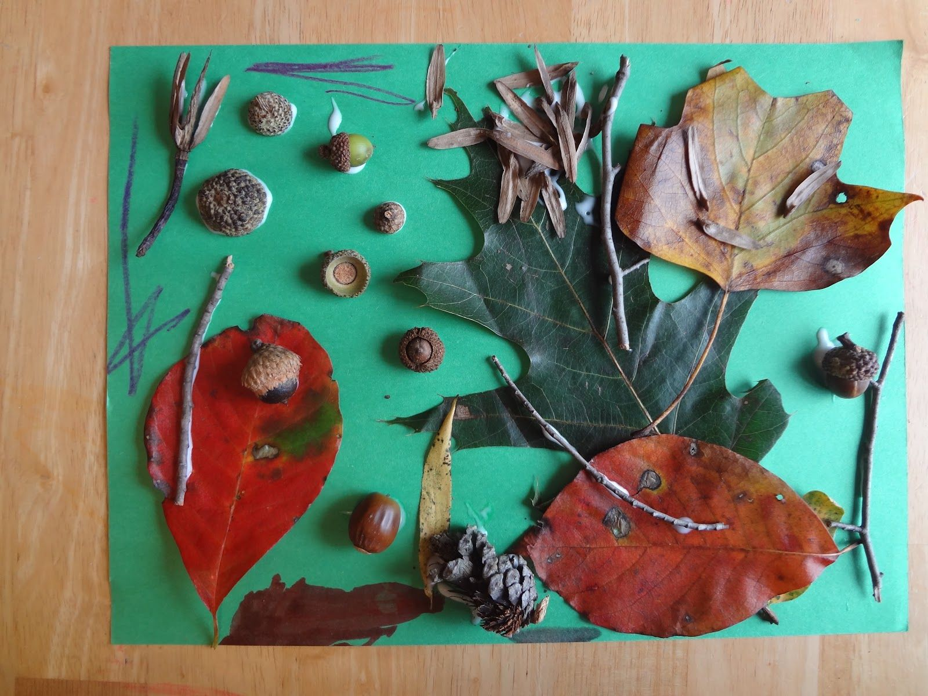

Geography

Can you write a few paragraphs about your local area? What do you notice about your street when you walk to the shop or look out of the window? When you walk to the park or drive out of the area look around carefully and try to build up a picture in your head of what your local area looks like.
In your description, try to answer these questions:
- Is it busy with people or cars?
- Are there lots of shops?
- What are most people doing?
- What types of transport can you see?
- What sounds can you hear?
- Are there many trees or green areas?
Once you have written a few short paragraphs, please illustrate your work with a picture of your road or your nearest busy street.

PSHE

Write a letter to your new teacher telling them all about yourself. You should be positive and really talk about all of the great things that you can do, all of the subjects you love learning about at school, what you’ve been doing over the holidays and why you are looking forward to returning to school.
Try to include a little fact file about yourself that includes your name, favourite food, favourite game, favourite subject, most difficult subject and of course a beautiful picture of yourself.

