Year 1
Summer
Week 2

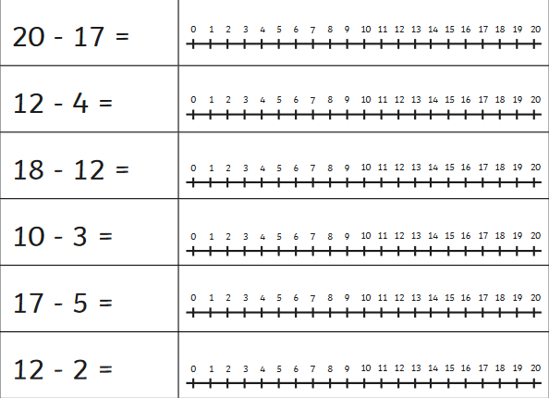
Maths

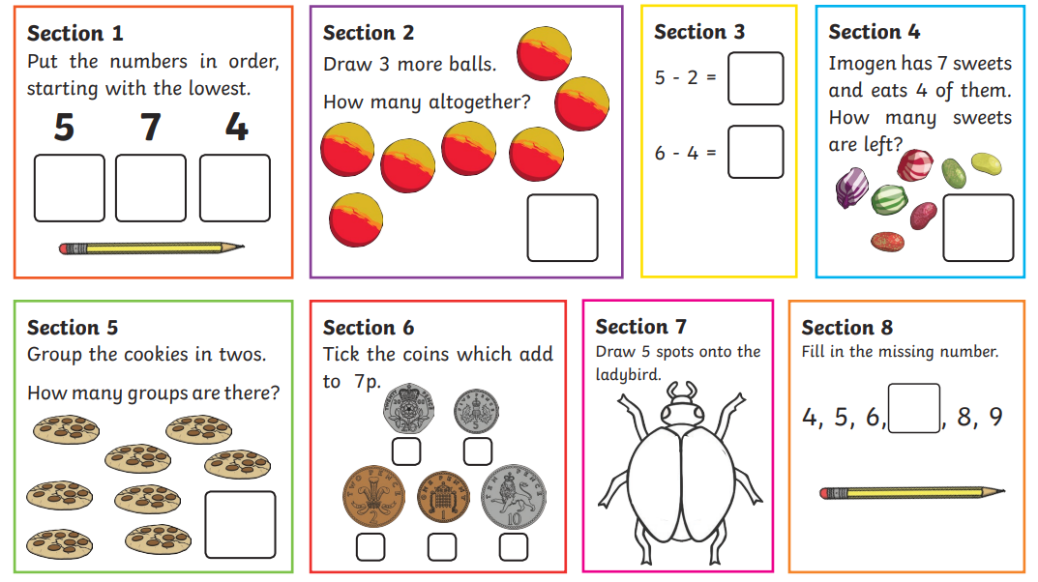

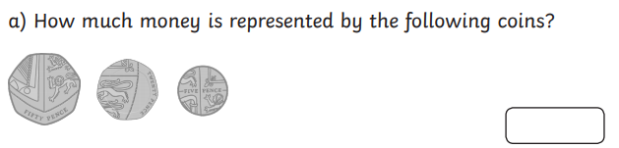
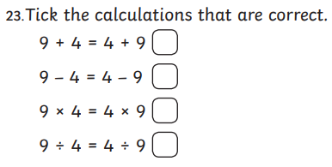

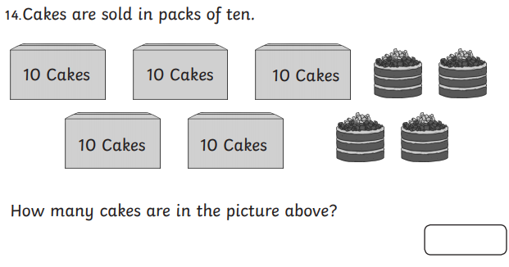
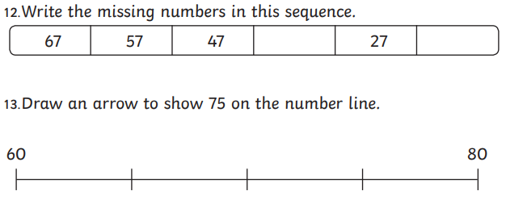
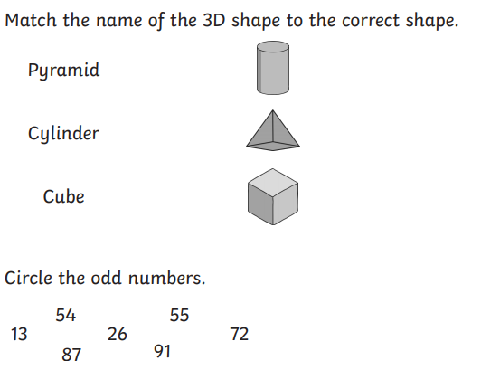
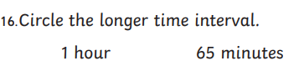
Complete the sequences:

2, 4, 6, 8, ____, 12, ____, 16, 18 ______

3, ____, 9, 12, _____. 18. 21, _____, 27.

5, 10, 15, ______. 25, ______, 35, 40, _____

100, 90. 80, ______, 60, 50, ______, 30, 20

50, 45, 40, _____, 30, _____ 20, 15, _____, 5.

10, 9, 8, ____, _____. 5 , ____, 3 , 2, ____

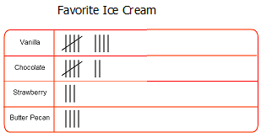

How many people liked vanilla?
___________________________________________
How many people liked chocolate?
___________________________________________
How many people liked strawberry?
___________________________________________
How many people liked Butter Pecan?
___________________________________________

If you doubled the amount of people who liked vanilla, what would the new total be?

1x5 =
5x5 =
10x5=
3x5=
9x5=
11x5=
7x5=
12x5=
2x5=
4x5=
8x5=
6x5=
1x2 =
5x2 =
10x2=
3x2=
9x2=
11x2=
7x2=
12x2=
2x2=
4x2=
8x2=
6x2=
2x10= 2x10= 4x10=
5x10= 11x10= 7x10=
9x10= 1x10=
6x10= 3x10=
12x10= 8x10=

2 + 8 + 2 = ___
3 + 7 + 2 = ___
4 + 6 + 1 = ___
2 + 5 + 3 = ___
6 + 2 + 1 = ___
4 + 6 + 4 = ___
13 + 7 + 6 = ___
11 + 9 + 5 = ___
15 + 5 + 6 = ___
12 + 8 + 8 = ___
13 + 7 + 8 = ___
9 + 11 + 5 = ___
12 + 18 + 15 =___
15 + 15 + 12 =___
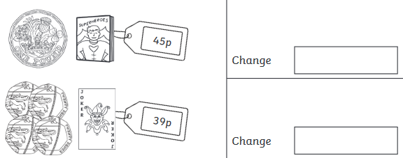
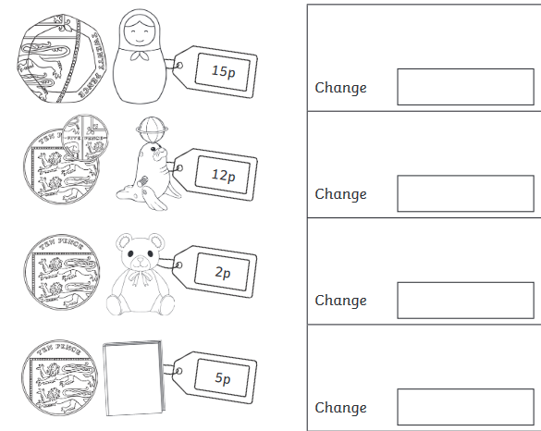
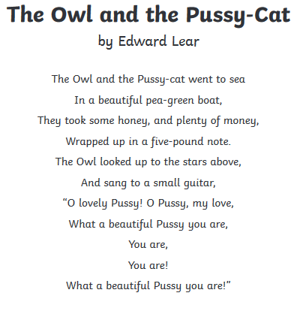
English

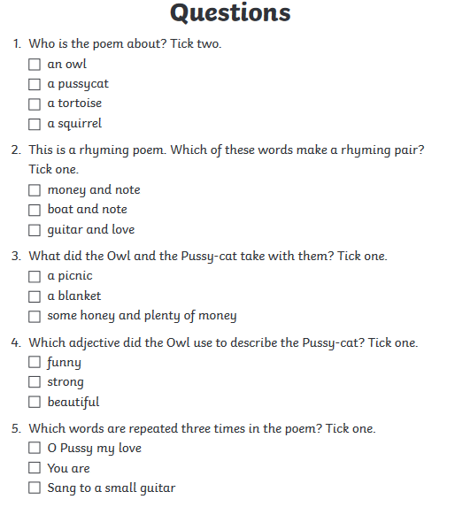
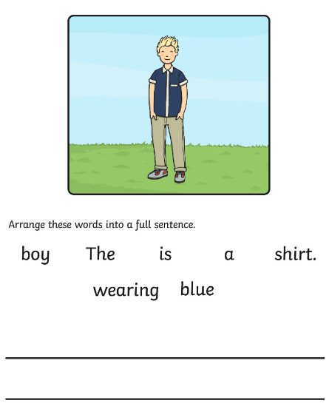

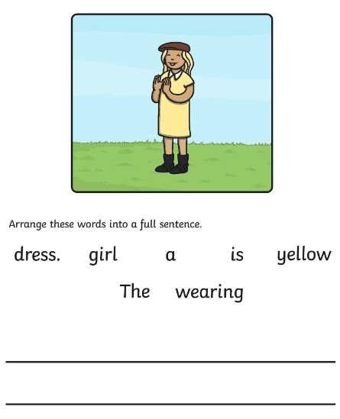

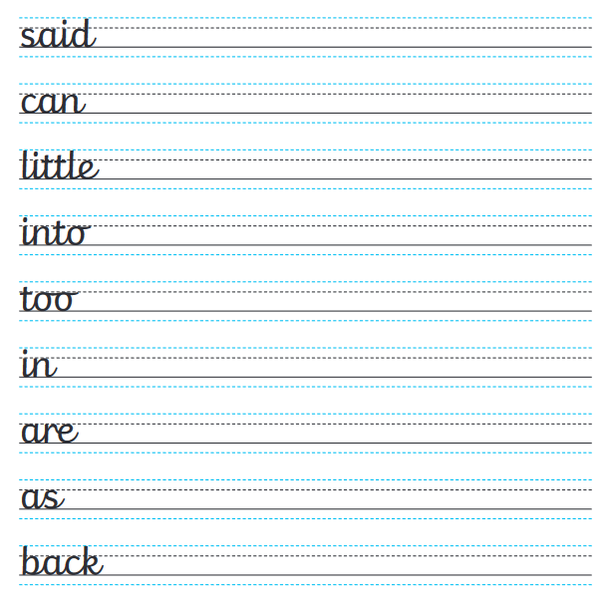
Using the lines below, write a letter to your new teacher explaining who you are, what you like to do, what your family is like and anything else you would like to tell them!
History
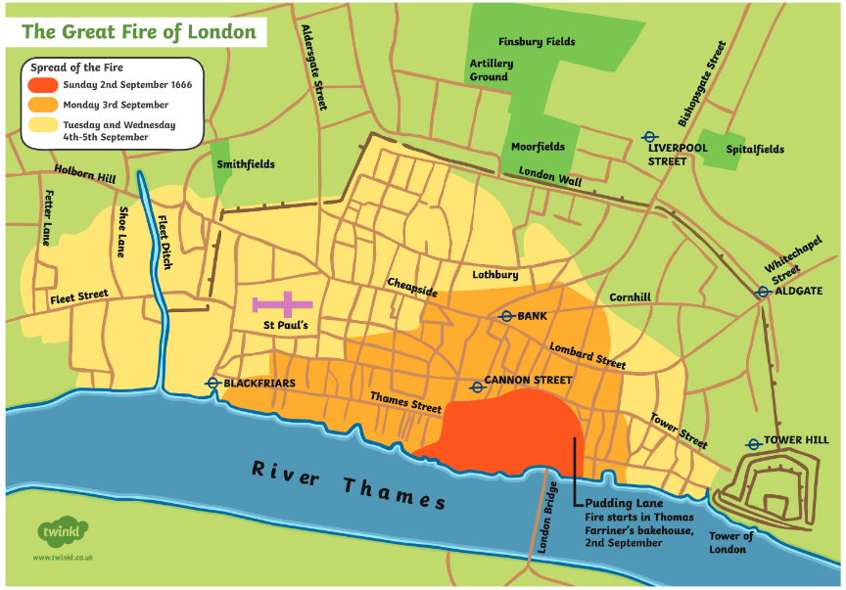

Look at the map above. Can you figure out what it is showing us? Explain what the map tells us and how the city of London looks different compared to today.

_________________________________________________________________________________________________________________________________________________________________________________________________________________________________________________________________________________
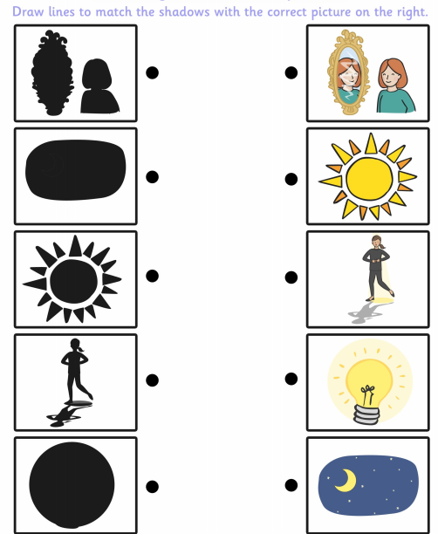
Science
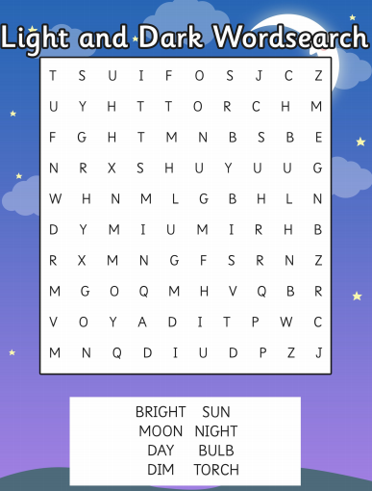
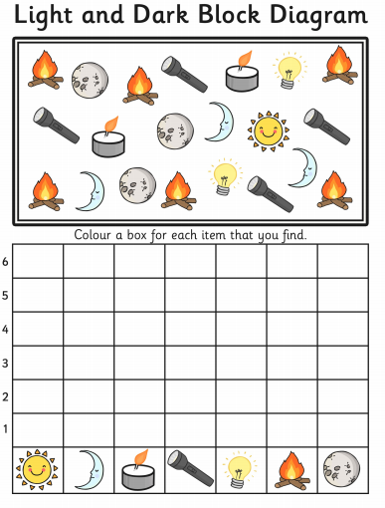
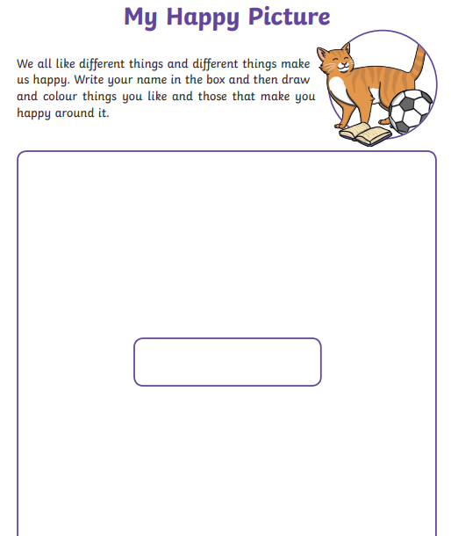
PSHE

