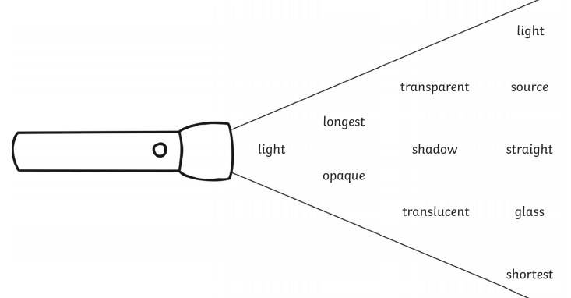

Light travels in __________________________ lines from a ____________________ of light, which bounces off an object.
We can see the object, because the ______________________ enters our eyes.
Wood and cardboard are __________________________ objects, which light cannot travel through.
__________________ is a _______________________ material, which allows light to pass through.
When an object blocks out the light, a ___________________ is formed.
Shadows are ______________________ at midday and ____________________ at the end of the day.
Challenge:
Can you explain the relationship between light and heat?

