**Year 1 Summer Pack week 4**

Hello Year 1,

We cannot believe how time flies!

Very soon we will have to call you Year 2!

We are already missing you so much!

Try to have lots and lots of fun before the school starts again ☺

Year 1 Teachers

**English**

Task 1: **Capital Letters for Names**



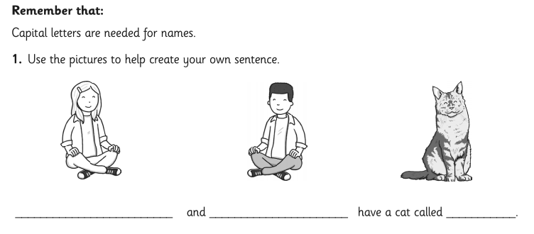

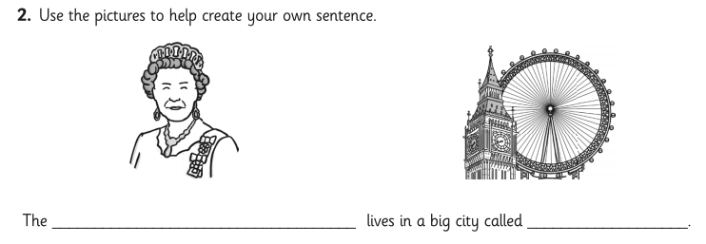 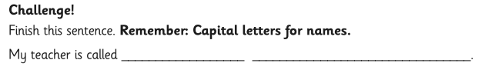

Task 2:



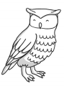 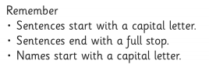

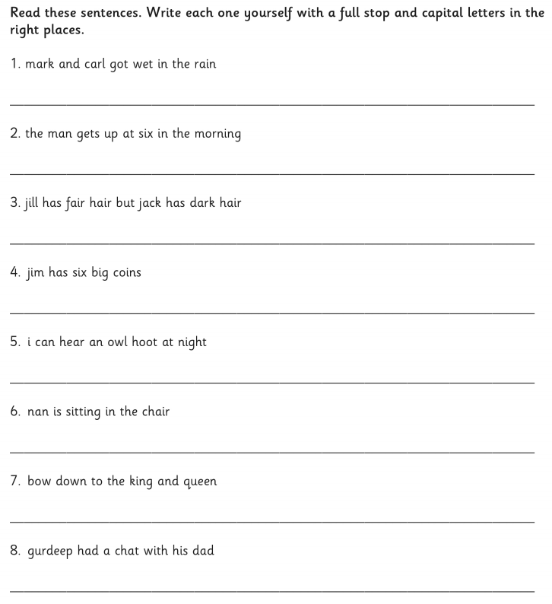

Task 3:





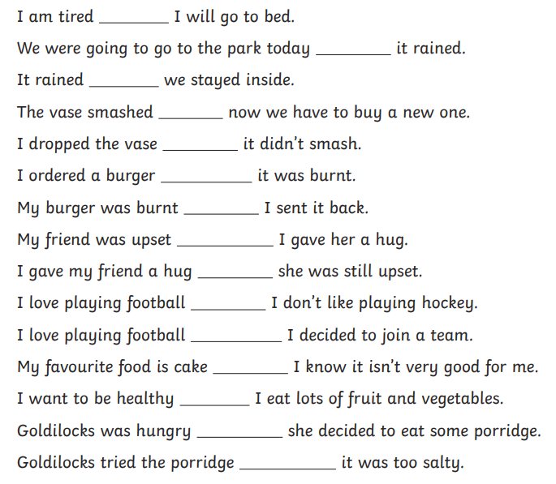

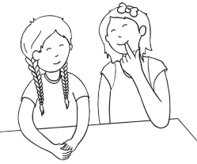

Task 4:



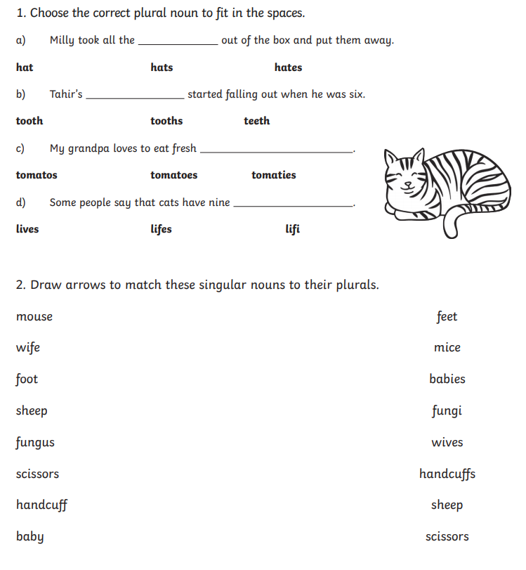

Task 5:



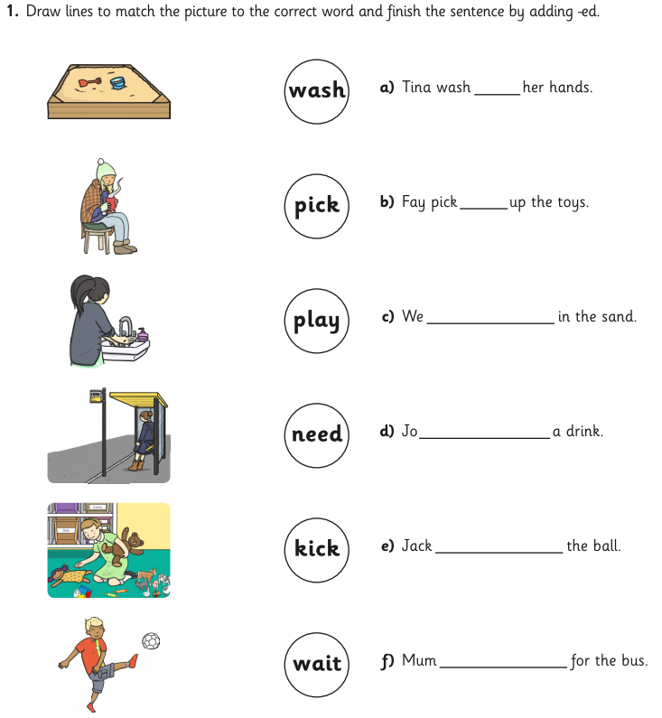

**Maths**

Task 1:



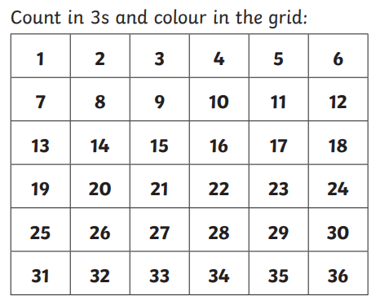

Task 2:

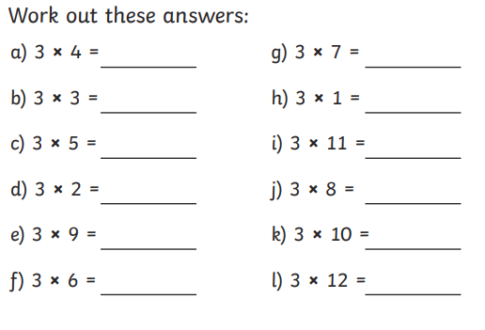

Task 3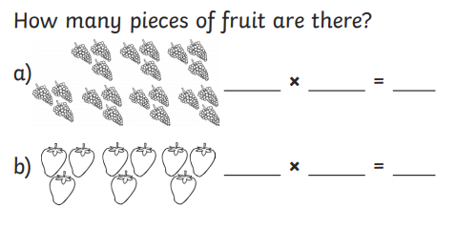 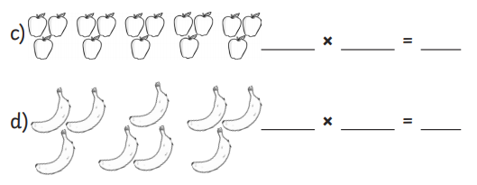

Task 4:



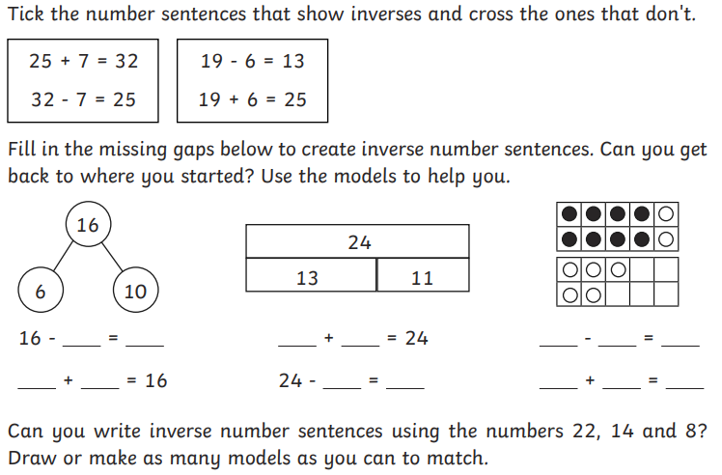

Task 5:



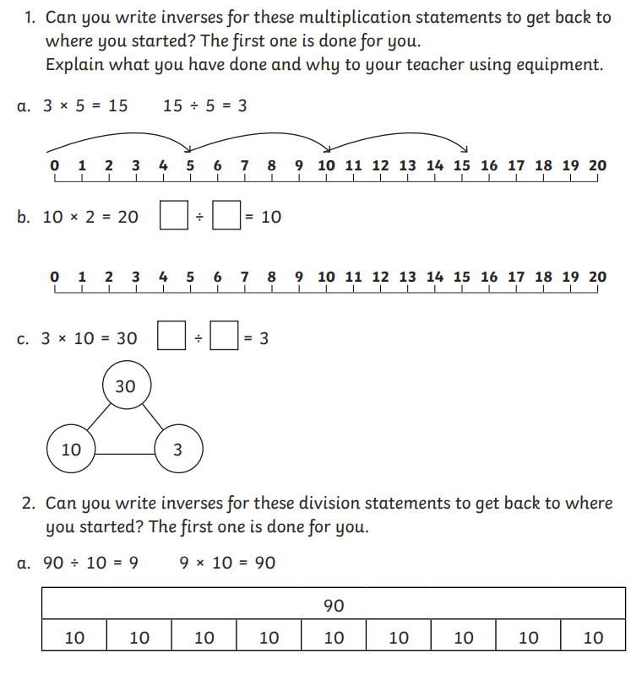

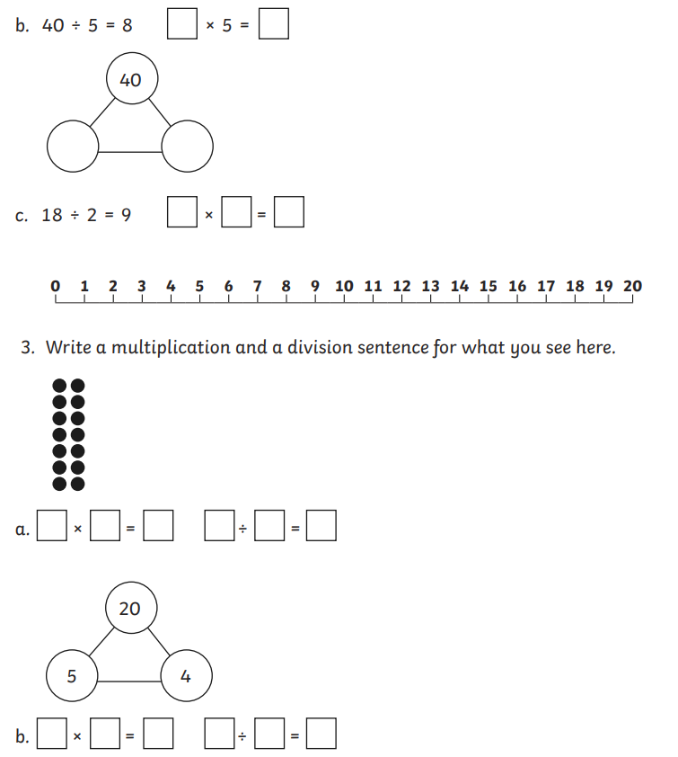

**Science**

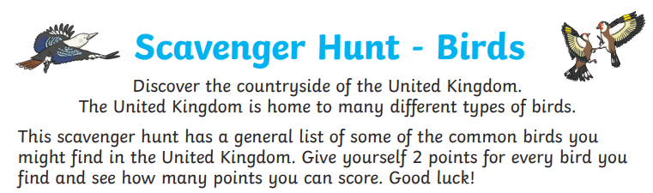

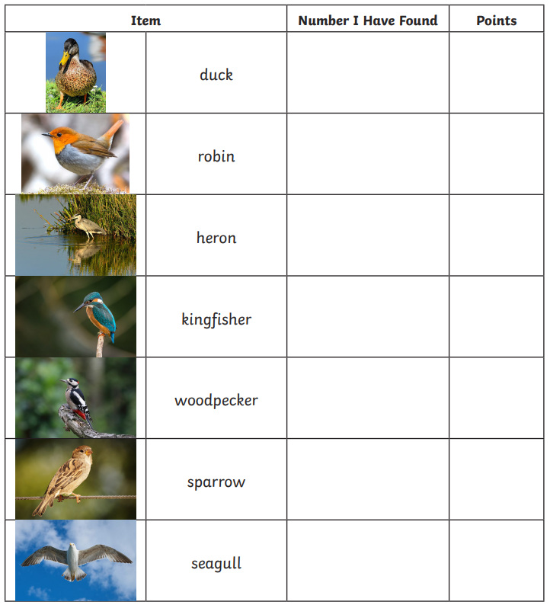 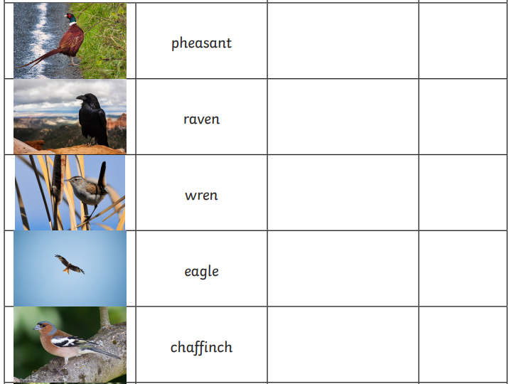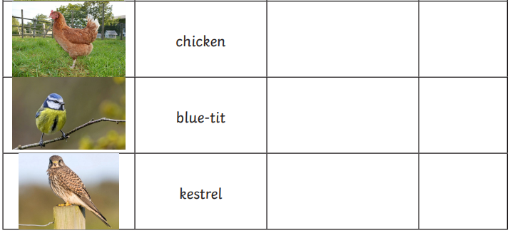 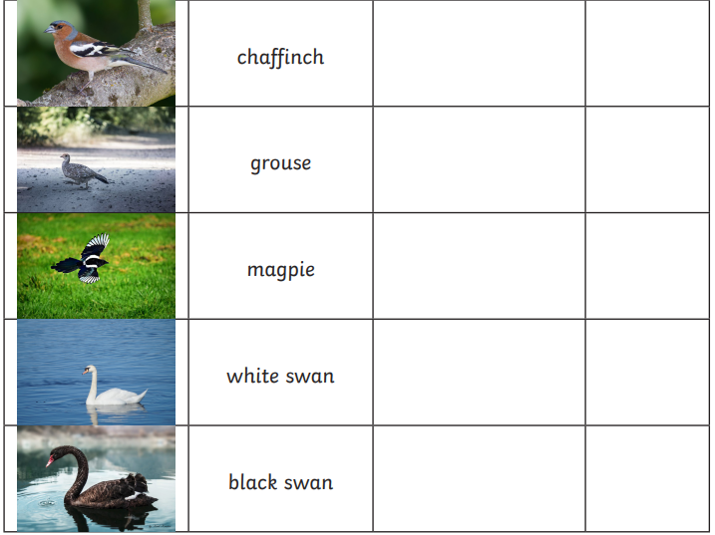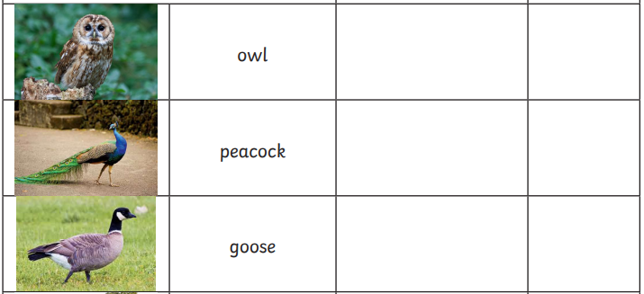

PE

Practise yoga.

<https://www.youtube.com/watch?v=LIBz0IdOFiQ>

then clap your hands and stamp your feet <https://www.youtube.com/watch?v=gtlxZiRprtY>

History

Can you sort out these toys by placing them into the correct table?

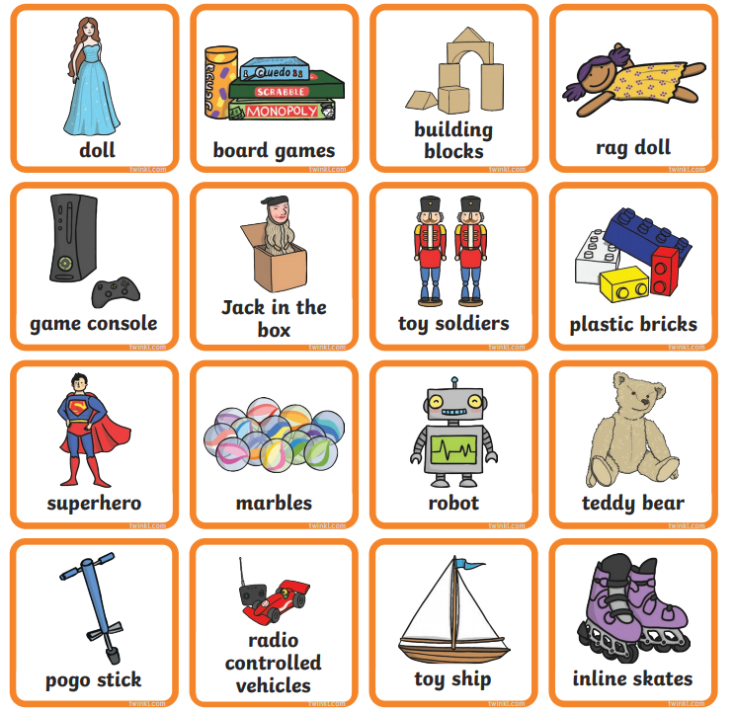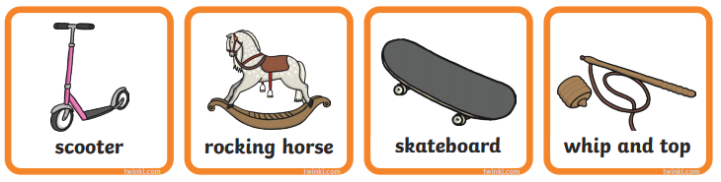

|  |  |
| --- | --- |
| **Old toys** | **New toys** |
|  |  |

**Art/DT**

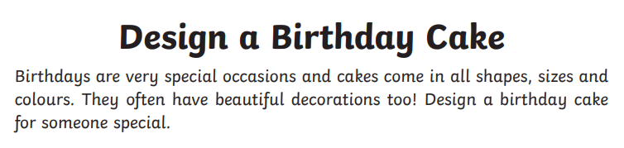

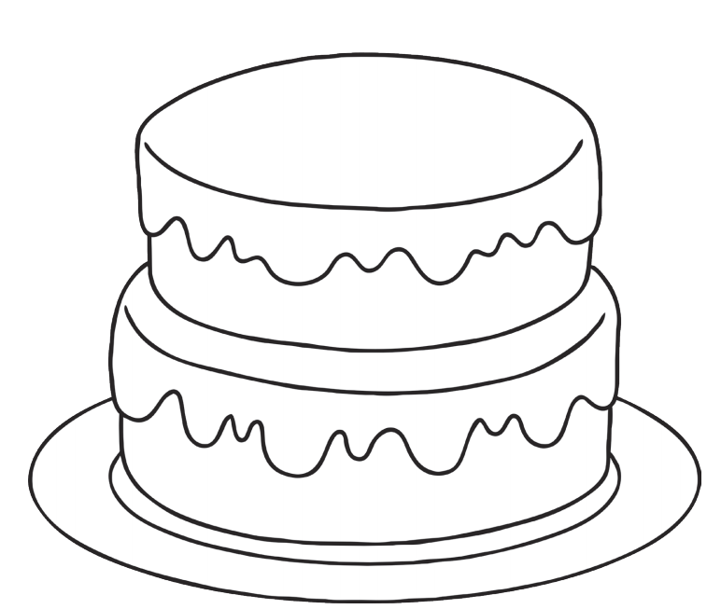

**Geography**

**Task 1:**

Can you label all the continents correctly?

Do you remember the song you have learnt previously?

<https://www.youtube.com/watch?v=K6DSMZ8b3LE>

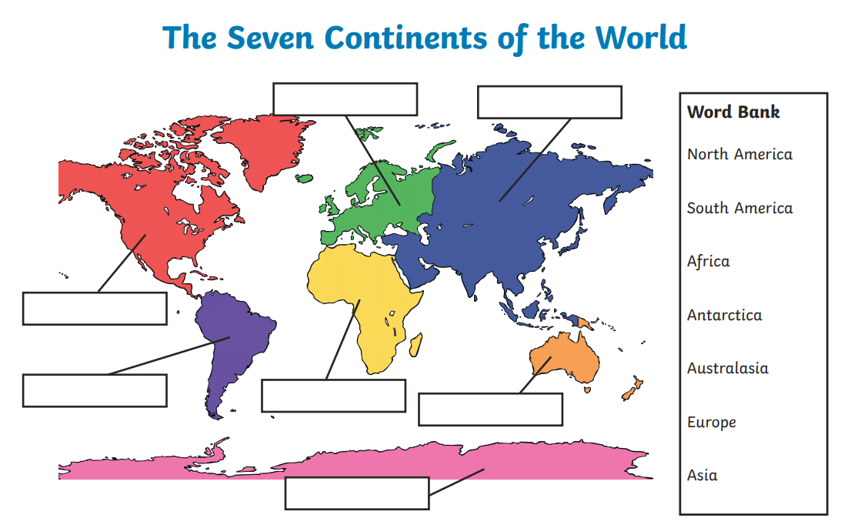

**Task 2:**

**Compass Directions Game**

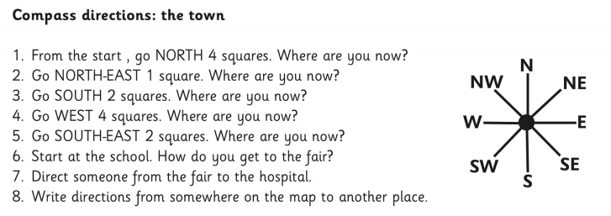

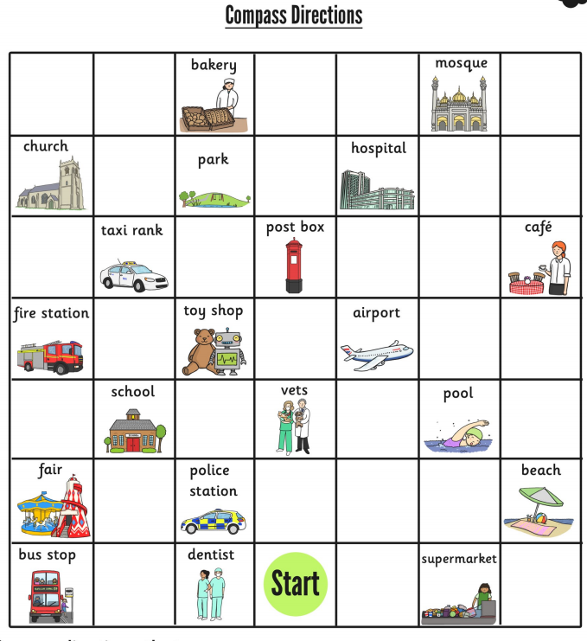

**RE:**



