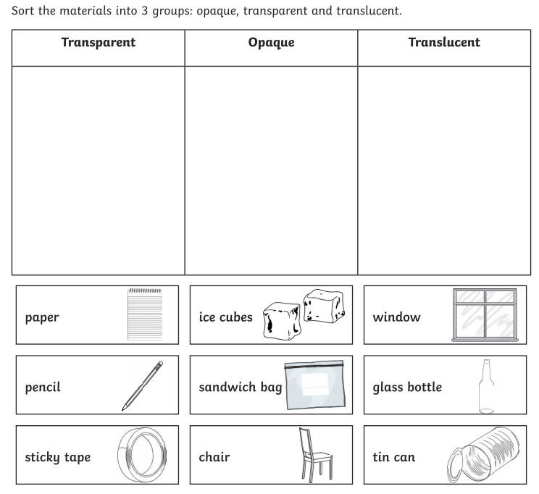
Challenge:
What is the brightest light on Earth?

