Friday 3rd April 2020

To my amazing pupils in class 1G,

It has only been a couple of weeks, but I miss you already! I know it must be very confusing to suddenly do all your learning at home, but I am sure you are doing so well with the support from your lovely family members. How do I know that? It’s easy peasy! It’s because I know that you all are very smart, ambitious, hardworking and you have always made me proud.
Here’s a little reminder of what is most important:
- Making mistakes is a good thing! We are learning from our mistakes. (Do not use eraser 😉)
- It’s ok not to know something! All you have to do is ask for help.
- Last but not least- Don’t ever give up and always try your best!
Why not use this time wisely in the most pleasant way and do some reading? How about writing a lovely book review? Some of you have already produced some fantastic ones!
Also, don’t forget about being creative and passionate. Follow your interests and dreams! Cook, dance, paint, sing, build, or learn something new!
Tie your shoelaces, make muffins or design a superfast vehicle!
Take some pictures too, so when we get together again, we can share them with our class or your parents can email it to the school.
Eat healthy, do some exercise and stay safe.
Your sincerely,
Miss G
P.s. I nearly forgot! (Clumsy me 😊)
Thank you all for the fantastic work you are doing on Purple Mash (you can find your login details at the back of your purple Reading Diary. If you can’t find them, please contact the school and you will be provided with them).
I am checking your work each day and I am extremely happy to see all the efforts you have been putting in! Check for my comments, stickers and trophies that I have awarded you with! Some of your works are even on the display board!
If you have taken any pictures of any exciting activities you have done at home so far and would like to share them with me, please e-mail them to school! I would love to see what you guys have been up to!
Now, if you happen to wonder what I have been up to…well, I was trying to decorate my Easter basket last night, but guess what stopped me?...
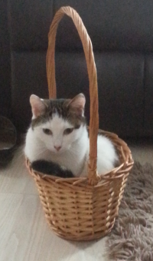 My beloved cat Chica!

