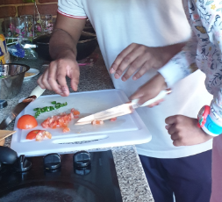
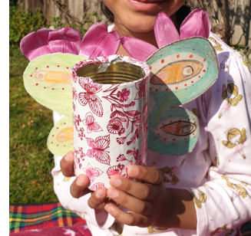
Dear year 1!
I hope you are having lots of fun at home and are enjoying time with your families. Us year 1 teachers have been so impressed with the work we have seen on purple mash and the work that has been emailed to us. You are doing so well! We are giving you some extra challenges this week to work through, remember to ask your parents for help if you need it. To answer the questions you need to watch the storytelling videos!
Don’t forget to keep up with Joe Wick’s PE workouts at 9am on YouTube Monday-Fridays! Get that heart beating! We all need to stay happy and healthy to keep our bodies strong.
Good luck with these activities, we can’t wait to see what you’ve done
Year 1

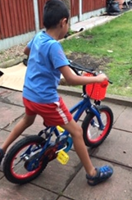
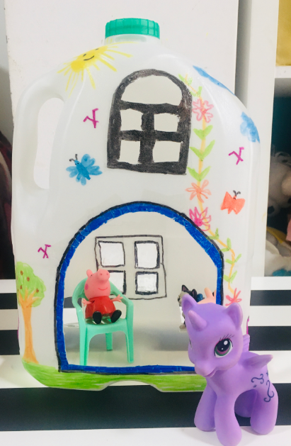
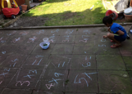
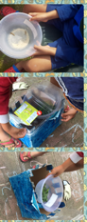
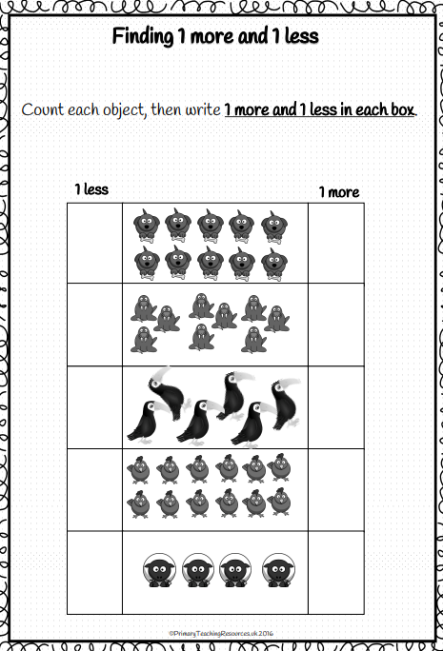
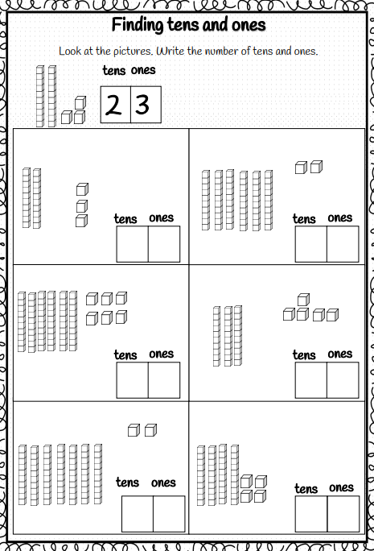
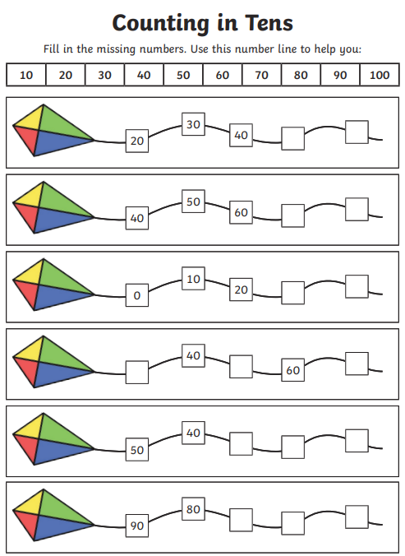
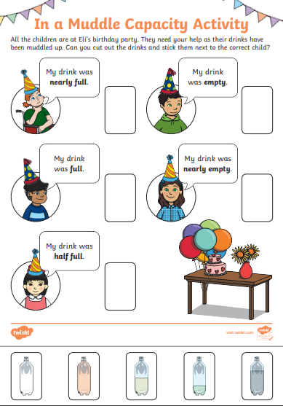

KS1 Mixed tables test
Can you complete it in 5 minutes?
Times table | Inverse
0 x 2 = | 24 2 =
1 x 5 = | 110 10 =
2 x 10 = | 50 5 =
3 x 2 = | 18 2 =
4 x 5 = | 80 10 =
5 x 10 = | 35 5 =
6 x 2 = | 12 2 =
7 x 5 = | 50 10 =
8 x 10 = | 20 5 =
9 x 2 = | 6 2 =
10 x 5 = | 20 10 =
11 x 10 = | 5 2 5 =
12 x 2 = | 0 2 =

The rest of the booklet is based around the storytelling videos you have watched!

If you have not watched the storytelling videos yet, follow the links below to find them!
https://www.youtube.com/watch?v=fweyWViw88M&t=4s
https://www.youtube.com/watch?v=UDxJjB93dj8
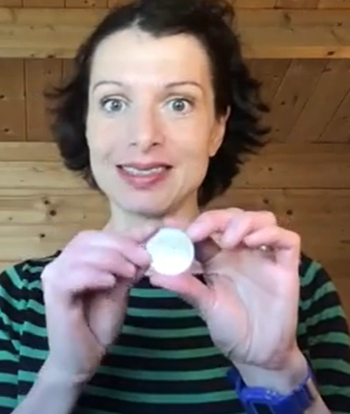
What is the story about?
___________________________________________________________________________________________________________________________
Why is the button called a ‘pearl button’?
____________________________________________________________________________________________________________________________

What was beside the river?
__________________________________________________________________________________________________________________________________________________________
What city is the story set in?
__________________________________________________________________________________________________________________________________________________________

What did the children eat? Did they like it?
__________________________________________________________________________________________________________________________________________________________
What did the grown up boy want to do for the children?
__________________________________________________________________________________________________________________________________________________________

What job did the man have?
__________________________________________________________________________________________________________________________________________________________
What types of fruit were sold in the market?
__________________________________________________________________________________________________________________________________________________________
Where did the man sow the buttons?
__________________________________________________________________________________________________________________________________________________________

Finish the simile – the man’s jacket ‘shone like the __________________’.

Describe what the jacket and hat looks like with as many adjectives as you can!
____________________________________________________________________________________________________________________________________________________________________________________________________________________________________________________________________________________________________________________

Here is an example of people wearing pearly clothing!

In the box opposite, can you draw yourself with your own pearl outfit?!

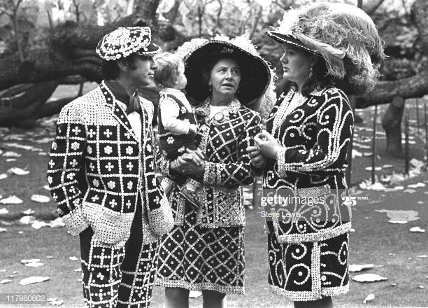

Draw a picture of yourself wearing
a pearl outfit!

The next part of the booklet is about the second story video – The Calabash Boy’.

Where is the story set?
__________________________________________________________________________________________________

What was wrong with the lady? How do you know?
__________________________________________________________________________________________________

What did the calabash boy ask for when he arrived?
____________________________________________________________________________________________________

What other things did the calabash boy help with?
____________________________________________________________________________________________________

What is the name of a baby chicken?
_____________________________________________________________________________________________________

What did the lady do to show she was very happy?
_____________________________________________________________________________________________________

What was wrong with the boys leg?
_____________________________________________________________________________________________________
What happened during the party?
_____________________________________________________________________________________________________

What happened when the lady shouted at the boy?
_____________________________________________________________________________________________________

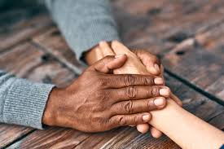
PSHE – Describe what you would do if you upset someone you know like the lady did with the calabash boy.
Here are a few ideas! You could…
-give them a hug
-say sorry
-promise to never do it again
_____________________________________________________________________________________________________________________________
_____________________________________________________________________________________________________________________________
_____________________________________________________________________________________________________________________________

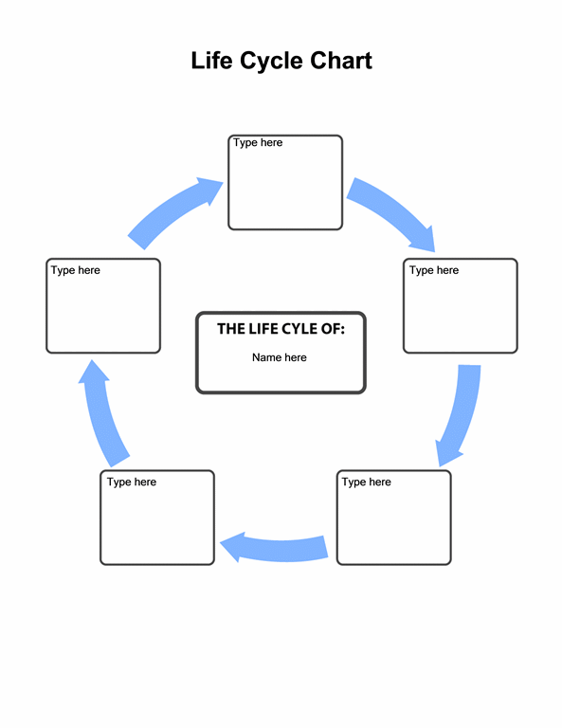
Science
In the story there was a chick. Can you create the life cycle of a chicken?

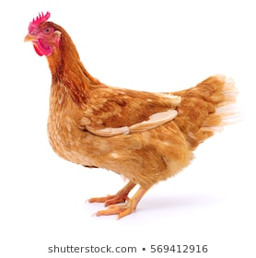

Geography – in the stories there were forests, rivers and mountains.
Can you draw a map of YOUR local area from birds-eye view. It could include: the school, shops, parks, roads and anything that you see in the streets around your house!

Using your map, write directions of how you would get from one place to another! For instance, how you would get from the house to the school.
Key vocabulary:
Left, right, forwards, backwards, road, destination, turn (quarter, half), or the names of the roads if you know them! (walk forwards down Plashet Grove…)

________________________________________________________________________________________________________________________________________________________________________________________________________________________________________________________________________________________________________________________________________________________________________________________________________________________________________________________________________________________________________________________________

RE – in the story, The Calabash Boy, the boy is made by the Gods at the top of the mountain.
Can you name the Gods in the religion of Hinduism? There are some below to help you!
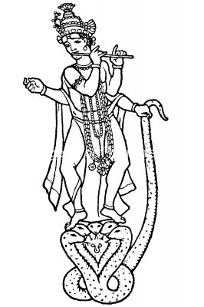
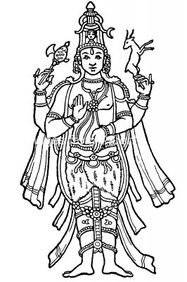
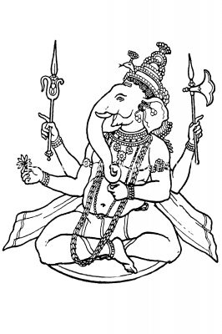
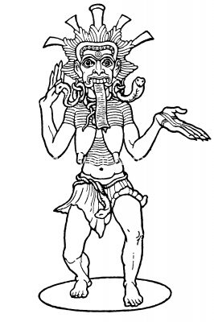
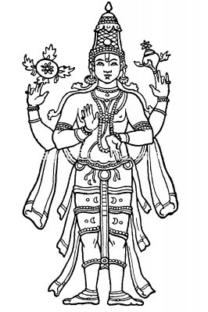
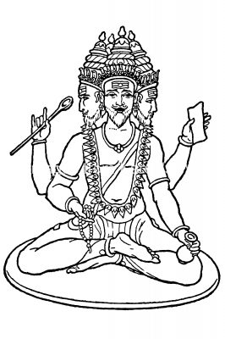

PE – make up your own dance like the one you made in the video!
Make sure your dance has at least 6 different moves in it! You could use some of the moves that you know from TikTok or 5 a day!

Music – Watch the story again and join in as much as you can with all of the noises of the story. What sound does water make? What sound does sweeping make? What sound does happiness make?
Be creative!

History – Think about how fire is made – if you were out in a forest and felt cold or wanted to make some hot food, how could you make a fire without matches? The storyteller did not make a real fire, why?

