Year 1 Summer Pack week 3

Hello Year 1,
Hope you are all enjoying your holidays and having lots of fun!!
It’s important to exercise all our muscles, but we have to remember to keep our brains active too!
Here is your weekly pack of activities.
Take care and stay safe,
Year 1 Teachers

English

Task 1: Once upon a time there was a …
Use your own imagination to write a fantastic story to amaze your friends.
Draw your picture too!

Challenge: Can you circle above all the nouns in red, all the verbs in blue and all adjectives in green?
Task 2: Learn each of these spellings and use them in a sentence.

won’t haven’t wouldn’t couldn’t weren’t wasn’t didn’t

See how many of the words you can use in one sentence, ensuring that it still makes sense.

Task 3: Add an apostrophe to these sentences. Remember, we use an apostrophe when something belongs to someone and when a letter has been missed out to shorten a word. We never use an apostrophe for plural words.

- I havent done the shopping yet.
- He doesnt sing very well.
- My mums cooking is delicious.
- His sisters dog is very cute.
- Lets jump in the puddle.
- It wasnt really spicy.
- We cant go there.
- My cats fur is so soft.
- They are good at football, arent they?
10. Id rather go to the park.

Task 4

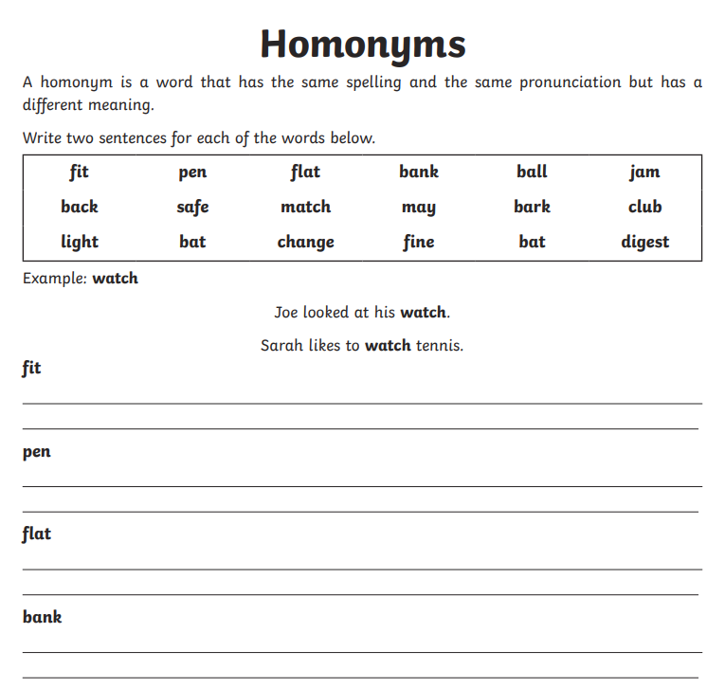
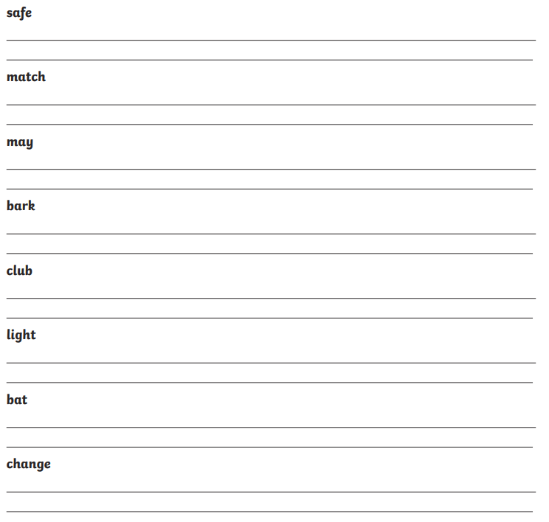

Task 5:

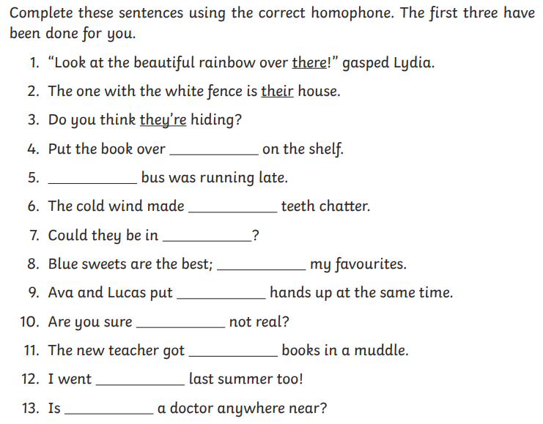

Maths
Task 1:
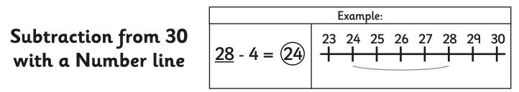

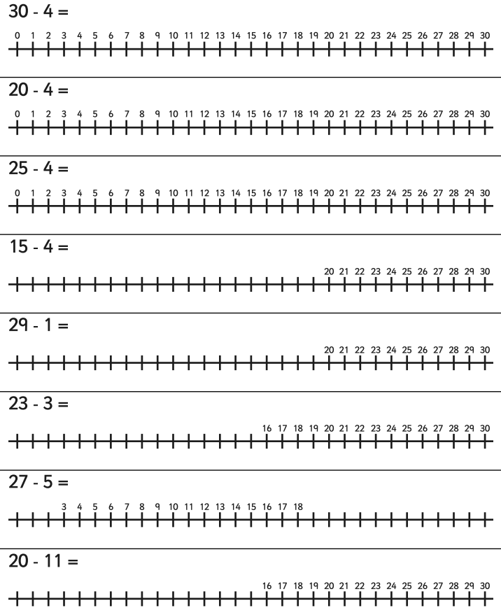

Task 2:
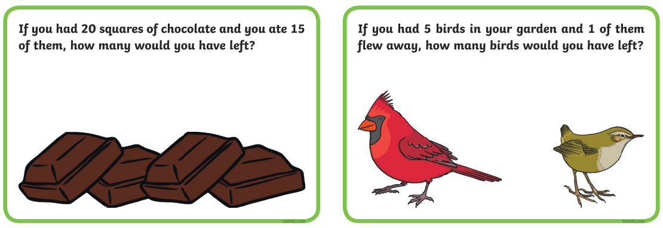
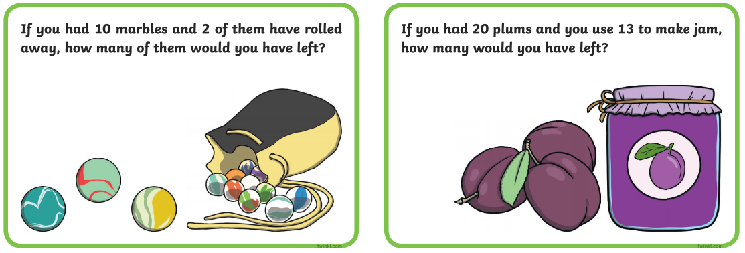
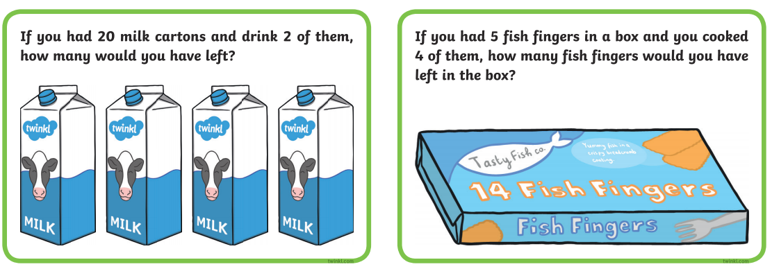
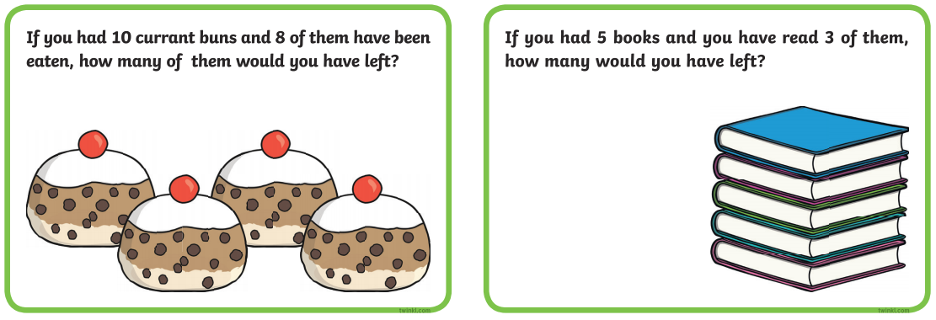

Task 3: Read and colour the fractions.

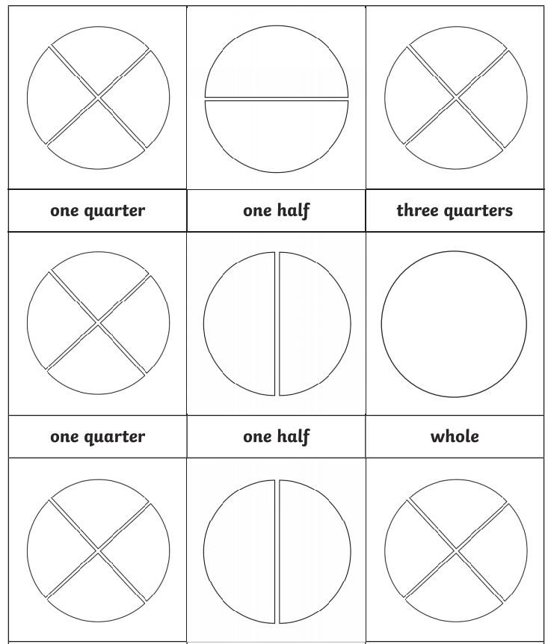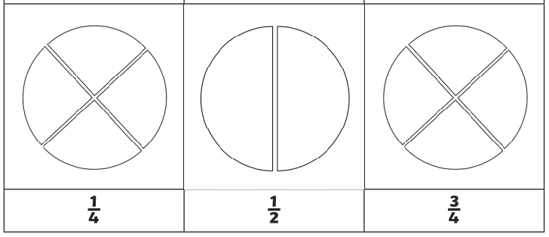
Task 4:
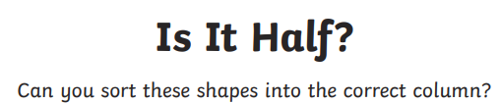

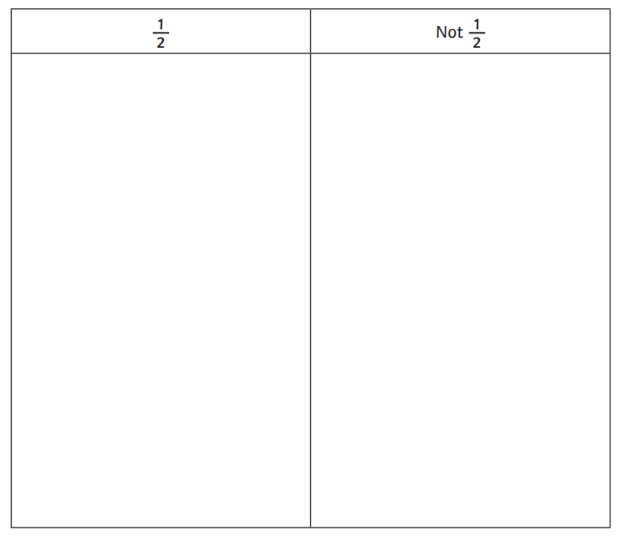

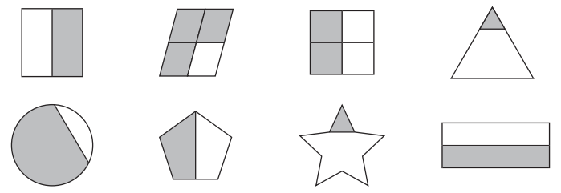
Task 5:

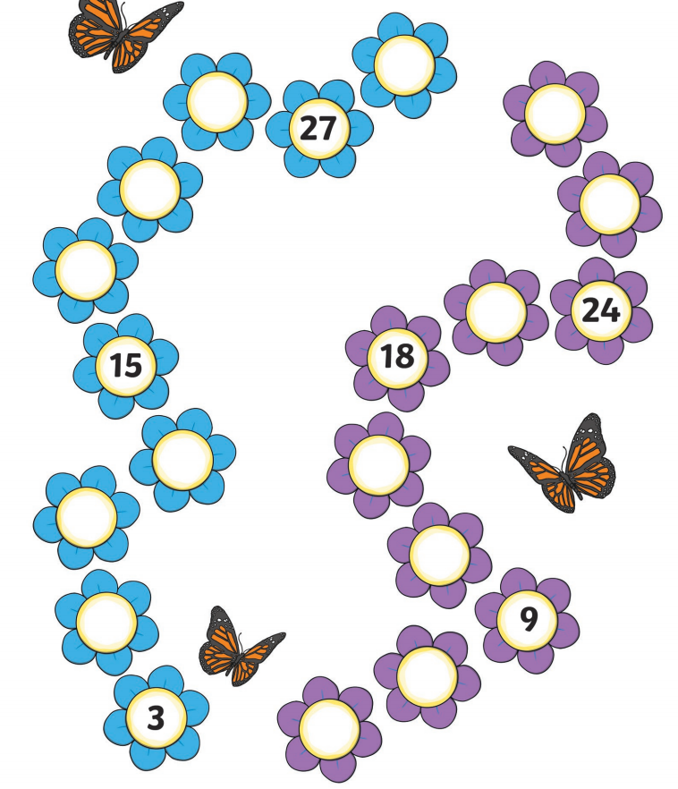

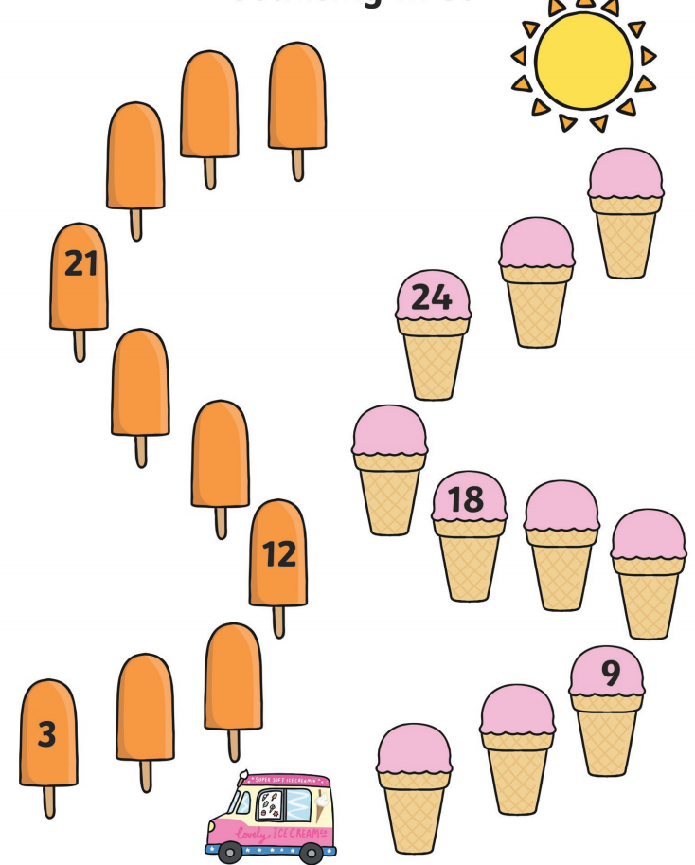
Challenge time!

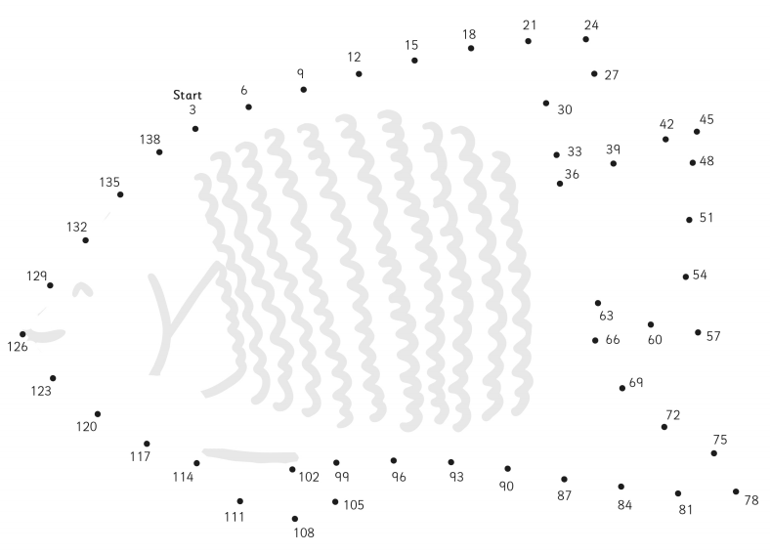

PE
Practise yoga.
https://www.youtube.com/watch?v=xhWDiQRrC1Y

Science

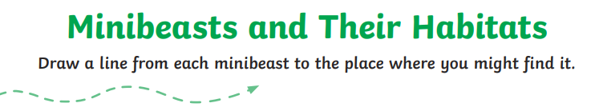

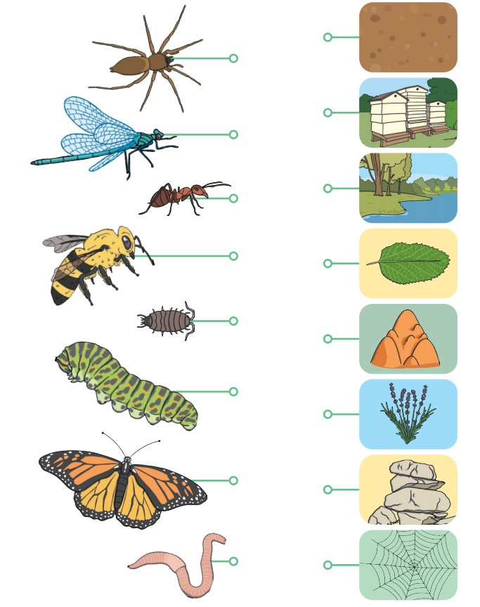
Geography – Local knowledge

London Word Search

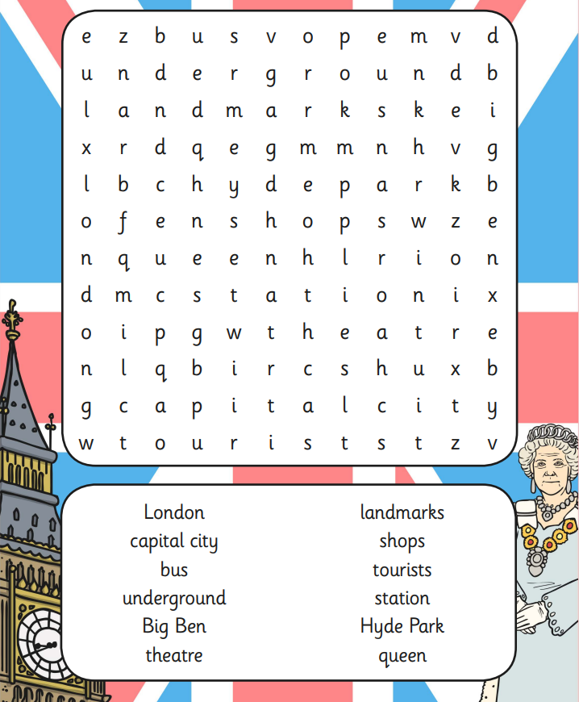
Art

