Year 2 Summer Holiday Homework Pack

Week 4

English- Fact File

Think of a famous person, that you admire for their achievements. It can be an Actor/Actress, Musician, Scientist, Writer and so forth. Once you have chosen your favourite person, you will need to carry out research on them and complete a fact file. Use the template below or create your own one.

Maths- Time
Science- Materials and their Properties
Geography- Kenya

Using the internet or books, research what a Kenyan rural home looks like. You will then need to draw or create a model of it. Be as creative as you like and look for objects around the house to use e.g. cardboard, tissue roll, newspaper. You can even use grass from the garden!

Below are some pictures of Kenyan rural homes.

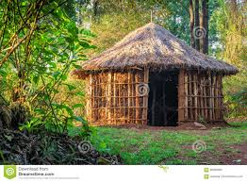
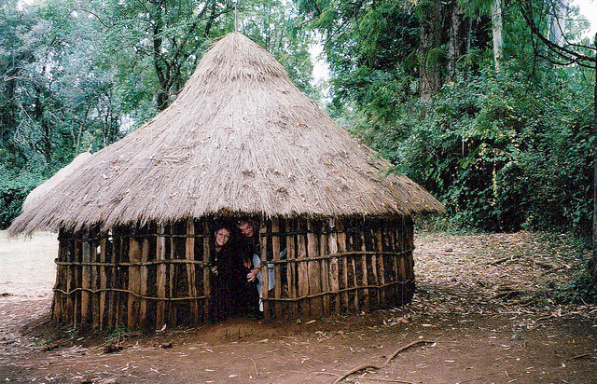

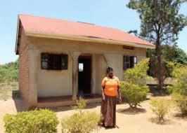

Good luck!
Don’t’ forget to take pictures!

