Week beginning 18th May 2020

Hi Year 2!
Thank you for continuing to send us your amazing work.
This week we have lots more fantastic tasks for you!

English
This week’s writing challenge:
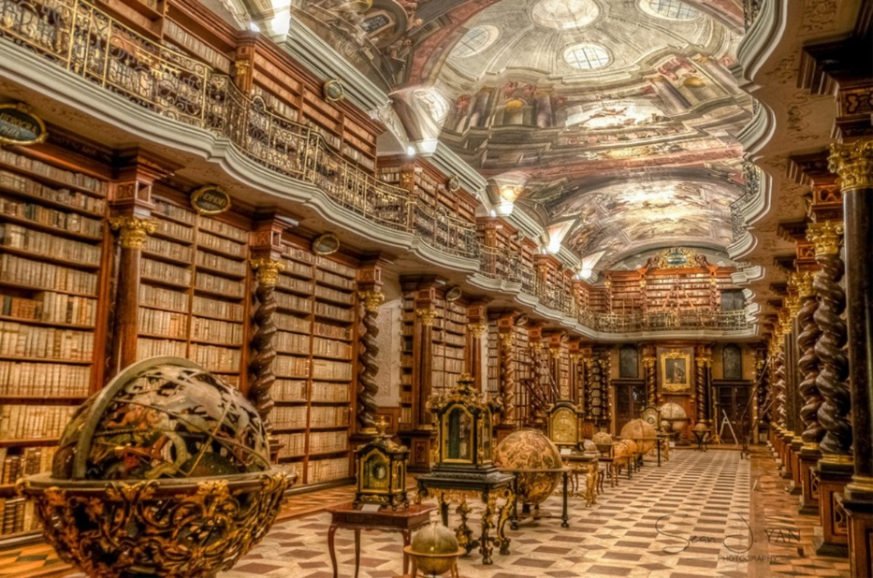
https://www.pobble365.com/the-magic-library/

Question time!
Why is Elsa in The Great House?
Why are some rooms ‘out of bounds’ to her?
What time of day do you think it is?
How does Elsa feel as she enters the library?
What is she hoping will happen in the library?
What happened the last time she was here?
Will anyone notice she has gone?

Perfect picture!
Can you draw a picture of what will happen when the orb in front of Elsa opens?

Sentence challenge!
Verbs are action/doing words.
Can you identify all the verbs I have used below? Can you replace them with more interesting verbs?
Elsa walked bravely across the floor. Light came down from the windows. She looked back over her shoulder to see if anyone was there.

Sick sentences!
These sentences are ‘sick’ and need your help to get better. Can you help?
Elsa stood in the room. It was a big room, with rows of books and a nice floor. The ceiling was very high and it was very light.

Maths
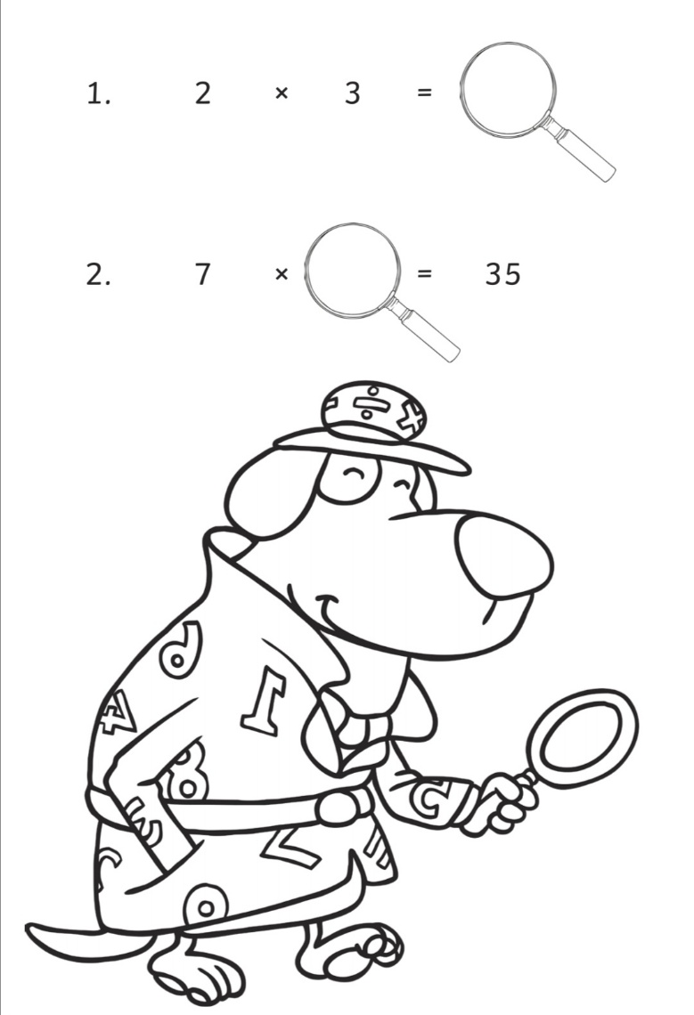
This week’s maths learning:
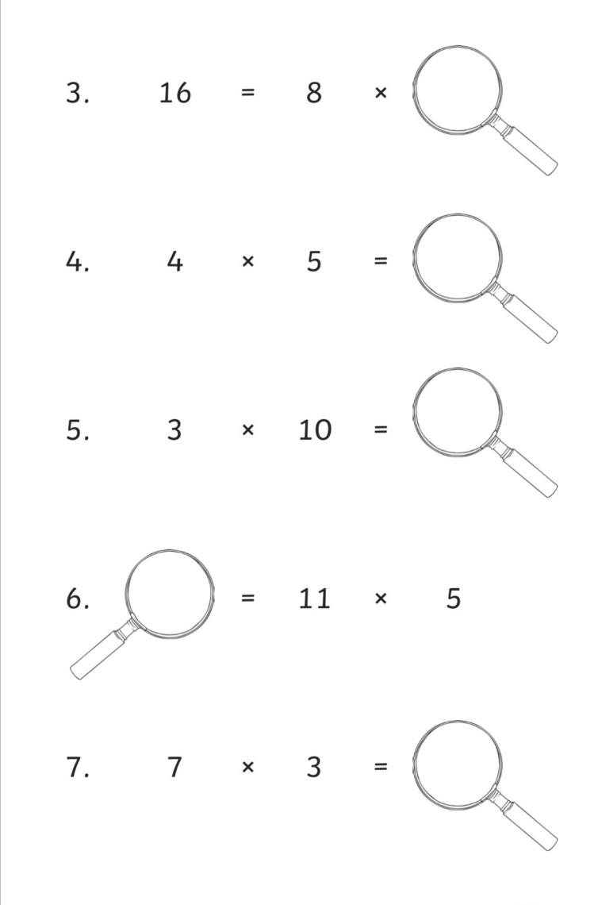

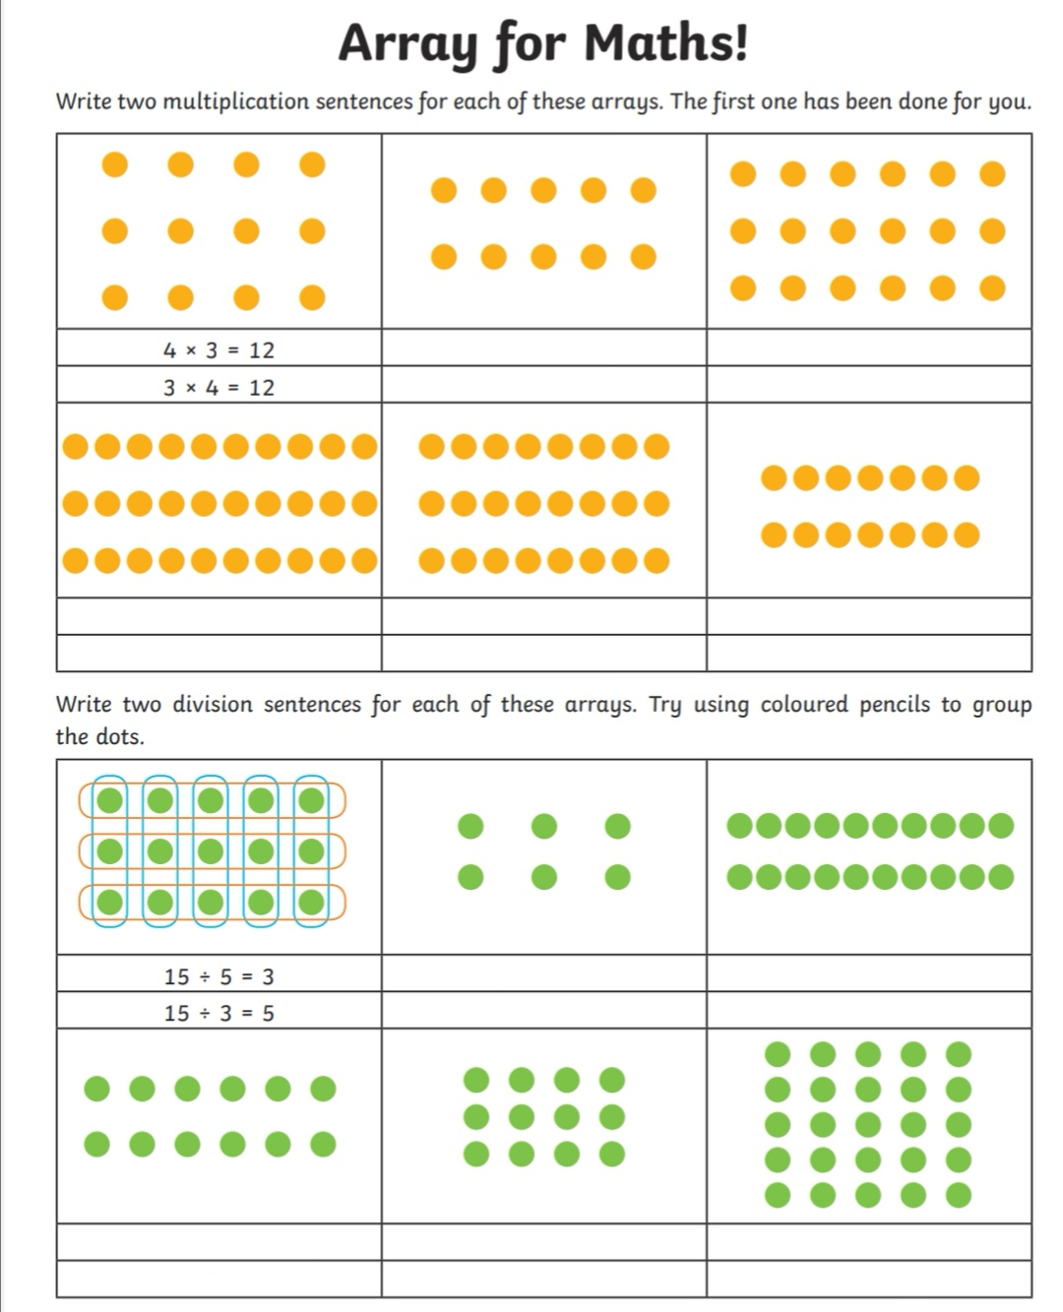
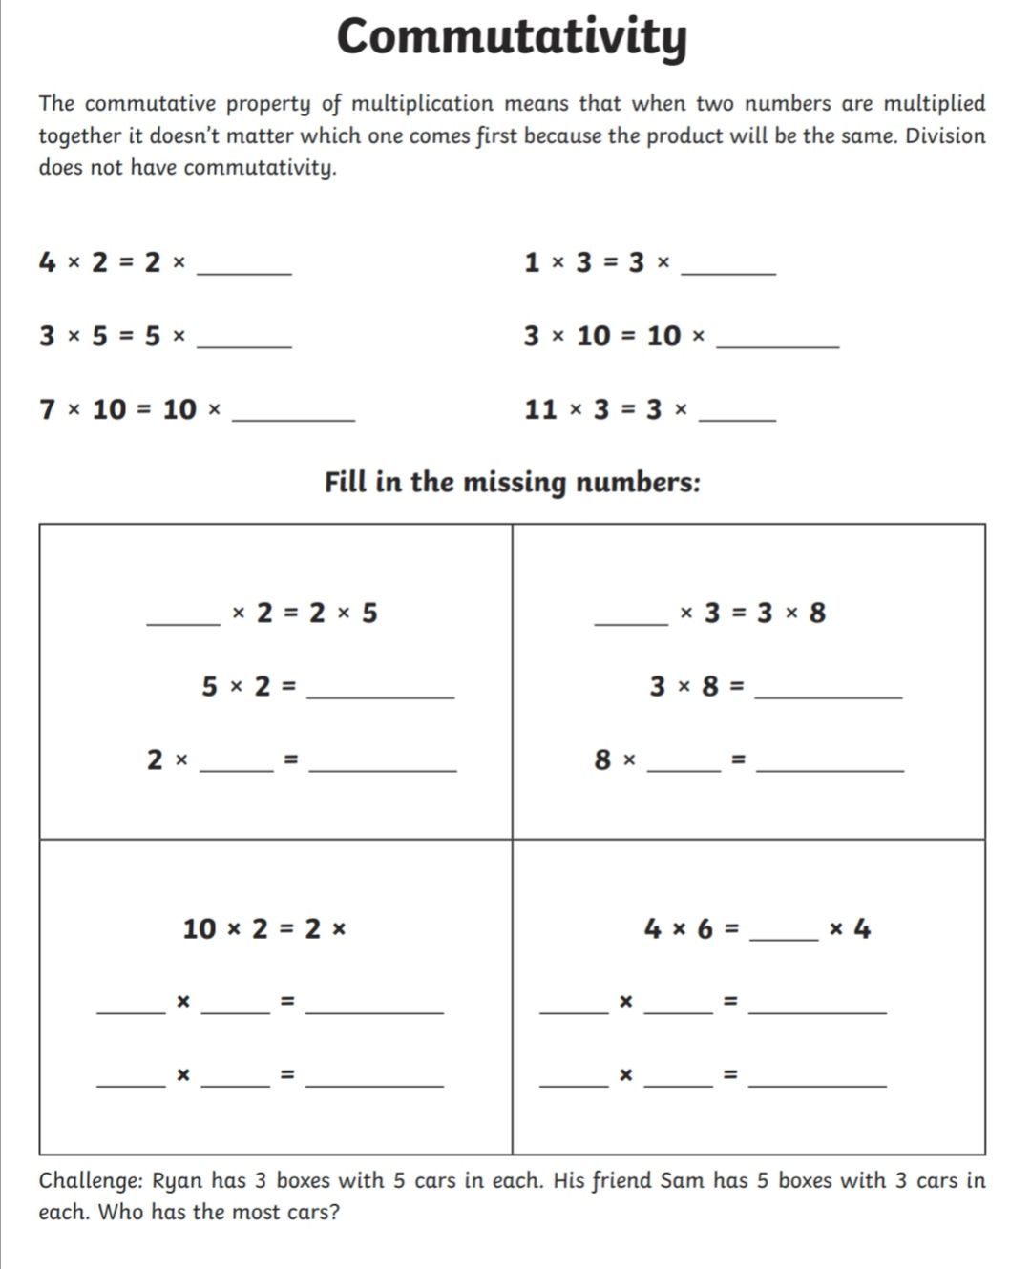
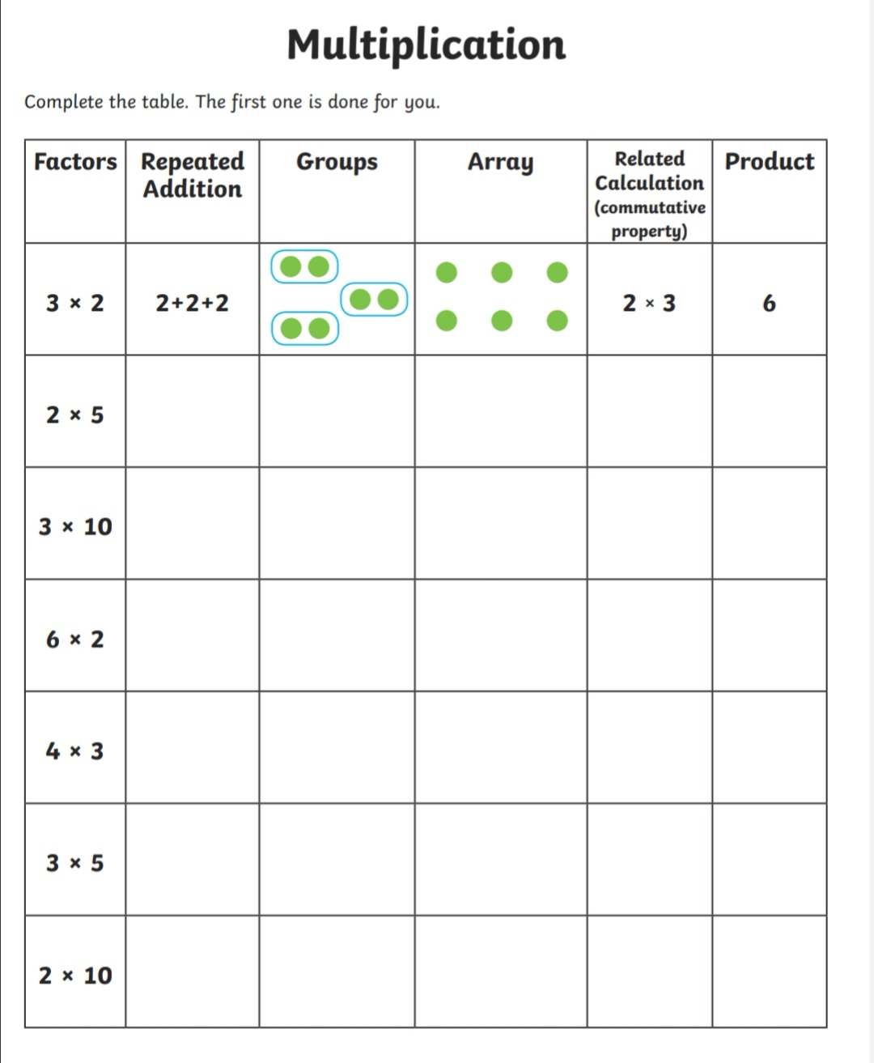
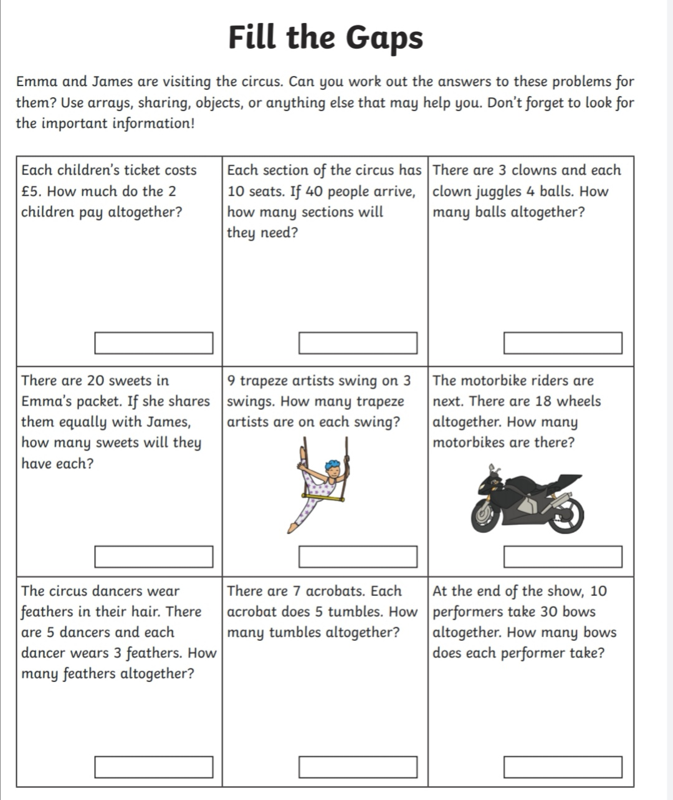
Topic work
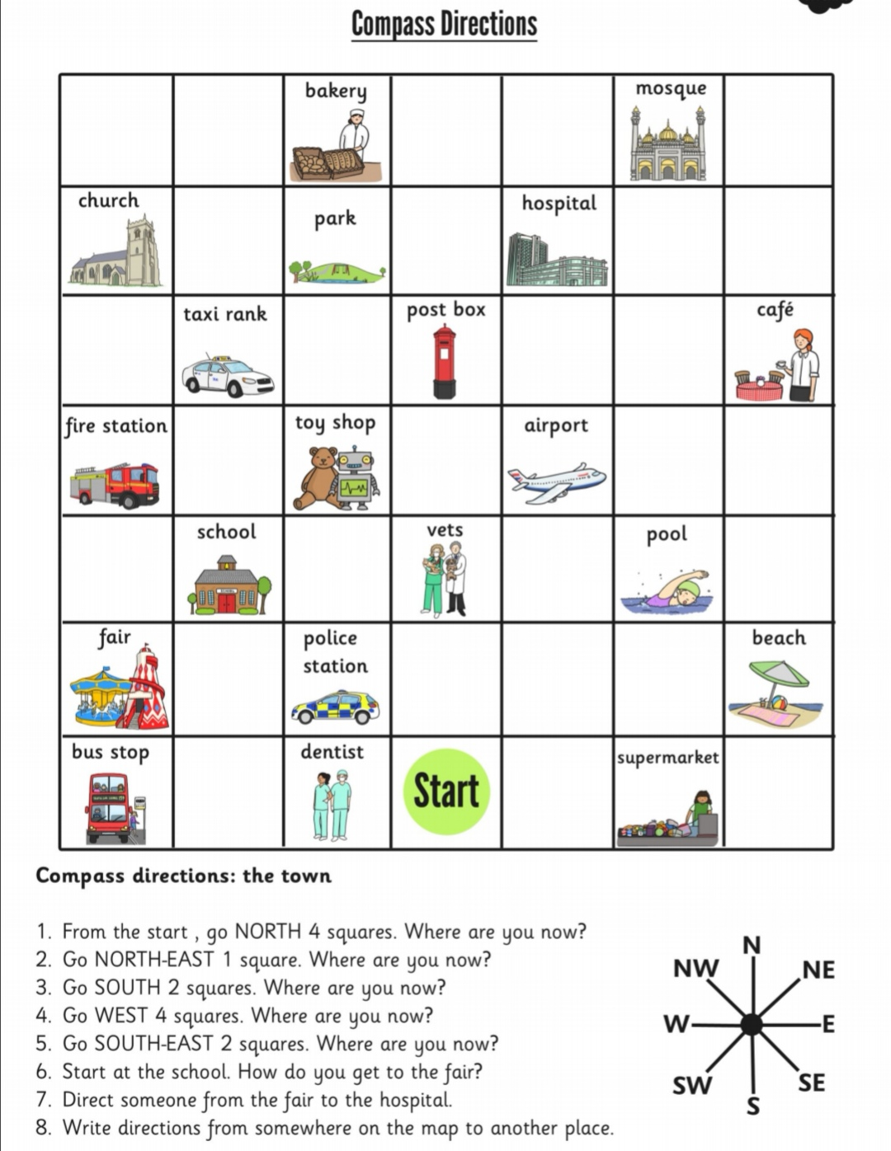
Geography
Music time
Ask someone else to choose a song for you.
First, I would like you to listen and appraise.
What sounds/instruments can you hear?
Does this sound similar to any other songs you know?
What style of music do you think this is?

Next, I want you to listen to the song again and see if you can clap your hands or tap an instrument in the same rhythm as the song.

Science
Can you draw a food chain for a different animal?
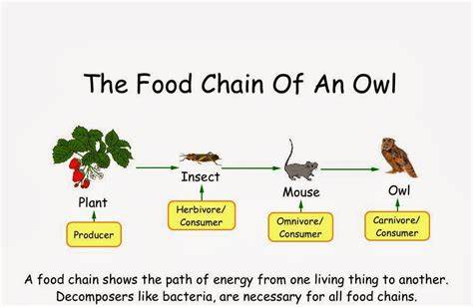

P.E.
https://www.twinkl.co.uk/resource/hide-a-saurus-ebook-t-or-1336
Art
Can you decorate these sea creatures? Try to use pictures online or from memory to help you decorate your creatures. If you have different materials at home, you can use those to help you decorate.
R.E
- The Qur’an is the Islamic holy book. It is very special to Muslims. It teaches Muslims the best way they can follow their religion by writing about stories that help people learn.
- The Guru Granth Sahib is the Sikh holy book. It teaches people in the religion of Sikhism how to follow their religion. The book is written in a different language called Punjabi. It is a very special book so is kept on a raised platform.
- The Bible is a holy book for people who are Christians. It has many stories inside to teach people how to be better in their lives. There are two parts to the bible - the old testament and the new testament.
- The Bhagavad Gita is the holy book for Hindus. The name means 'Song of the Bhadavad'. A lot of people call it Gita for short.
- The Torah is the holy book for Jewish people. It is normally not a book at all, but a scroll which is a rolled up piece of paper. It is written in a different language called Hebrew. The Torah is so special to Jewish people that it is always hand written. They do not use a computer to type the words so it takes a long time to finish writing it.

PSHE
How can we stay safe in these different places?
Online:
Crossing the road:
In the park:
In the classroom:
In the kitchen:

