Week Two Summer Learning
Maths – Multiplication and Division

English
This week you will need to be the weather boy/girl. You will need to keep a record of the weather for the week, and by the end of the week, you will need to do a video presentation on how the weather has been. Rather than forecasting, it will be more like a report. You can draw pictures and diagrams for your video report.
https://www.bbc.co.uk/weather
https://www.youtube.com/watch?v=c1npkEoEtos
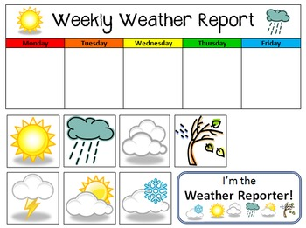

Science
Todays investigation is going to be about forces (foreward and backwards).
Create a ramp using a book leaning on another object, investigate how the change of height can affect how fast something goes down the ramp.
Do you need extra force to make it go faster on a flatter surface?
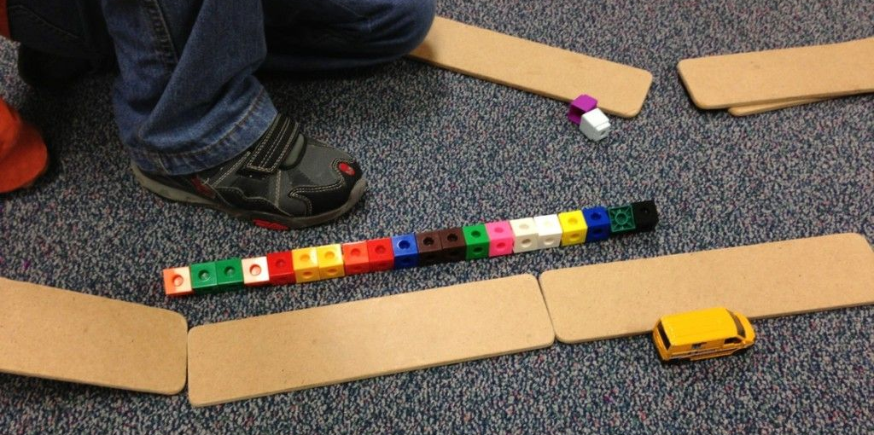

DT – Sock Puppet
https://www.youtube.com/watch?v=1Nh0n2LcU7I&feature=emb_logo

