Week One Summer Learning

Hi Year 2!
We’ve made it to the end of a very strange type of year.
As your teachers we are so proud of how well you have all adjusted to this new type of learning.
To help you get ready for Year 3, we’ve been putting together some fun and some challenging tasks for you to complete in the summer holidays.
We hope you find ways to have an enjoyable summer break and we can’t wait to see you all in the new school year.

Maths – Addition and Subtraction

English
Choose a character from their favourite book and stay in that character the whole day. You can even dress up as that character.
Now write a diary entry on how your day went as your chosen character.
For example: If Ms Adams favourite book character was Belle from Beauty and the Beast she would spend the day reading and helping her family.

Sentence starters:
Dear Diary,
Today I decided to act like my favourite book character __________________.
First I ____________________.
Then I _____________________________________.
Next I ___________________________________________.
My favourite part about being __________ was ____________________________.
From,
__________________________
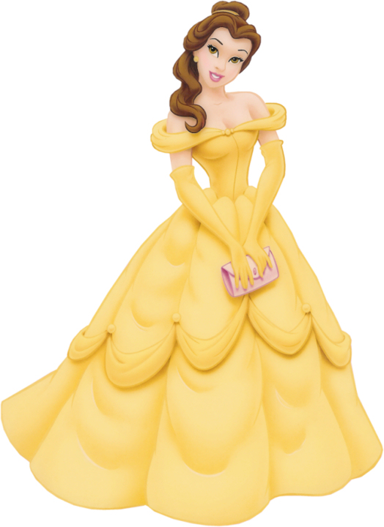

Science
This week in science we would like you to write instructions for planting a seed.
If you have any seeds at home, follow your instructions to plan one.

Art
In art we’ve been learning about sculptures.
Today’s task is to use items you have in your house to create a sculpture. You can use: playdough or lego or other items.
