Week Three Summer Learning
Maths: Fractions

English
This week you will need to plan and write a recipe. You can then need to follow this recipe and serve the dish to their family members.
An example recipe is:
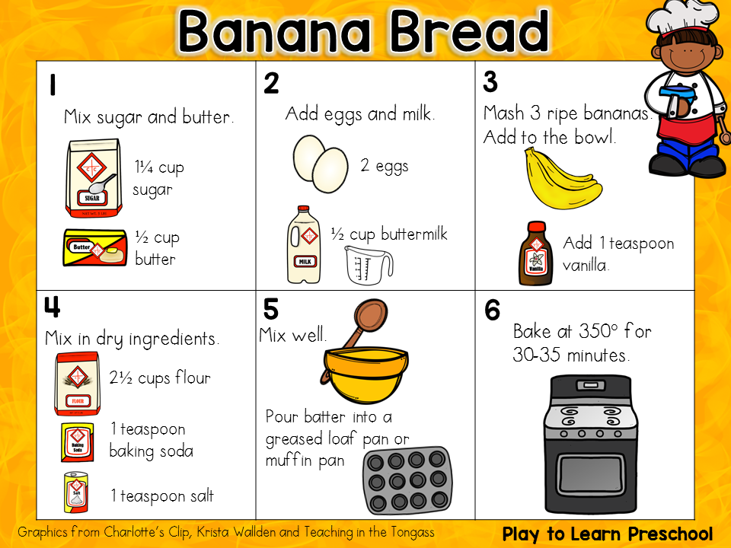
Science
This weeks investigation is forces (up and down - gravity as a force). Use the below website to create a forces experiment.
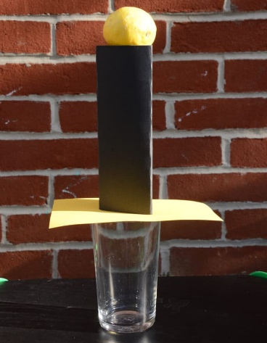
https://www.science-sparks.com/easy-inertia-experiment/

RE
In RE we have been learning about special books and the rules about how to live our lives.
For this weeks RE task we would like you to create a special book and inside write all the rules you follow to live a good, happy life.
