Year 2 Summer Holiday Homework Pack

Week 5

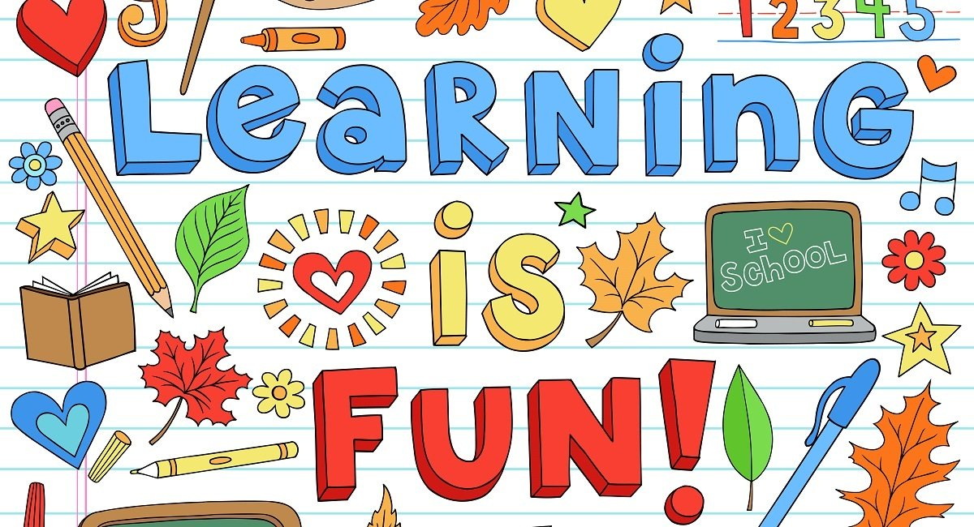

English- Writing your own story

You are going to unlock your imagination and write story. You can make your story as creepy, funny, weird or as dramatic as you like. The twist is, in addition to using other characters, you must also use your family members as characters. Remember, a story must have a beginning, middle and end. Use the story mountain below to plan your story.

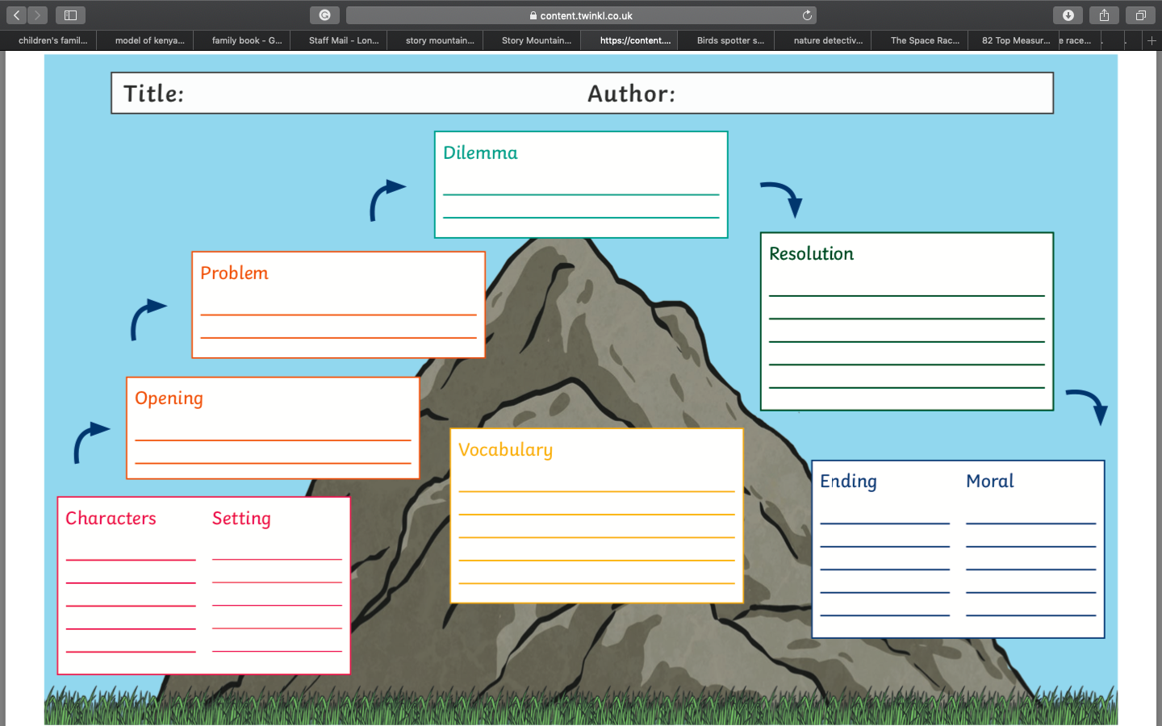
Maths- Measurement
Science- Animals

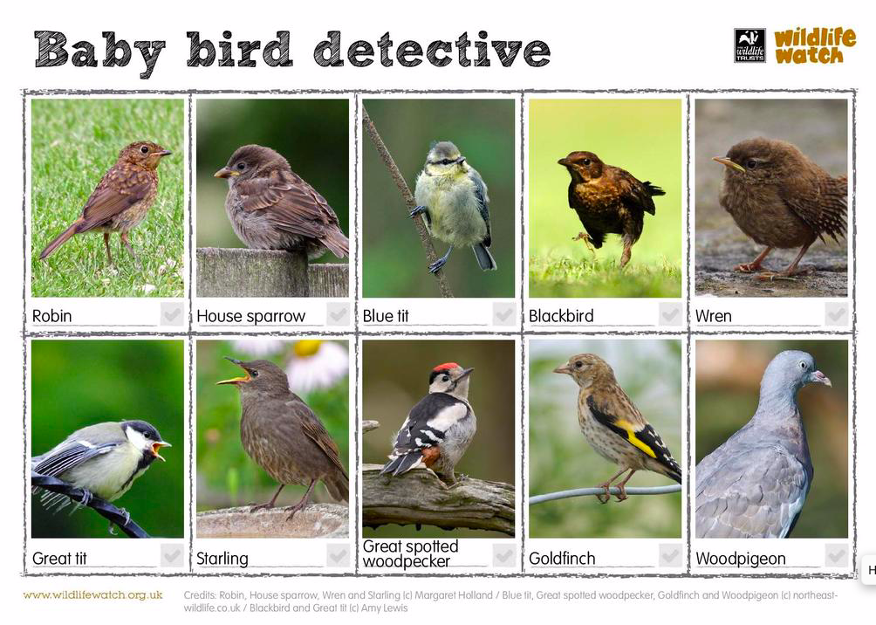
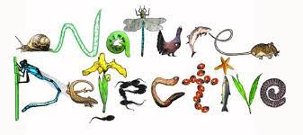
You are going to be baby bird detectives. Below are pictures of a range of local baby birds. Can you spot these birds your garden, park or anywhere else that you have travelled? When you spot a bird, try to take a picture of it and create a poster. If you don’t manage to take a picture, you can draw the bird instead.
History- The Space Race

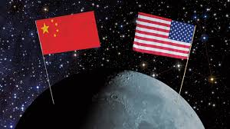
The space race was a series of competitive technology demonstrations between the United States and the Soviet Union, aiming to show superiority in spaceflight

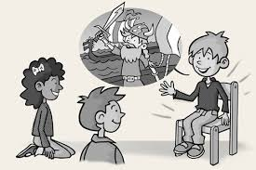
Research the different people that were involved in The Space Race. Use your family members to hot seat the important people. Don’t forget to use ‘who, what, where, how, why’ questions.

