Dear 3A,
I wanted to write this letter to you to let you know that I am thinking of you all. I really miss you guys and hope you are all doing very well regardless. I hope you are all staying safe and spending lots of quality time with your families. Please continue to wash your hands often and stay indoors.
I can understand that some of you may be quite worried and scared about what is happening at this very difficult time, however you are not alone. We all can’t wait for things to go back to normal where we can see our friends, play outside and enjoy the fresh air. I can just imagine you all wish you were back at school! 😊
I have already received a few emails from some of you on ‘2Email’, I was so pleased! Please feel free to email me anytime! Thank you to those children who have submitted their work on Purple Mash. I am really impressed with your results. Please check the feedback I have given if you have submitted any work. If you are unsure about how to complete the work on Purple Mash or cannot access it, please have a go at the activities set on the school website by clicking on https://www.shaftesburyprimaryschool.co.uk/ > Parents > School closures > Home learning year 3. There are also so many different ways of learning online on different websites such as https://www.bbc.co.uk/bitesize/levels/zbr9wmn and https://www.khanacademy.org/math/cc-third-grade-math. You could also have a go at a new skill or find games to play with your family. Since I love painting and haven’t pained in a long time, I decided to sit in my garden and paint this..
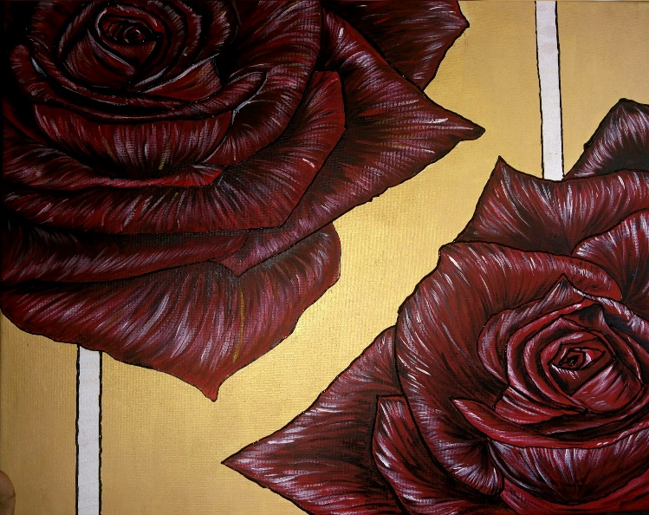
I hope you guys like it!
I would love for you to bring in some of your work and creations when we are back at school. It would also be lovely to see some emails sent to the school with pictures of what you have been doing at home! Also please take some time out of your day or week to complete some mindfulness activities, this will really improve your mental health which is just as important as your physical health!

Please do not hesitate to contact the school if you have any concerns.
I hope to see you all very soon. Stay safe and happy!
From Miss Ali.

