Monday 6th April 2020
My new home classroom, London

Dear wonderful 3B,
Well, this is different isn’t it!? How are you all? I hope you and your families are well!
So first of all, I wanted to say well done and thank you for all the children in 3B who have been able to use to stay in touch and do some learning at home. I know for some of you it must be hard to find time to use a laptop or tablet when everyone in your house also needs it! So well done if you have been lucky enough to log in. 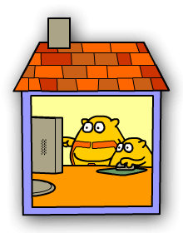
I’d like to crown Humaid and Wiktoria, king and queen 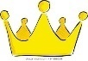of 3B for these two weeks for their dedication and commitment when completing their tasks set on Let’s see who is going to be crowned next!

And it’s more nice things happening to Mrs Bokciu (me) during these days! I’ve had some fantastic work from: Sarika, Arya, Aisha, Zarwa, Hammem, Aleena, Safwan, Asiyah, and Zahra. Keep it up!

If you haven’t been able to access Purple Mash for whatever reason, fear not! I have some s and activities for you to do here which don’t involve a computer! Read on…

1: Put a Ring on It:
Measuring the circumference of tree trunks and working out their age.
Materials – Measuring tape or some pieces of string, pen, paper and your SMART brain.
We are all allowed out once a day for exercise, so make the most of it! On your daily walk, find some trees. You may need to include a park on your walk to find different trees!

During your walk, the challenge is to measure the circumference of at least five different tree trunks using a measuring tape. If you don’t have a measuring tape, use strings but you might need your parents to help you with estimating lengths. Look at the slides below to approach this activity! Record you data on paper during as you walk and measure each tree. You can draw and label just like below.

After your busy and productive walk, you could work out the age of each tree you’ve investigated! You can use a number line or making groups of when dividing by 25 to find the age of each tree.
Next, you can present your data on a bar chart and other types of charts/graphs if you like.
Save your very valuable work and bring it to school when we are back please.

Have fun!

2. Maths investigation:
Materials – pen, paper, brain!
Safe Cracker:
Can you crack the code to open the safe?
To crack the safe code you need to solve three problems.
Each one will give you one of the two digit numbers needed to open the safe.
You must get all three numbers right to crack the code.
Are you ready?

Problem 1:
What is 102 -7?

Problem 2:
600 – _________= 548 What is the missing number?

Problem 3:

327 + _____ = 365 What’s the missing number?

If you have got three two digit numbers, you have cracked the code.
Your answers to each problem should be two-digit numbers which you will use to crack the code.

And finally:
4. DIY book corner
Choose your favourite book, or several books! Then find somewhere new to sit or curl up and read. Can you think of somewhere to go that no-one else has thought of? Maybe behind the sofa? Or under the table? Or, use some blankets to create your own tent/shelter. Get cosy and send us a picture!
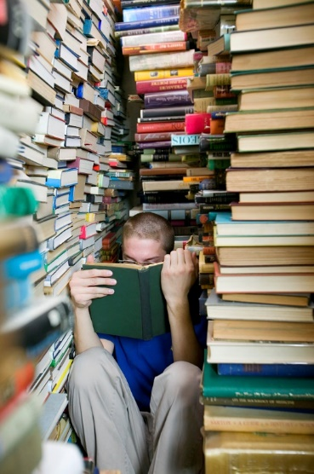
I can’t wait to hear from you all as I miss seeing your faces every day! I’m sure we can all make the most of this time and try new things! For example, I had a
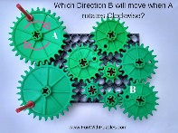 brain challenge with my parents on WhatsApp! Shhhh! I am writing on ‘my top-secret’ diary every day! Are you? Share some of your bests when we are all back to school.
These days, I’m eating more than usual as I am getting to cook at least twice a day for my family. I am trying new healthy dishes with fewer ingredients and they are delicious. Well, most of the time!!! Why don’t you try this with your parents too?
😊 3B you are an extremely kind, smart and imaginative class. All of you! I know you will come up with some fantastic new ways for learning together with your families at home!

Take care of yourselves, keep moving and keep in touch!

Best wishes
Mrs Bokciu x

