Summer holidays week 1

Grammar

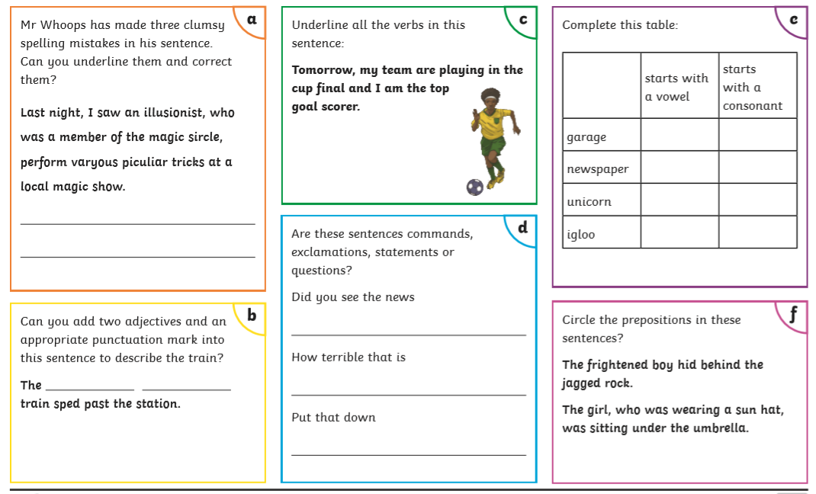

Writing task 1: Character Profiles

Pick a character from any fiction book and write a character profile.

In your character profile you should:

* Tell me basic information (e.g. name, age, where they are from etc.)
* Describe the appearance of the character.
* Describe their personality (What do others think of them?).
* What makes them special (any abilities or hobbies).

Try to separate your information into paragraphs.

Challenge: Can you use any words from the story to help you describe them and put them in quotation marks?

e.g. The other children thought Mildred was “clumsy” as she was always falling off her broom. (Taken from The Worst Witch)

 [](http://www.towntalk.co.uk/subdomains/lib/image.php/39087_Horrid%20Henry%20logo%20copy.jpg?domain=.co.uk&image=http://www.worksop.towntalk.co.uk/images_folder/eventsimg/39087_Horrid%20Henry%20logo%20copy.jpg&width=700)  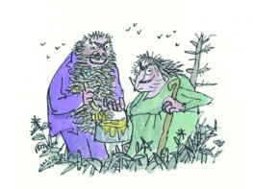 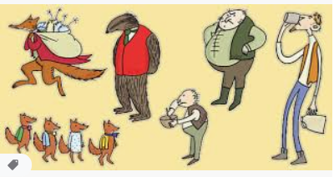

Vocabulary:

mean, clever, frightening, cunning, brave , foolish, silly, disgusting, courageous, brilliant, careful, accident-prone, fantastic, crook, villain, hero, shy, scared, frightened, confident, cocky, proud, genius, evil

Answers to week 1 grammar:

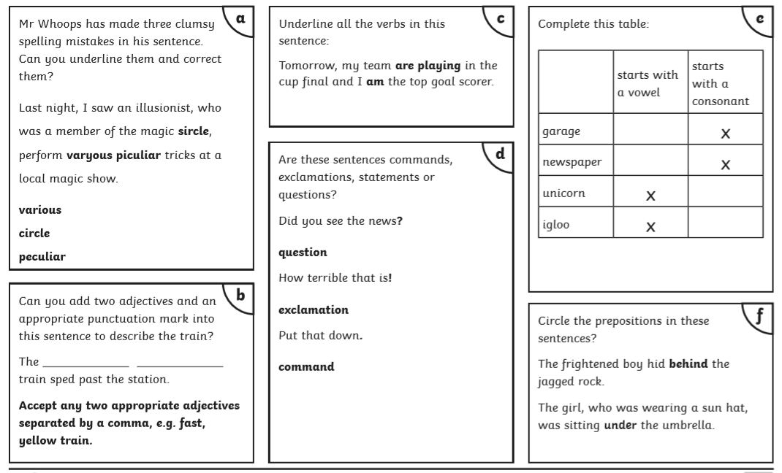

Summer holidays Week 2

English

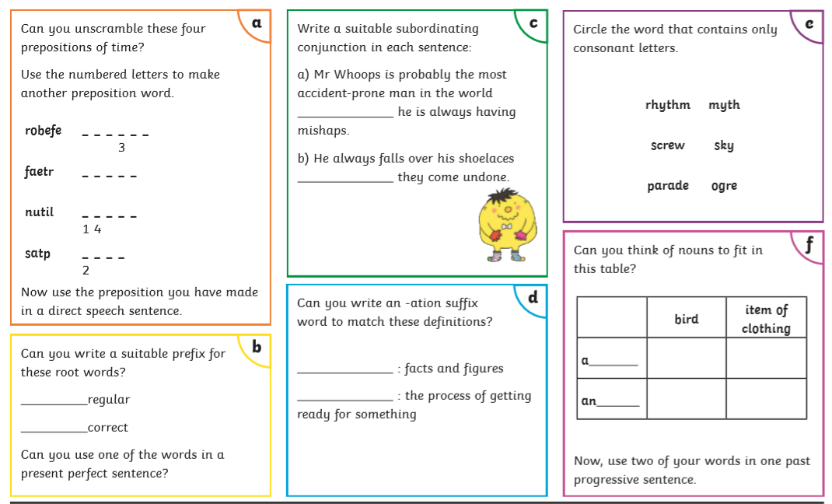

Writing

Task 2 Instructions

I have been selected to fly to Mars on the next Space Shuttle. Even though this will be a great adventure, I am a little worried. There is a chance I might meet an alien there and as I have never met one before I won’t know what do.

Can you help me by writing out some instructions on what to if I met an alien?

I have included an example of “How to Keep Your Teacher Happy” to give you some ideas on how you could set it out.

**Instructions vocabulary:**

**First, … Then, …. Next, … Carefully, Finally, …**

**Always try to … Make sure you … Never forget to …. It’s a good idea to….**

**Alien vocabulary**

**antennae, feelers, eyeballs, spaceship UFO, signal, communicate, green skin, species**

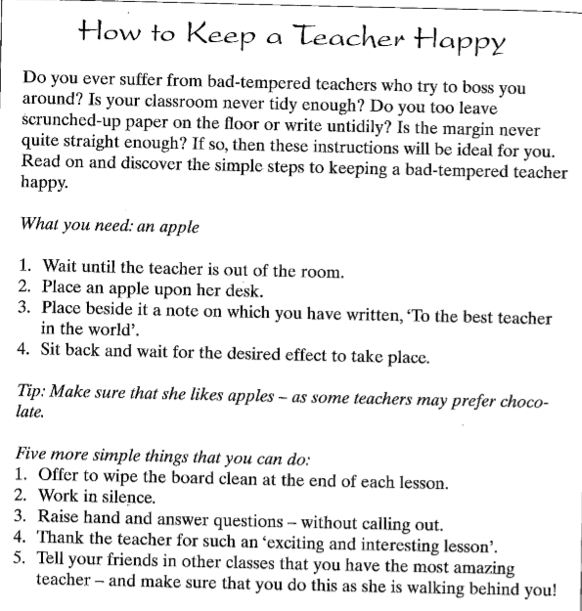

 C:\Users\marie.hanratty\AppData\Local\Microsoft\Windows\Temporary Internet Files\Content.IE5\CKJKF0A3\MC900149712[1].wmf

Grammar answers

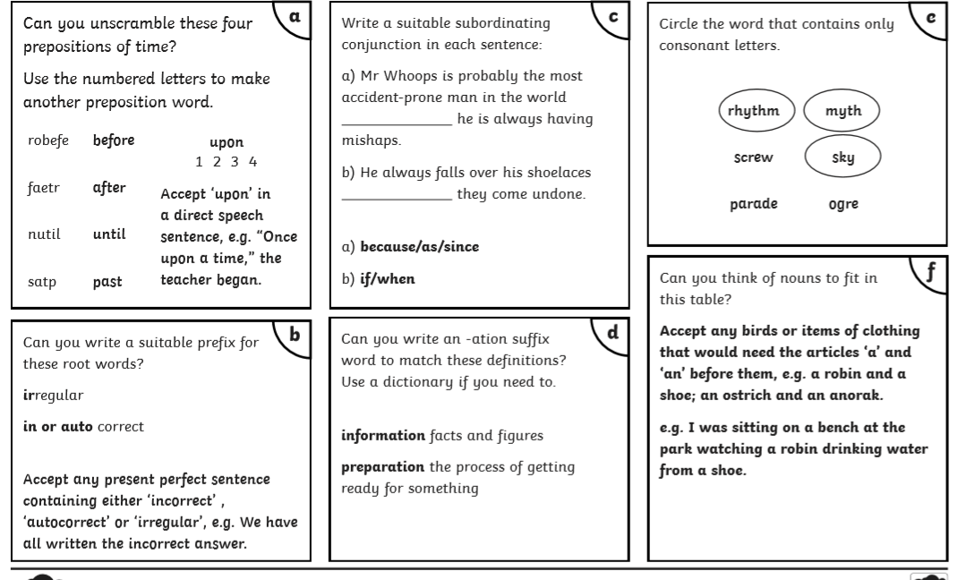

Summer holidays Week 3 English

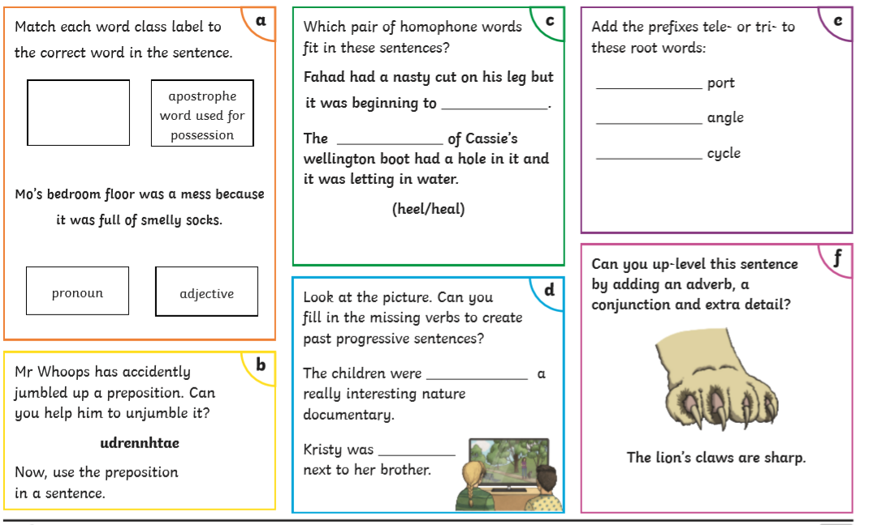

Task 3 Persuasive writing

The government are enforcing a new rule on children.

“Children between the ages of 6 and 11 are responsible for all household chores. This includes:

* Washing dirty dishes
* Hovering the whole house
* Cooking for the family
* Dusting and polishing all of the furniture/household ornamentsC:\Users\marie.hanratty\AppData\Local\Microsoft\Windows\Temporary Internet Files\Content.IE5\CKJKF0A3\MC900287187[1].wmf
* Making all of the beds before school
* Washing and ironing every item of clothing.

Write to the government to persuade them this is not a good idea. I have included a planning sheet to help you organise your ideas and a list of some persuasive phrases you may want to include in your writing.

C:\Users\marie.hanratty\AppData\Local\Microsoft\Windows\Temporary Internet Files\Content.IE5\CKJKF0A3\MC900434455[1].wmfC:\Users\marie.hanratty\AppData\Local\Microsoft\Windows\Temporary Internet Files\Content.IE5\7HFLDO7O\MC900280971[1].wmf

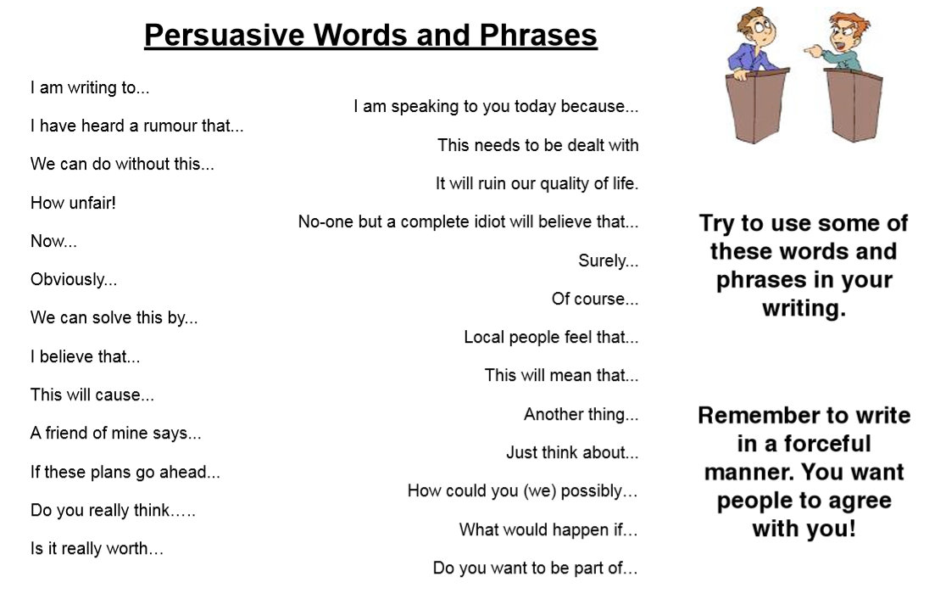

Grammar answers

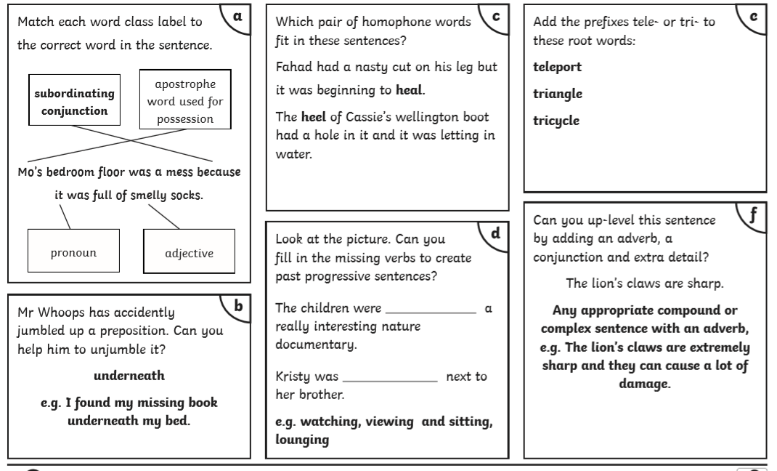

Week 4 Summer holidays English

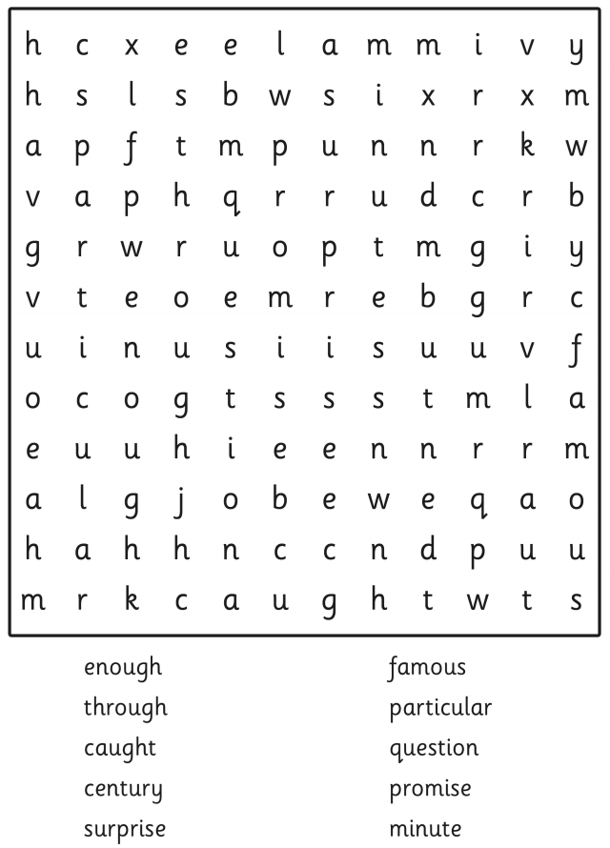

Can you make a sentence with each of the spelling words?

------------------------------------------------------------------------------------------------------------------------------------------------------------------------------------------------------------------------------------------------------------------------------------------------------------------------------------------------------------------------------------------------------------------------------------------------------------------------------------------------------------------------------------------------------------------------------------------------------------------------------------------------------------------------------------------------------------------------------------------------------------------------------------------------------------------------------------------------------------------------------------------------------------------------------------------------------------------------------------------------------------------------------------------------------------------------------------------------------------------------------------

Task 4 Adventure Story

Here is the beginning of an adventure story set at sea. Complete the story.

Remember:

* Paragraphs (New one for a new place/time /speaker)
* Wow words (adjectives/adverbs/verbs)
* Does it make sense?

**PIRATE ADVENTURE!**

One day as the sun rose over the ocean and the Captain shouted to the crew to raise the sails, I nervously peered out of the port hole. My father had told me as we boarded the ship that our journey was very dangerous as these waters were notorious for PIRATE attacks! As I looked out over the swaying ocean I couldn’t help but wonder if indeed pirates were out there just waiting for us. Suddenly…

C:\Users\marie.hanratty\AppData\Local\Microsoft\Windows\Temporary Internet Files\Content.IE5\7HFLDO7O\MC900250887[1].wmf C:\Users\marie.hanratty\AppData\Local\Microsoft\Windows\Temporary Internet Files\Content.IE5\0V1JQ6I9\MC900055651[1].wmf C:\Users\marie.hanratty\AppData\Local\Microsoft\Windows\Temporary Internet Files\Content.IE5\CKJKF0A3\MC900037177[1].wmf C:\Users\marie.hanratty\AppData\Local\Microsoft\Windows\Temporary Internet Files\Content.IE5\CKJKF0A3\MC900150095[1].wmf

Week 5 Summer holidays English

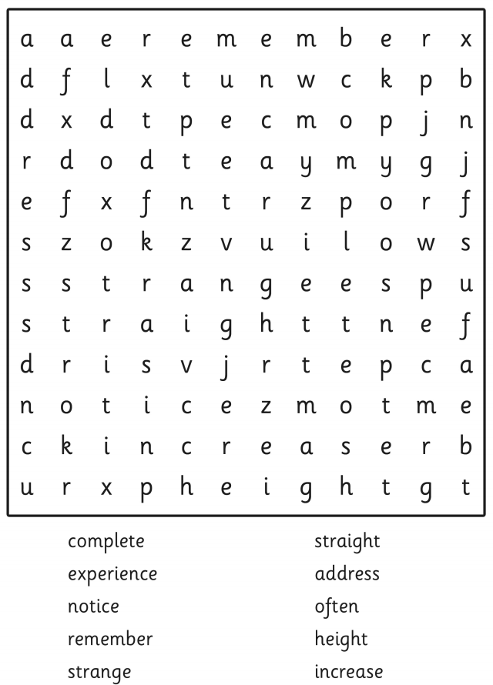

Can you make a sentence with each of the spelling words?

------------------------------------------------------------------------------------------------------------------------------------------------------------------------------------------------------------------------------------------------------------------------------------------------------------------------------------------------------------------------------------------------------------------------------------------------------------------------------------------------------------------------------------------------------------------------------------------------------------------------------------------------------------------------------------------------------------------------------------------------------------------------------------------------------------------------------------------------------------------------------------------------------------------------------------------------------------------------------------------------------------------------------------------------------------------------------------------------------------------------------------

Task 5 Description and reasoning

Imagine you are going on an adventure to the North Pole. You are allowed to bring some personal items along with you for while you are away. Describe what you would bring and why.

Don’t forget:

* Use adjectives to describe the objects.
* Use connectives to explain the reason you are bring the object.
* Think about how you start your sentences.

C:\Users\marie.hanratty\AppData\Local\Microsoft\Windows\Temporary Internet Files\Content.IE5\SYX2WGFM\MC900090891[1].wmf C:\Users\marie.hanratty\AppData\Local\Microsoft\Windows\Temporary Internet Files\Content.IE5\SYX2WGFM\MC900290903[1].wmf

Week 6 Summer holidays English

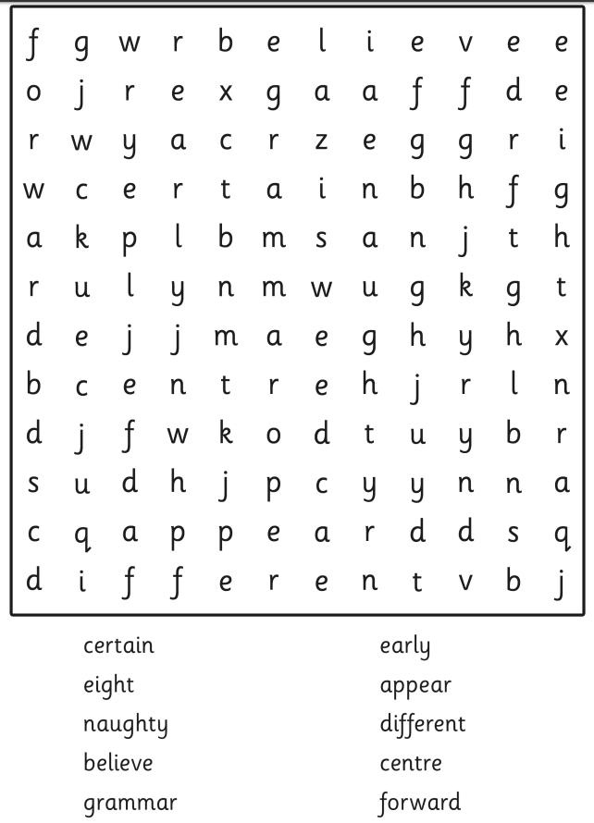

Can you make a sentence with each of the spelling words?

------------------------------------------------------------------------------------------------------------------------------------------------------------------------------------------------------------------------------------------------------------------------------------------------------------------------------------------------------------------------------------------------------------------------------------------------------------------------------------------------------------------------------------------------------------------------------------------------------------------------------------------------------------------------------------------------------------------------------------------------------------------------------------------------------------------------------------------------------------------------------------------------------------------------------------------------------------------------------------------------------------------------------------------------------------------------------------------------------------------------------------

Writing

This week we’d like you write a poem! :D

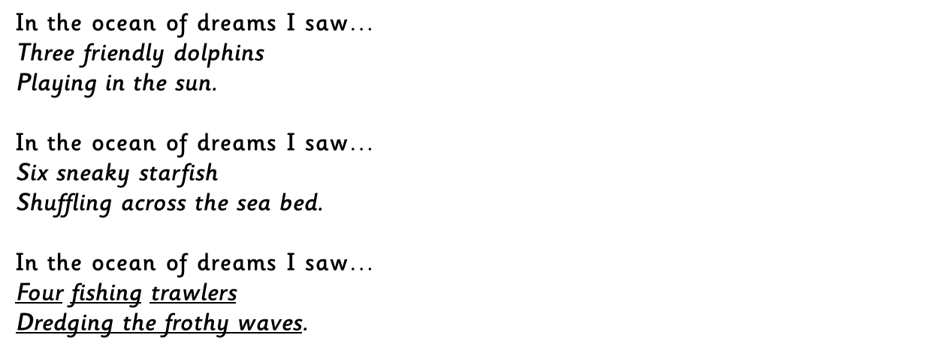

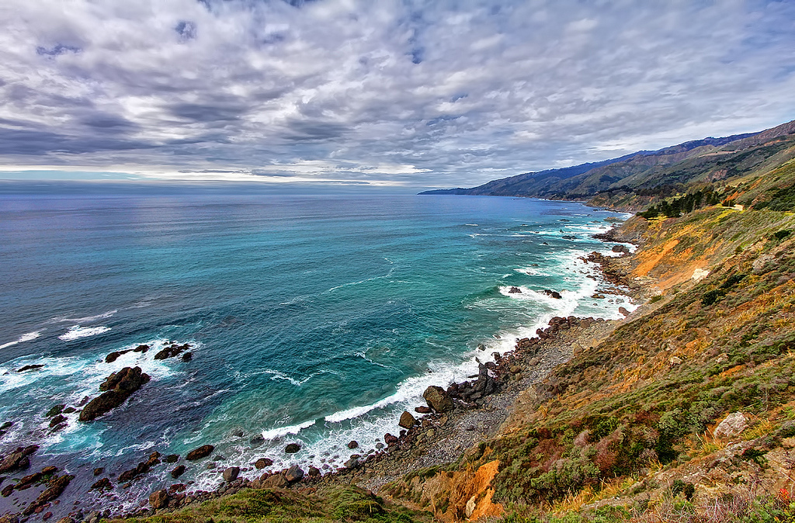

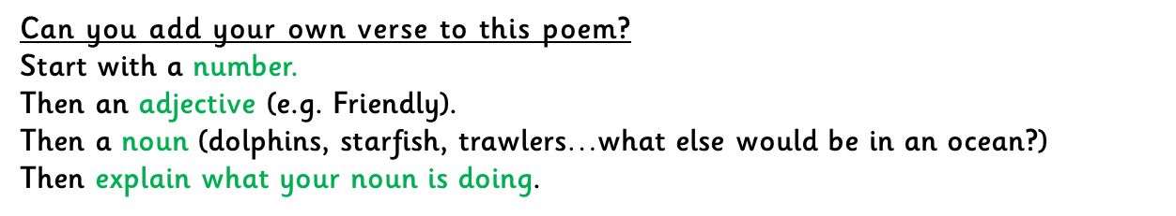

Then add 2 more verses

Or you could change the structure:

