Friday 3rd April 2020
My new home classroom, London

Dear wonderful 3C
Well, this is different isn’t it!? How are you all? I hope you and your families are well!
So first of all, I wanted to say well done and thank you for all the children in 3C who have been able to use to stay in touch and do some learning at home. I know for some of you it must be hard to find time to use a laptop or tablet when everyone in your house also needs it! So well done if you have been lucky enough to log in. 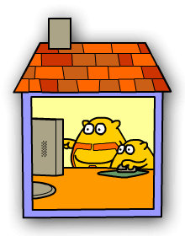
I’d like to crown Abir king of using the 2Email. He’s an absolute pro! And I’ve had some great work from Ammara, Dhairya, Amirah, Gauri, Abdul, Kavya, Karima, Zahraa and Zahra. Keep it up!

If you haven’t been able to access Purple Mash for whatever reason, fear not! I have some s and activities for you to do here which don’t involve a computer! Read on…

1: Make a journey stick
Materials – string, safety pins or a bag
We are all allowed out once a day for exercise, so make the most of it! On your daily walk, find a stick. You may need to include a park on your walk to find a good stick!
During your walk, the challenge is to collect 5 different items (all natural, no rubbish!) and attach them to your stick. If you don’t have a stick you could simply collect the items in the bag.
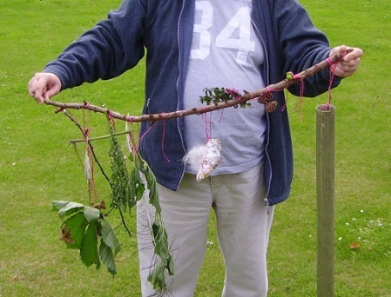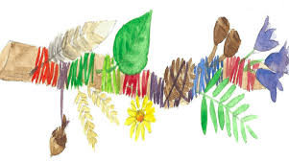
After your walk, you could draw your stick, or simply take a picture!
(Shhhh .. OK I was fibbing because you need a computer for this next part but it’s optional)
Then you can log into Digimaps and draw the route that you took for your walk! How long did it take you? Can you drop a pin for each place that you found an object on your journey? How many KM did you walk? You can save your map and it can be seen by your teacher!
https://digimapforschools.edina.ac.uk/login username srakdby8 password rarmed1296
Have fun!

2. Make a table!
Materials – clean, empty packaging (boxes, bottles cartons etc)
This challenge is simple – you need to build a table strong enough to hold 3 books on top! Your table can be any size, have any number of legs, but it must be strong. If you’re feeling creative, maybe you could add a drawer to your table or build a chair to go with it! Send us a picture!
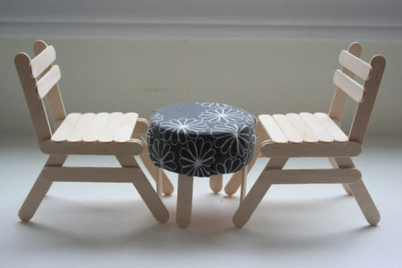
3. Maths investigation:
Materials – pen, paper, brain!
We start with any four numbers (not zero!):
We then add them in pairs and place the total above them:
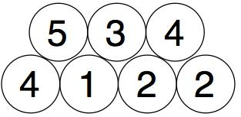
And we then add in pairs the new numbers we just got:
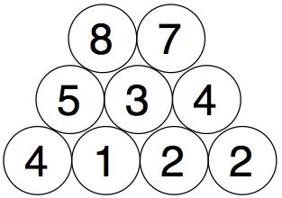
We do the same with those two numbers to get our final number:
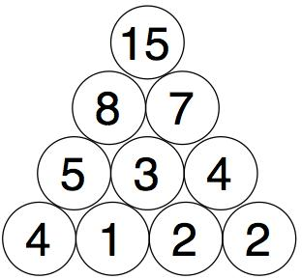
You need to find four starting numbers to place at the bottom so that when you get to the top it's 15 each time.
Try to find as many starting four numbers as you can.
Think about good ways to do this. Maybe use a system!

And finally
4. DIY book corner
Choose your favourite book, or several books! Then find somewhere new to sit or curl up and read. Can you think of somewhere to go that no-one else has thought of? Maybe behind the sofa? Or under the table? Get cosy and send us a picture!

I can’t wait to hear from you all as I miss seeing your faces every day! I’m sure we can all make the most of this time and try new things! For example, I had a dance with my friends online, each of us in our living rooms! I’m eating more pancakes than usual as well! 😊 3C you are the most kind and imaginative class I have ever taught so I know you will come up with some fantastic new ways for learning together with your families at home!

Take care of yourselves, keep moving and keep in touch!

Best wishes

Miss C x

