Week beginning 18th May
Hi all of you!
Thank you for all the lovely work you have been sending us. We really enjoy seeing what you have been up to at home and a big thank you to all the children who have been completing their Purple Mash work and who have been leaving comments. Please continue to look at the school’s website for updates on home learning- Parents- School Closure – Year 3. Did you all see the storyteller? She was very entertaining! We can’t wait to hear more about what you’ve been doing this week. Keep it up year 3!
English:
This week’s writing challenge
https://www.youtube.com/watch?v=ytsKeZTtRV8
Watch this video of the story The Wolves in the Walls by Neil Gaiman again and complete the tasks below.
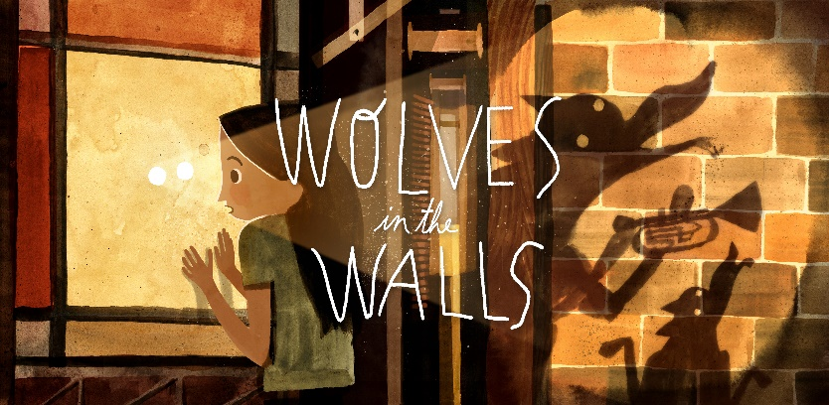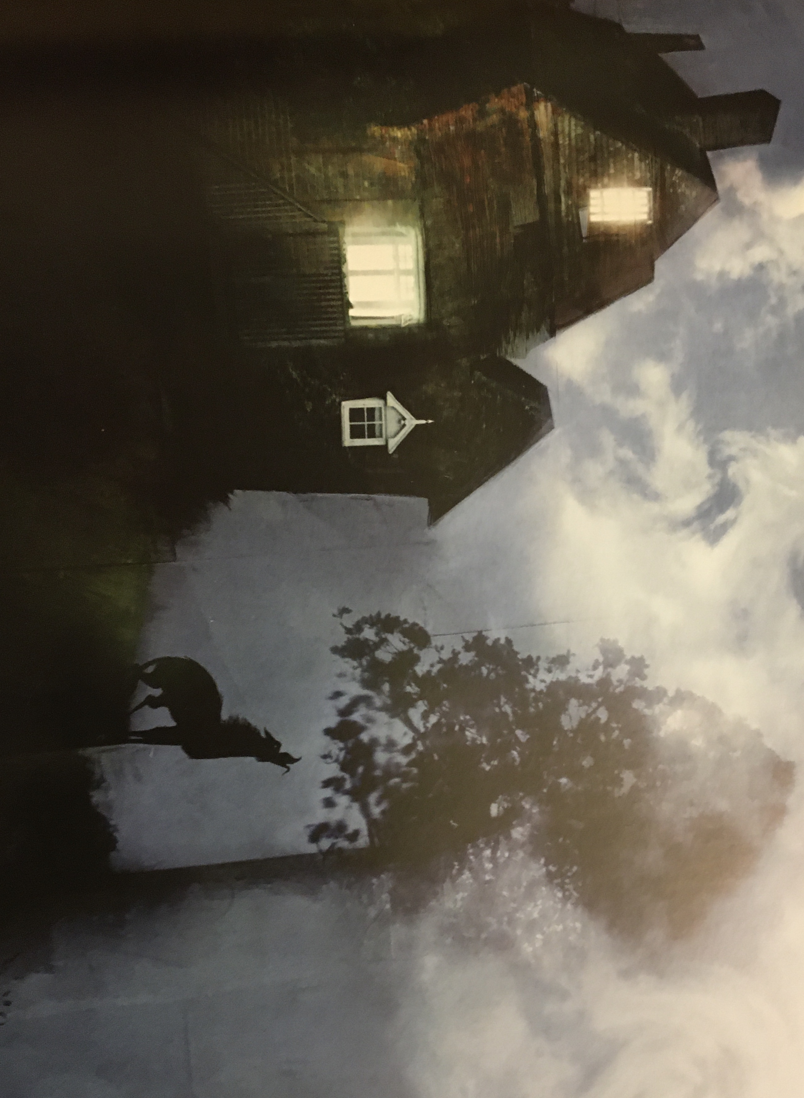
Inspired by the story above, can you write a story of your own about mystifying creatures disrupting yours or someone's normal life badly?
Use: powerful verbs, adverbials to describe verbs/actions, prepositions, a variety of noun phrases and a variety of subordinating and coordinating conjunctions to extend your sentences and add detail to your work.
Make your words SPEAK by using a range of punctuation also.
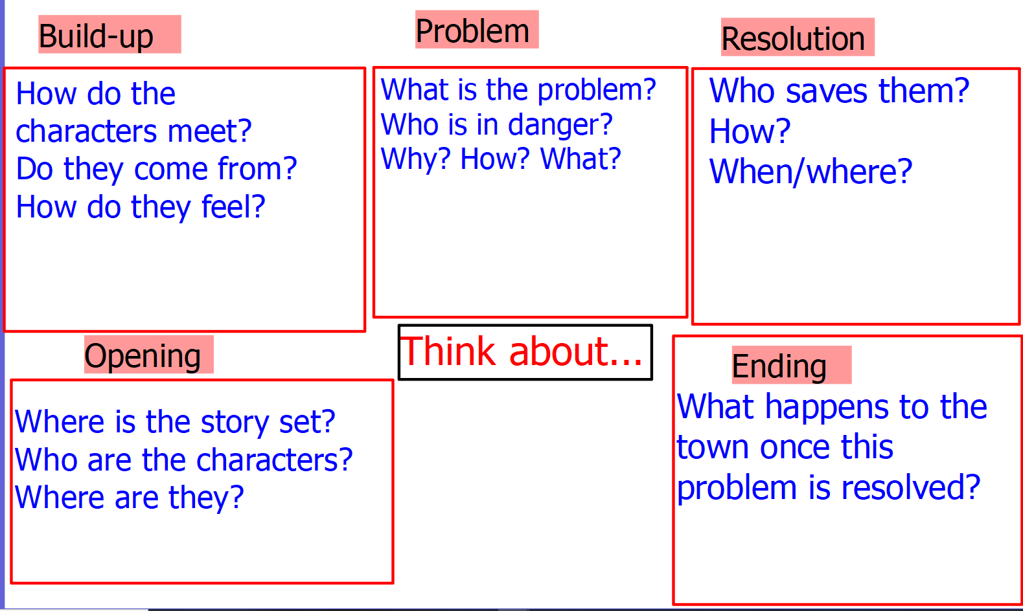

Question time! (Wolves in the Walls)
1.Can you retell the story to your family members picking the 6 main key points?
2. Can you think of another story, which has a similar theme; e.g. The Worst Witch; Bill’s New Frock; The Tunnel; Jim and the Beanstalk? Find similarities and differences.
2.Comparing characters: Compare the wolves from this story to Fantastic Mr Fox.
3.Do you think anyone has a stuffed animal like Lucy's that they also talk to?
4. Why do you think Lucy talks to her pig-puppet? .Do you think this is a bit is silly and why?
5. Is the pig-puppet alive? How do you know?
6. Does something have to be able to talk, move, eat and sleep to be alive? Give examples.
7.Why did the author set the story at Lucy's home, at night? Will that influence how the story develops?

Sentence challenge!

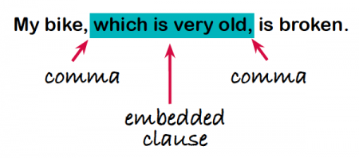
Embedded clauses:

Can you create 5 or more sentences based on the story above including embedded clauses?
For example:
Lucy, who was very brave, crept through the walls.
Even better if you could use conjunctions to extend your sentences. Lucy, who was very brave, crept through the walls because she wanted to get her pig-puppet.

Sick sentences!
These sentences are ‘sick’ and need your help to get better. Can you help?
The wolves came out of the walls. They were big and scary. The wolves had sharp teeth. Lucy and her family ran outside. They were scared. They slept outside. The wolves wore socks. They messes the house up. Lucy was brave.
Writing challenge
Could you edit and improve your sentences just like we used to do on Friday’s Literacy lessons?
Look for spelling, grammar and punctuation mistakes. Add powerful vocabulary, adverbs, noun phrases, prepositional phrases, a range of conjunctions and punctuation to add detail, to improve your sentences.

Maths:
Practice your multiplication and division facts of 7 times tables. Learn it all by heart this week.
Fractions:
Hit the button: Please practice your 3, 5 and 8 times tables!
https://www.topmarks.co.uk/maths-games/hit-the-button

Science:
Become a scientist as at home: Growing beans in a glass jar:
Can you grow your own beans in a glass jar? You only need few seeds, a small bunch of cotton and water.
1. Put the cotton into the glass jar.
2. Put the bean seeds in between the jar and the cotton as shown in the picture above.
3. Add water into the jar.
Add more water when needed as the plant grows.
The glass will allow you observe the plant’s growth every day. Record your observations.
See if you can identify each part of the plant as it grows (The primary roots, secondary roots, seed, stem and the leaves.)

Topic Work – Climate
http://www.weatherforkids.org/climate.html
Use these links to research climate and in particular the three main climate zones.
https://climatekids.nasa.gov/menu/weather-and-climate/
Miss C loves this website! What do you think?
What is climate? Present your work however you wish.

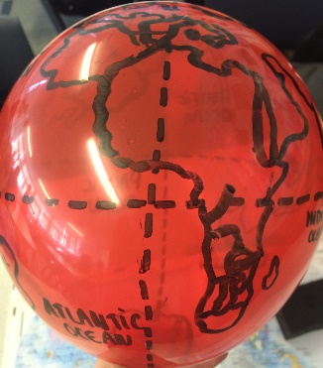
Special challenge:
Can you draw the world ???
Create your own globe to have at home by drawing the world map onto a balloon or a ball! Can you include the equator? Can you label the UK and any other countries or continents? Take a picture and show your teacher!

P.E: Can you complete a whole session with Joe?
https://www.youtube.com/watch?v=OBdmt0IEFl4
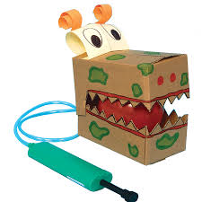
D.T: Create a moving monster of your own. Think about how you can create the same mechanism using different things.
https://www.youtube.com/watch?v=5QqinrOcblM

