https://www.bbc.co.uk/bitesize/topics/zqtf34j
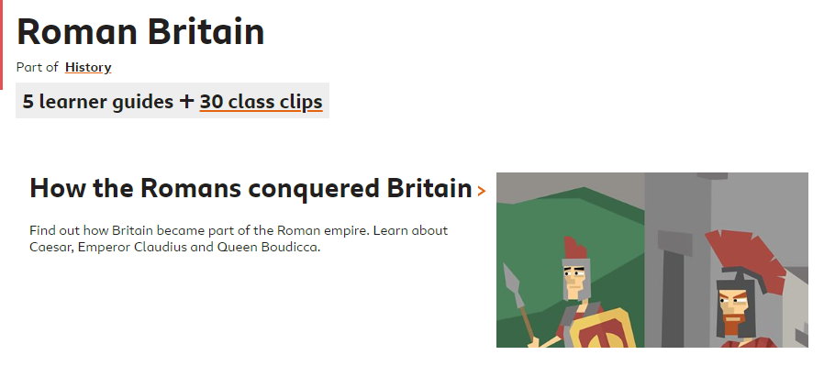
Year 3 Summer 2 History
Use BBC Bitesize to learn about the Romans!
Choose which clips to watch. Watch them twice! Take notes.
Then choose either… 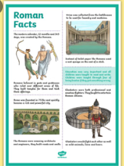
- To make a fact file about Romans. Teach your other classmates!
How did they live? What was different to how we live? If you lived in Roman times, what would be cool about your home? What would you miss?
Or 2)
Imagine you lived in Roman Britain. Draw and label your own Roman villa. Take us on a tour! 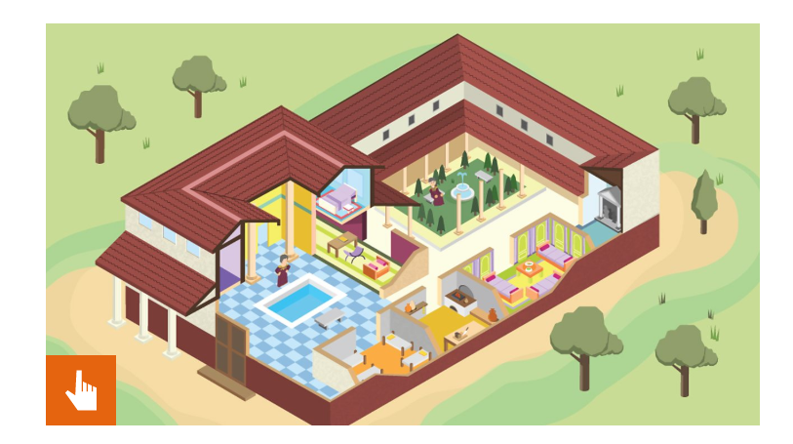

Don’t forget to take a picture of your work and send it to your class teacher!

