https://www.oddizzi.com/schools/login/
Follow this link and log in using the username: shaftesbury and password: geography
Summer 1 Geography year 3. Learn all about rainforests!
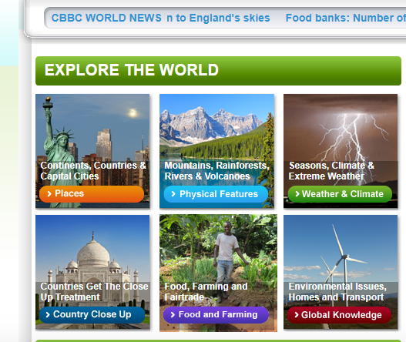
Click on the blue tab that says ‘Physical Features’ ,
Then on ‘BIOMES’, under the Orag’utan, click ‘Choose selection’ and click on ‘Rainforests’
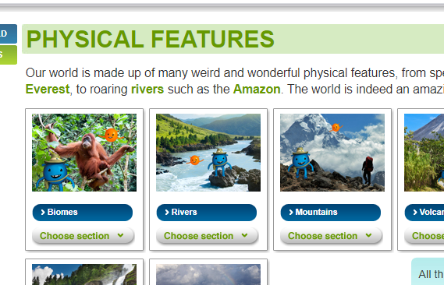
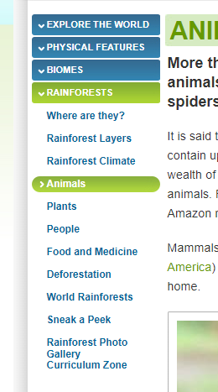
Read through, watch the videos, look at the maps, click on the different options at the side. Then have a go at the quiz! 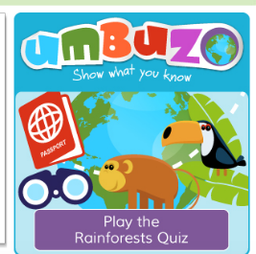

Challenge: can you draw a detailed picture of the rainforest? Label all the different types of plants and animals that are there. Which country is your rainforest picture of? Why are rainforests important?
Share a picture of your work with your class teacher!

