Dear 4P,
I hope you are all safe, keeping healthy and most importantly washing your hands! I am writing to let you know that I am thinking of you all. I can completely understand if you have been finding it hard having to stay at home all the time, and not being able to see some of your friends because of the difficult situation that we are in.
I have been checking Purple Mash and it’s been great to see lots of you working on the different activities online on there. You have made me extremely proud! I have added some more activities on the 2Do’s tab, keep checking and trying them. Thank you for all of your hard work and the learning you have been doing at home. Please continue to follow the timetable on the school website/completing your homework pack.
Here is a small checklist to remind you if you are unsure of what other things you can do while you are at home:
- Times tables from 1 to 12, practice these on Hit the Button and the test on Purple Mash.
- Go onto Twinkl.co.uk – KS2 - Year 4 – There are lots of free activities for ALL subjects.
- Read a page a day of any book you have, think of 2 or 3 questions that you could ask someone about what you have read. You could also write a summary of what the main events of the story were after each chapter.
- Practice joined up handwriting – you can write a story/poem, be imaginative! Add your favourite characters and different grammar techniques (noun phrases, adjectives, apostrophes, adverbials). Add some drawings and colour them in!
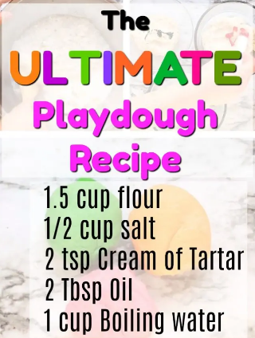
Find these on YouTube and see what other activities there are that you can try!
Stay safe,
From Miss Patel

