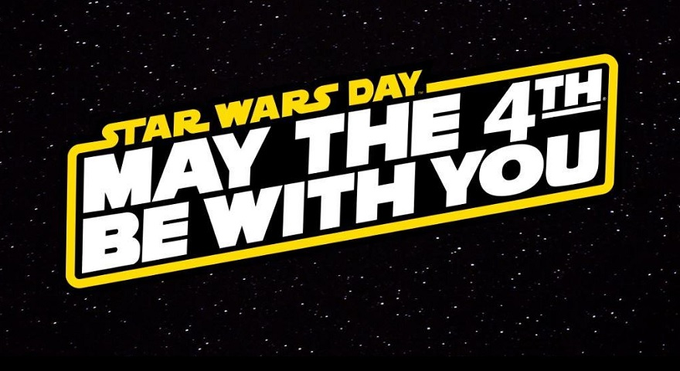

Today is Star Wars day!

Here are a few activities that to start you on your own journey to becoming a Jedi Master.

Below are some craft ideas for Star Wars themed goodies that you can make at home:
(Video links are provided too!)

Darth Vader Bookmark – Materials:
- Black Paper (Square either 12cm x 12cm or 15cm x 15cm)
- Silver pen
- Black Pen
- Nail varnish or paint or paper in blue and red
- Scissors
- Glue Stick
https://youtu.be/k6LzaVOBvSs?list=PL2vt_TPKQbZqTW-wPnYQUMcxPjOoIPjNH

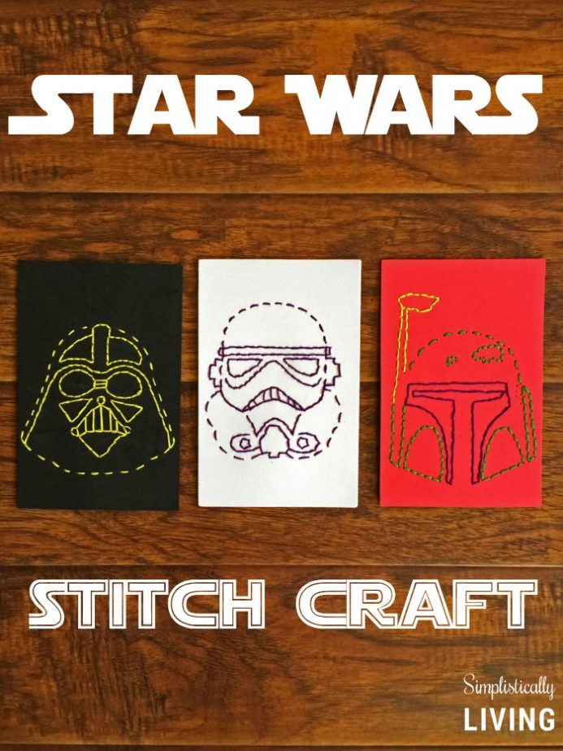
Create your own iconic Star wars character face using stitching: https://www.simplisticallyliving.com/star-wars-stitch-craft-free-printables/

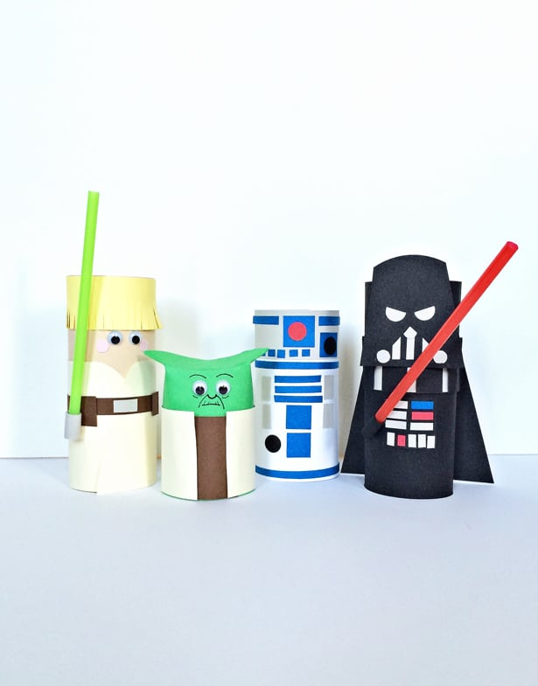

Since toilet roll is most likely in immense supply, why not put the left-over tubes to some use and make your own cast of characters!

https://www.hellowonderful.co/post/STAR-WARS-CHARACTERS-TOILET-TUBE-CRAFT/

Lastly, can you spot all the number of Star Wars characters and objects in the picture below? Colour them as you go!

Good luck young padawans and may the force be with you!
