Week beginning 18th May Homework to be completed by: 25th May 2020
Hello again everyone!
Well done for completing last week’s homework. If you haven’t yet completed it please give it a go this week along with this one! Thank you again to all the children that have been completing their Purple mash work! Please continue to look at the school’s website for updates on Home learning- Parents- School Closure.

English:
Have a read of the first few pages from the book ‘Billionaire Boy’ by author David Walliams.

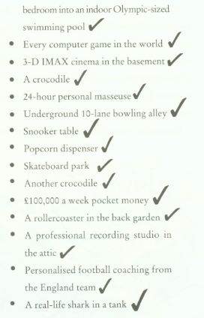
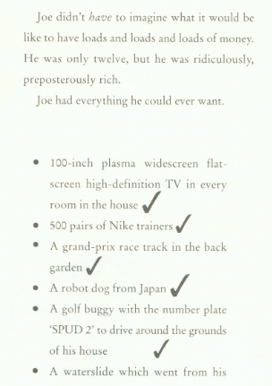
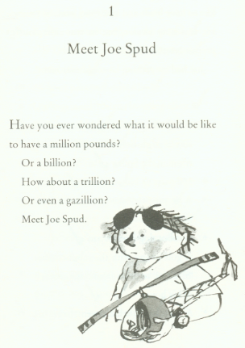

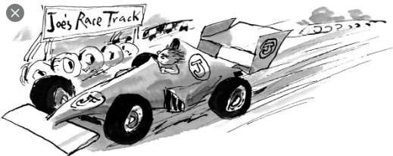

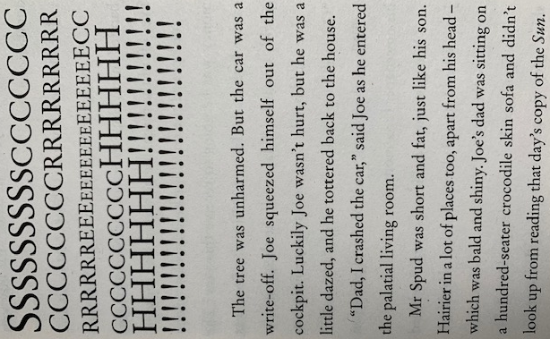
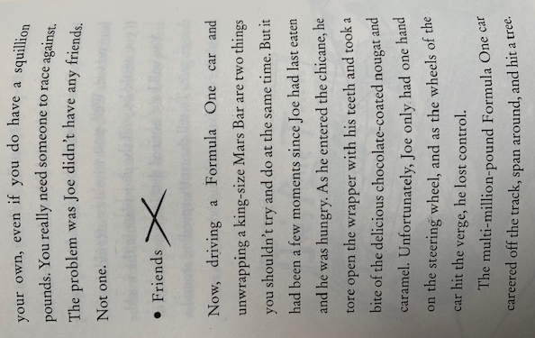

Task:
1.
On a separate page, create an acrostic poem about a Billionaire. How many poetic techniques can you include?
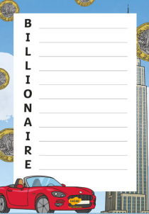

2.
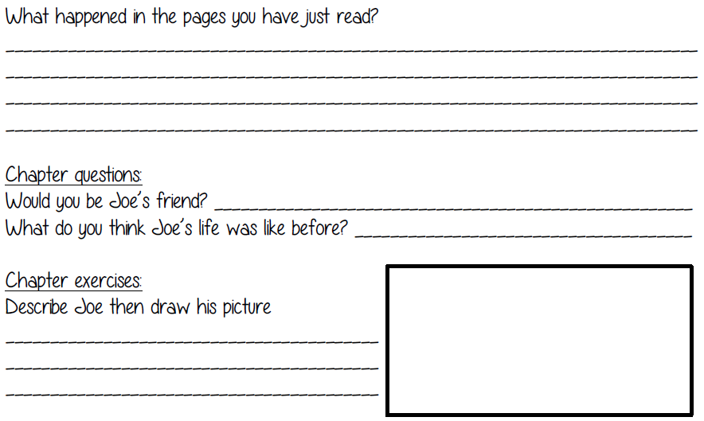
3. Can you…
…think of 3 best words to describe the way Joe Spud’s dad looks?
…think of as many adjectives as you can to describe Joe Spud’s race car?
…write a paragraph about what you think might happen next?
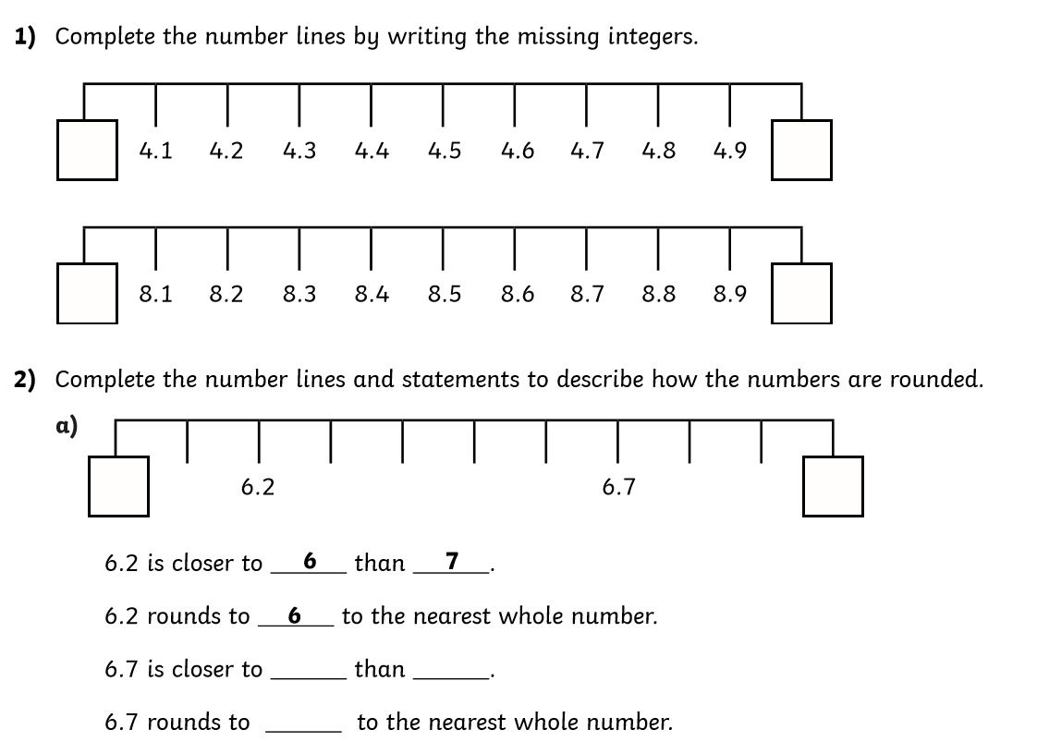
Maths: Calculation

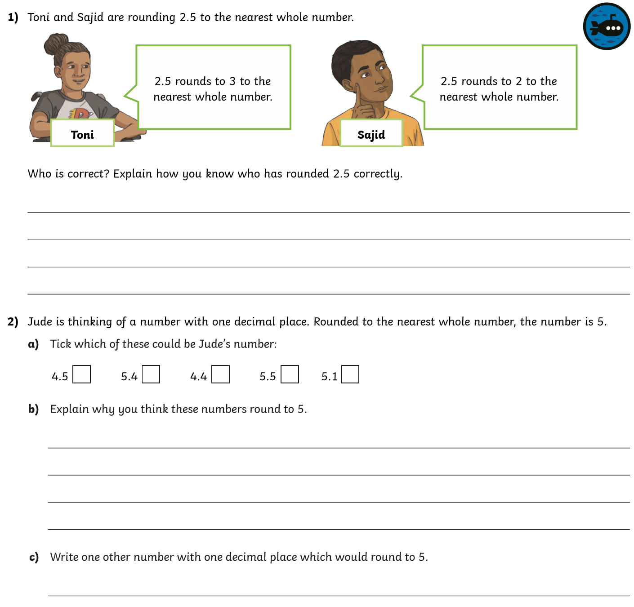

Science:

This week we are going to explore our gardens and look for living things. What living things might we find?

We need to look closely at them, observe what they do and explore their habitat.

Living things should be treated with care and sensitivity. How can we ensure we are caring and sensitive towards these living things?

Have you found any of these in your garden? What have you found? Take some pictures that can show their habitats. Please try and draw all the minibeasts you have found and write two sentences about their habitat.
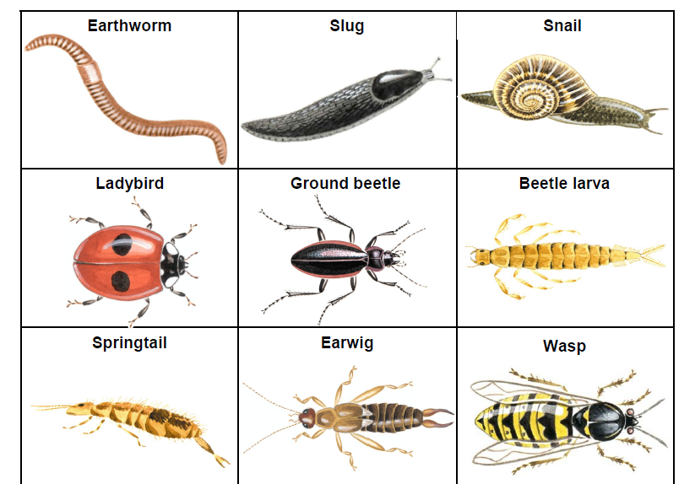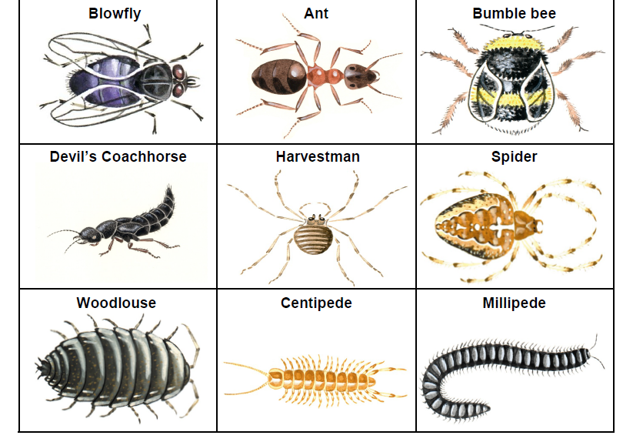
Even though your gardens are small, they are home to so many living things. Is that important?
What would happen if we tried to build a shed where the garden is?

Would you agree to that? What are the advantages and disadvantages of environmental change?
How does this affect the environment?
What happens to the wildlife?
Answer to all the questions on a separate piece of paper and bring it to school when we go back.

Geography
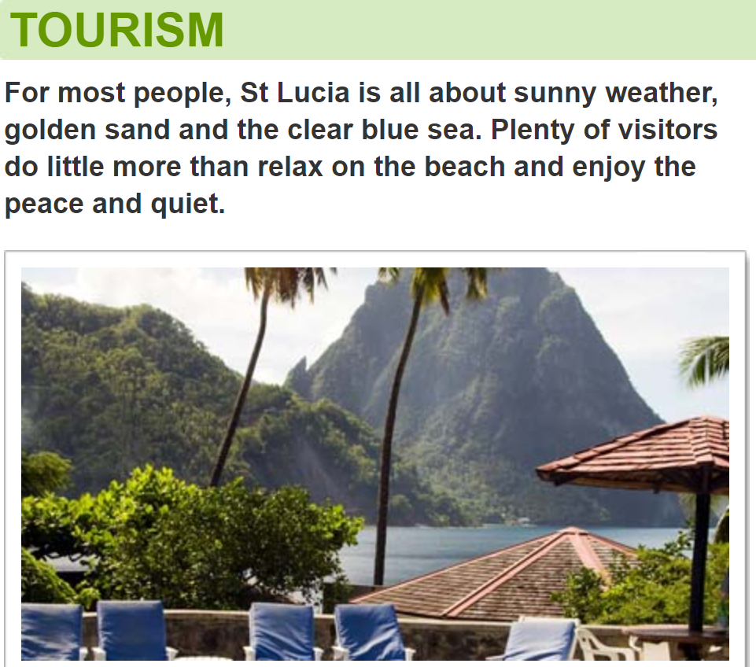

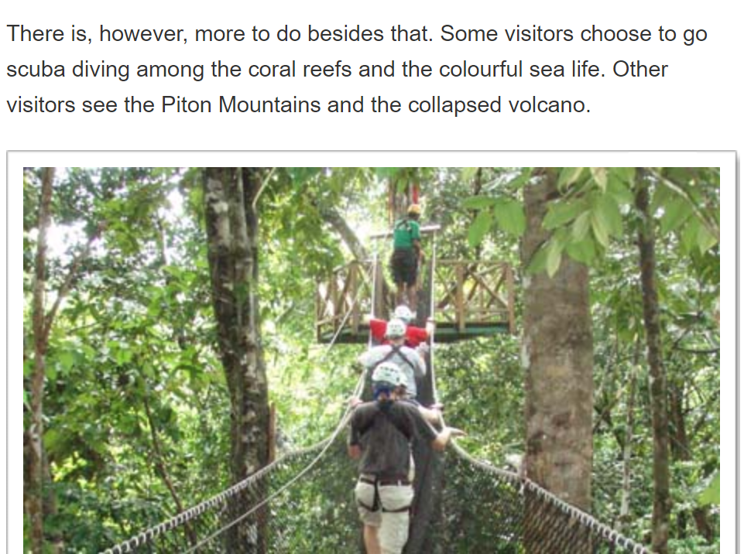

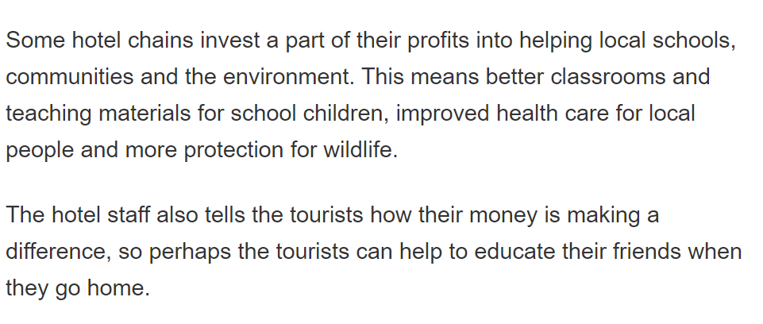
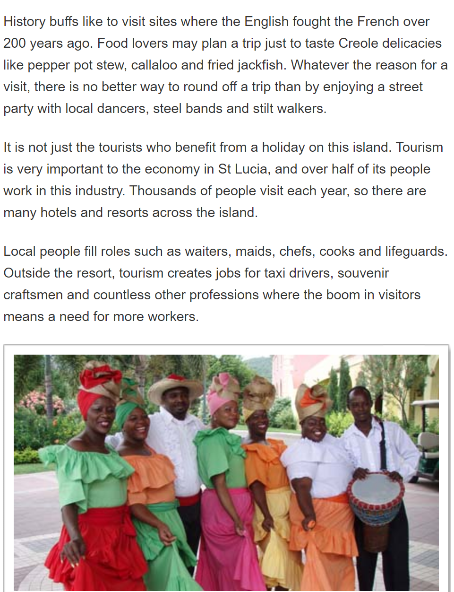
Activity
Above is information related to Tourism in St. Lucia. You may also carry out your own research regarding St.Lucia and tourism. Your task is to create a detailed list of the advantages and disadvantages of tourism. (Tourism in general, not just tourism in St.Lucia). Think of 3 advantages and 3 disadvantages.
For example:
Advantage:
An advantage of tourism is that it brings in money for the economy. This money can be used to build new and better facilities. Such as: roads, hospitals and restaurants.
Disadvantage:
A disadvantage of tourism is that it increases the amount of pollution that builds up. For example: increased amount of people increases the amount of littering.

Art:
See Viking Long Boat 3D model attachment (twinkl).
Can you create a 3D model of the ship?
