https://www.oddizzi.com/schools/login/
Follow this link and log in using the username: shaftesbury and password: geography
Summer Geography year 4. Learn all about Tourism in St Lucia!
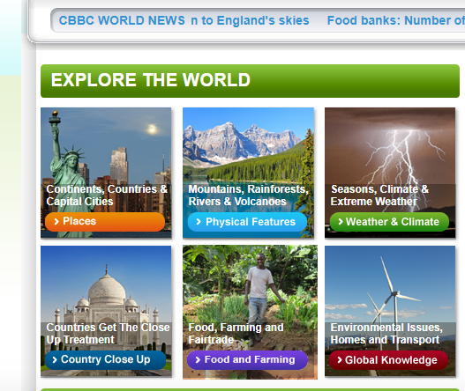
Click on the orange tab that says ‘Places ’ ,
Then on ‘St Lucia’,
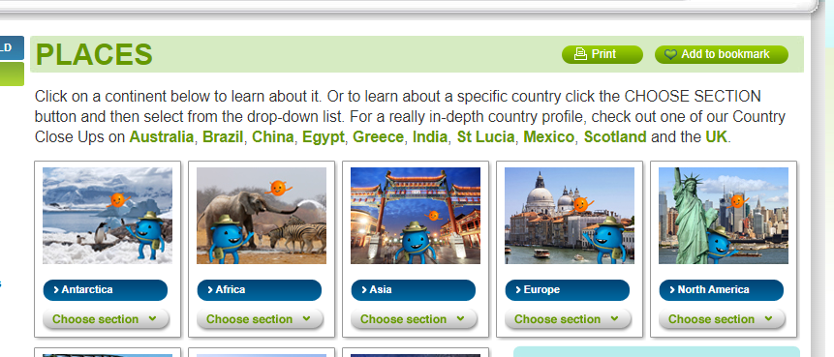
Read through, watch the videos, look at the maps, click on the different options at the bottom of the page.

Challenge: Either
- Imagine you are on holiday in St Lucia and send your teacher a postcard!

Or 2) Create a holiday brochure for St Lucia – tell people all about what it’s like to go on holiday there.

