Dear 5S,

I hope you are all doing well.
I have been thinking of you during this extremely difficult time and I understand that you may be feeling worried, anxious and scared. However, it’s completely normal to feel like this! When you feel these emotions, it’s our body’s way of telling us to take extra care to protect ourselves – and there are some important things we all need to do to stay safe, like continue washing our hands and staying at home.
I understand that this means you can’t play with your friends outdoors or attend a party that maybe you were looking forward to and this could be upsetting. However, there are many creative things to do at home which means you could still have lots of fun!
For example: baking/cake decorating, painting, playing boardgames, learning online, create an indoor kid’s gym with sports stations, create your own TV shows/stories, helping around the house and many more. I would LOVE to see what you have been up to – so anything that you create, keep it safe!
Here’s a picture of some delicious chocolate cupcakes that I baked last week:
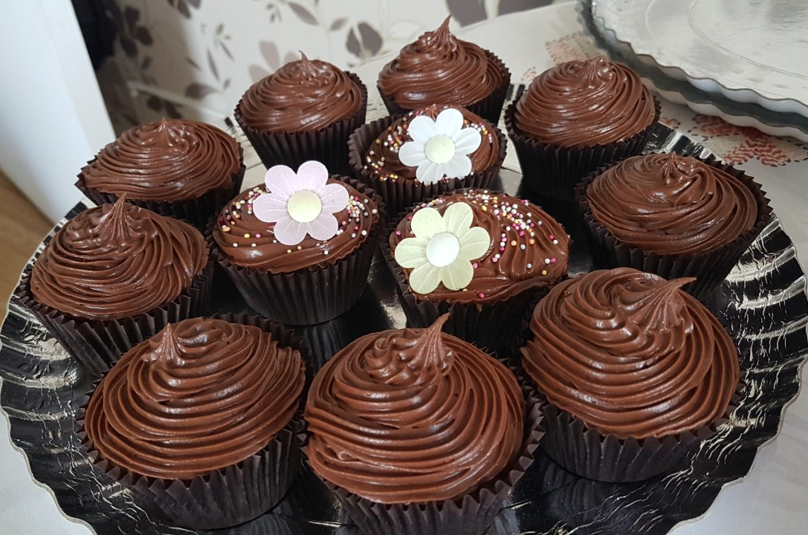 What do you think?
As most of you are aware, I have regularly been setting work on Purple Mash for you to do – please continue to check your 2dos. Well done to those of you who have been completing the work and putting lots of effort in. I’ve been very impressed with the quality of some pieces and I’ve seen some excellent superhero articles and recycling posters! (Check the comments under your work to see my feedback) If you would like to email me on Purple Mash just search 2Email and go from there or you can email the school showing us what you’ve been up to.
Remember there are a range of activities to carry out if you visit:
https://www.shaftesburyprimaryschool.co.uk/ > parents > school closures > home learning Year 5.
Please do not hesitate to contact the school if you have any concerns.
Stay safe, happy and healthy everyone!
Best wishes,

Miss Sayed.

