The Year Five Newsletter 17/8/20
Hey everyone!
We hope you and your families are well.
Thank you for all your hard work this year. Other than having fun and enjoying the sunshine, please continue to do some home learning over the summer holidays! There are lots of tasks that you can complete on Purple Mash and the school website. Well done for all your dedication towards your learning. Keep up the good work!
Purple Mash: https://www.purplemash.com/sch/shaftesbury-e7 and enter your username and password (this is the same details you use during computing lessons). Remember, make sure the school selection is Shaftesbury Primary school.
There are lots of activities on the school website! You can visit: https://www.shaftesburyprimaryschool.co.uk/page/?title=School+Closures&pid=101 alternatively when on the Shaftesbury website visit- Parents- School Closure.
English
Task 1: Infer from a picture
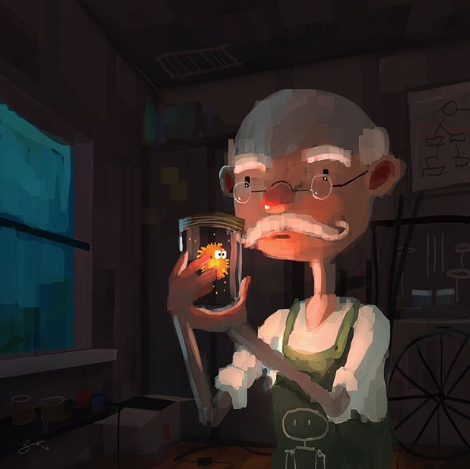

The image above is called Unknown Specimen.
Answer the following questions:
- Who is this man?
- What does he do for a living?
- What does he have in the jar?
- Why is it an ‘unknown specimen’?
- Where did it come from? What can it do?
- Does anyone else know about it?
- Where is this setting?
- What is the man going to do with it?
Task 2: Writing
Write a 3-paragraph character description for the man. What is his name? What is his background? Describe the character’s thoughts and feelings.

Maths
Angles
A - Work out the missing angles – remember a right angle = 90 degrees.
B – Work out the missing angles, remember a straight line = 180 degrees.
C – Work out the missing angles, remember angles around a point add up to 360 degrees.

Challenge: Create some of your own missing angle problems.

Angles reasoning problems:
1.

2.

3.

4.

Science
Forces
Friction including air resistance as a force slows moving objects and may prevent objects from starting to move. When objects are pushed or pulled an opposing push or pull can be felt. Think about ways in which the force pushing a rocket could be increased and how the force of friction or the force of gravity acting on a rocket could be changed.
Task – Balloon rocket investigation!
Build your balloon rocket using this diagram, what will you need?

https://www.youtube.com/watch?v=KMX7zgaLC0w – Watch this video for some inspiration on how to conduct this experiment!
Blow up the balloon using a balloon pump and use a peg to keep the air in. Use tape or elastic bands to fix the balloon to the drinking straw. Thread a long length of string through the straw, stretch the string tight and let the balloon go. When you have tried the rocket balloon a few times try to think of things that you could change about the balloon or string that would affect how far the balloon goes along the string.
Make a list of as many as you can. Two ideas are given below to start you off:
- Type of string
- How much air is in the balloon.
When you have written down as many as you can, decide on one idea from the list to investigate.
Write your idea down as a question, for example: How far will the balloon rocket go when we use thicker string? Try to make a prediction and if you can give a reason for your prediction, for example: With thicker string the balloon rocket will not go as far. I think that thicker string will rub more against the straw and this will stop the balloon rocket going as far.
INVESTIGATION TIME!
Now think about what your results tell you…
Write a conclusion paragraph - What did you find out? Was your prediction correct? Is there a pattern in the results? Could you improve your investigation?

History
Last week, you looked at the life of Victorian people. Now find out about some of the great inventions made by Victorian people!
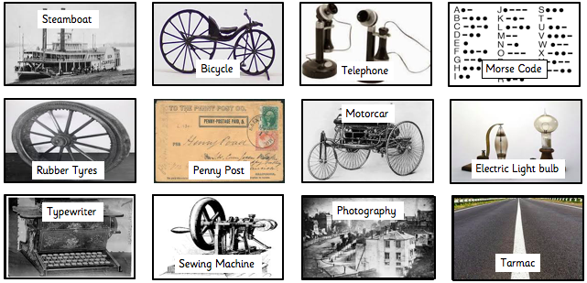
Task - Research inventions from the Victorian era. Make notes and create an information sheet ranking the inventions from what you think would be the most useful during this time, to the least. (Up to 10 inventions) Draw images and write a short summary for each one.
Think about - what the name of the invention is, who it was created by and how it was used.
For example:
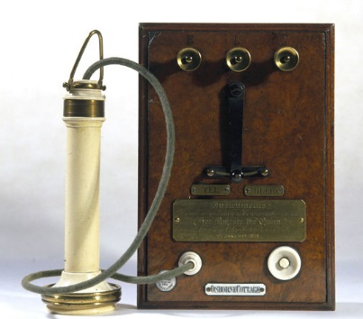
The Telephone
One of the most significant inventions and quite possibly the most famous inventor of Victorian times, Alexander Bell invented the first practical telephone. Bell will always be known as one of the most successful inventors of all time.

Use these websites for further information:
https://www.bbc.co.uk/bitesize/clips/zhwqxnb
https://www.bbc.co.uk/teach/school-radio/history-victorians-inventions/zbq78xs

