Hi everyone!
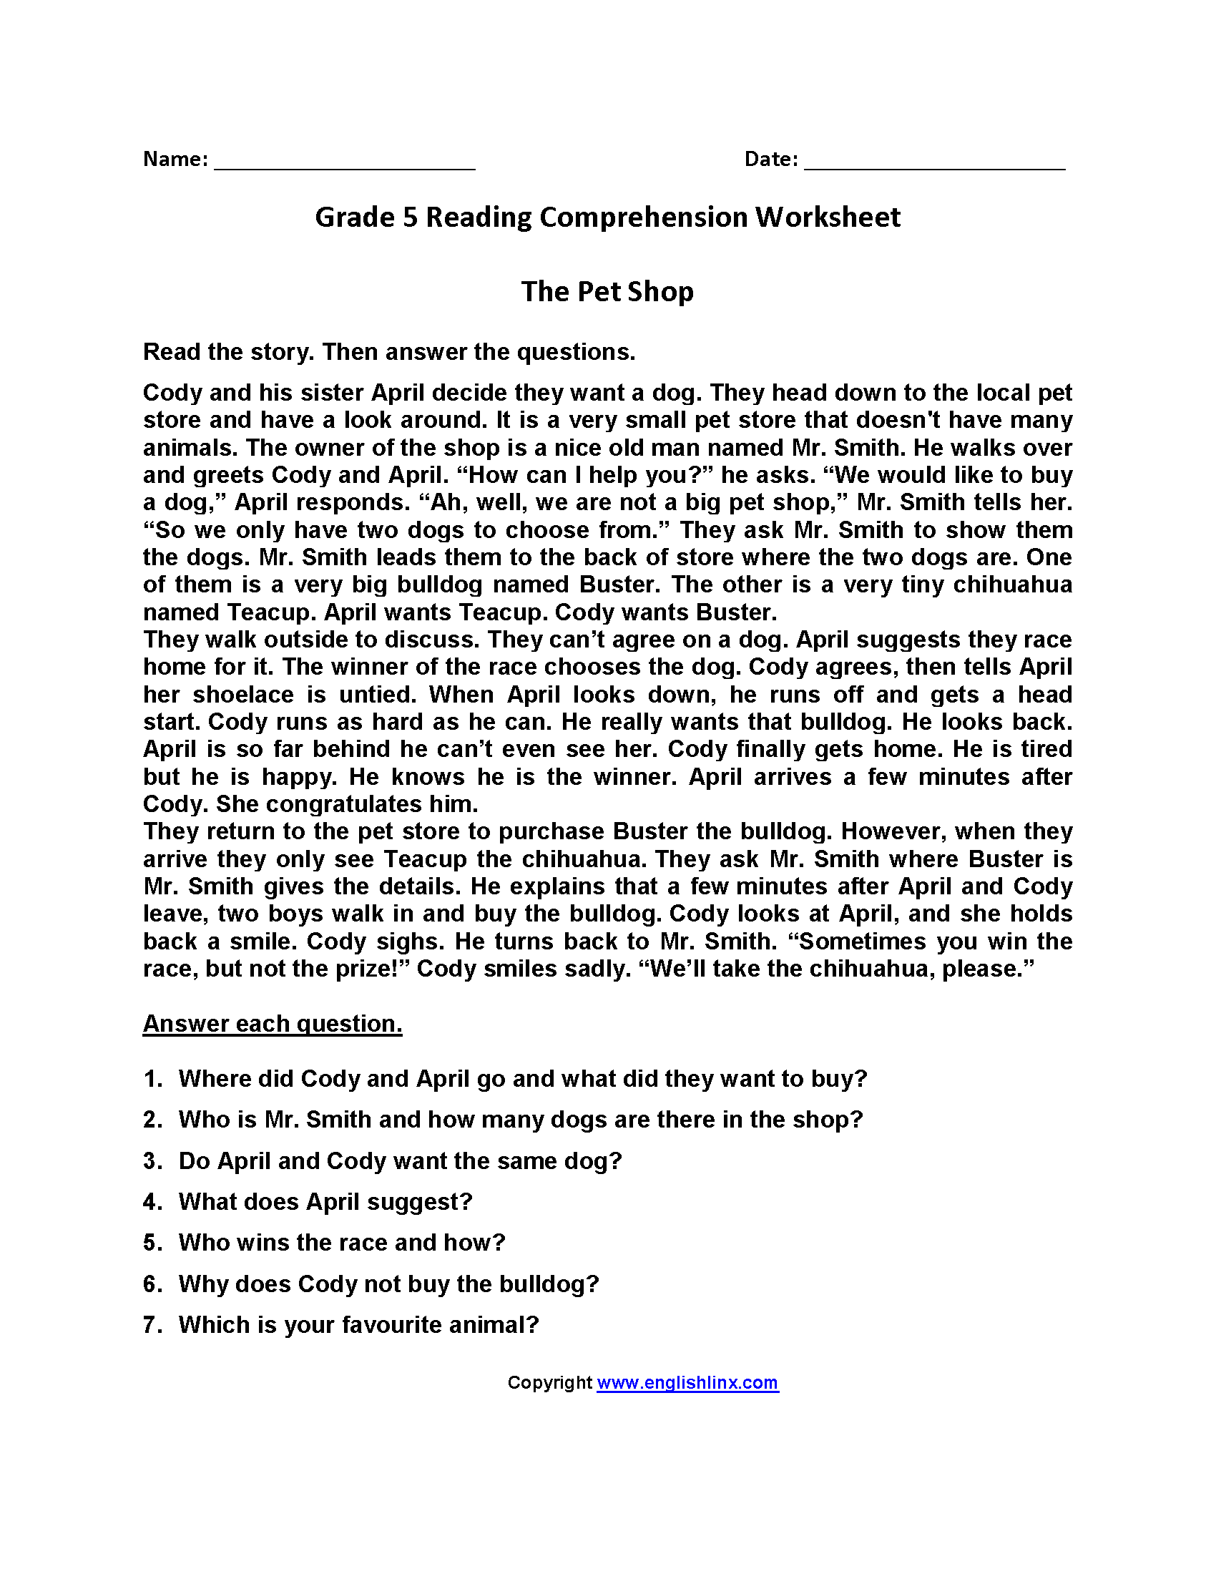
We hope you enjoyed last week’s newsletter and were able to complete all of the tasks given. Have a great summer! Please see the goodbye videos on the school website. Thank you for all your dedication towards your learning. Keep up the hard work! As before, please continue to check Purple Mash for weekly tasks and use Serial Mash to continue your reading. It is vital to use it if you can as we can also help you over it by marking and giving feedback on your work if you have found something difficult. If you have been having trouble accessing Purple Mash visit: https://www.purplemash.com/sch/shaftesbury-e7 and enter your username and password (this is the same details you use during computing lessons). Remember, make sure the school selection is Shaftesbury Primary school. Do not forget to also look at the school’s website for updates on home learning. You can visit: https://www.shaftesburyprimaryschool.co.uk/page/?title=School+Closures&pid=101 alternatively when on the Shaftesbury website visit- Parents- School Closure.
Maths
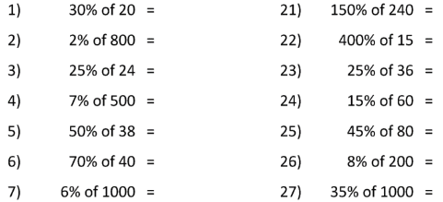

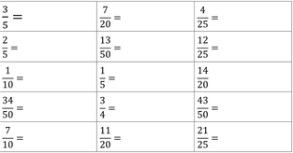

Round to the nearest whole number
