Hi everyone!
We hope you enjoyed last week’s newsletter and were able to complete all of the tasks given. Thank you for all your dedication towards your learning. Keep up the hard work! As before, please continue to check Purple Mash for weekly tasks and use Serial Mash to continue your reading. It is vital to use it if you can as we can also help you over it by marking and giving feedback on your work if you have found something difficult. If you have been having trouble accessing Purple Mash visit: https://www.purplemash.com/sch/shaftesbury-e7 and enter your username and password (this is the same details you use during computing lessons). Remember, make sure the school selection is Shaftesbury Primary school. Do not forget to also look at the school’s website for updates on home learning. You can visit: https://www.shaftesburyprimaryschool.co.uk/page/?title=School+Closures&pid=101 alternatively when on the Shaftesbury website visit- Parents- School Closure.
Please see your teacher`s goodbye and welcome video on the school website. The home learning packs will be continuing over the holidays. Keep learning and stay safe! Have a great summer!
Subtracting fractions

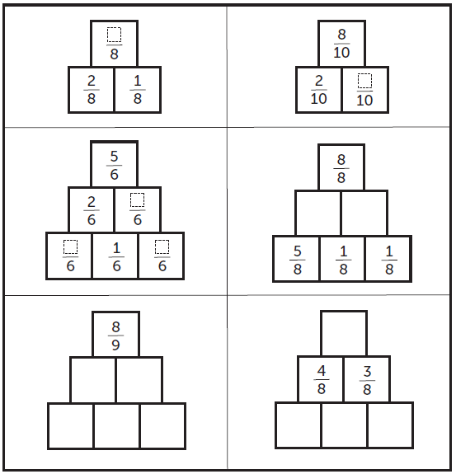
Fraction pyramid

Simplify fractions

Multiply fractions
For example

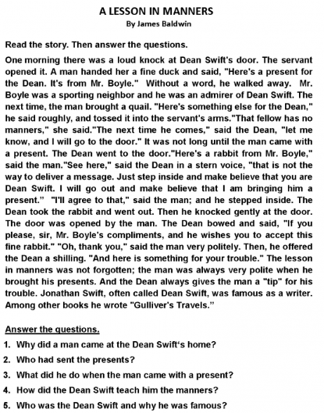
English

Geography
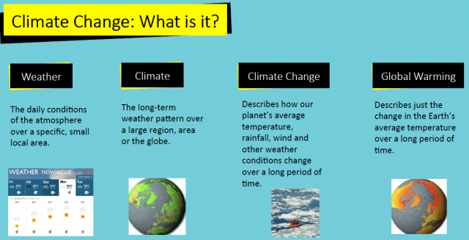

Global warming describes the current rise in the average temperature of Earth's air and oceans. Global warming is often described as the most recent example of climate change.
Glaciers are melting, sea levels are rising, cloud forests are dying, and wildlife is scrambling to keep pace. It has become clear that humans have caused most of the past century's warming by releasing heat-trapping gases as we power our modern lives.
- Speak up! ...
- Power your home with renewable energy. ...
- Weatherize, weatherize, weatherize. ...
- Invest in energy-efficient appliances. ...
- Reduce water waste. ...
- Actually eat the food you buy—and make less of it meat. ...
- Buy better bulbs
- Reduce, Reuse, Recycle. ...
- Use Less Heat and Air Conditioning. ...
- Replace Your Light Bulbs. ...
- Drive Less and Drive Smart. ...
- Buy Energy-Efficient Products. ...
- Use Less Hot Water. ...
- Use the "Off" Switch

Using the information create a poster how we can reduce the effects of global warming.

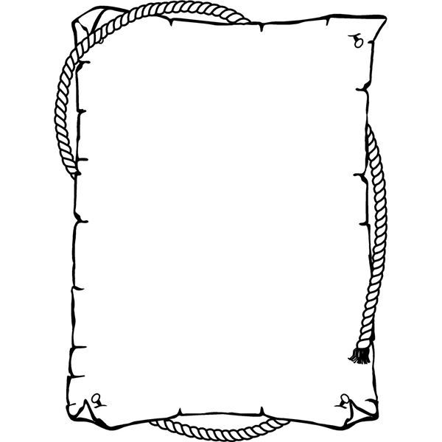

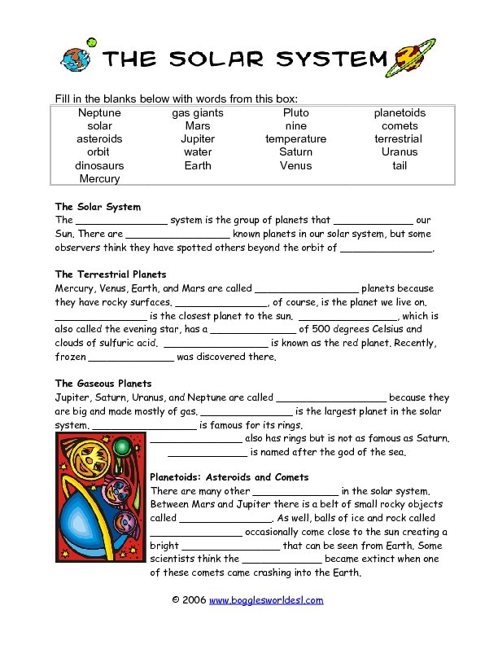
Science- recap complete the worksheet

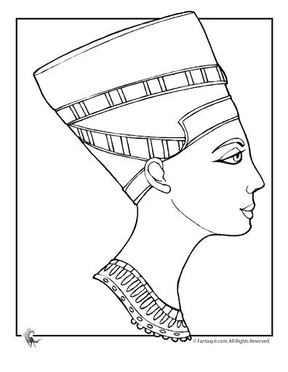
Art- create a self-portrait.

